American International University-Bangladesh (AIUB)


Department of Computer Science
Faculty of Science and Technology
Topic Name :
Student Details
Student Name | Student ID | Contributed Topic | Percentage%
MD. SHADMAN SHAKIB ALAM | 22-46262-1 | Introduction, User Interface, Normalization, Table creation, Adv PL/SQL | 25%
RIMON PRAMANIK | 22-46957-1 | Project Proposal, Table creation, Normalization, Adv PL/SQL | 25%
LAMIA TAHSIN | 22-46345-1 | Scenario, ER diagram, Table creation, Data insertion, Basic PL/SQL | 25%
MARUF AHMEND | 22-46354-1 | Schema diagram, Basic PL/SQL ,  Conclusion, Data insertion | 25%
Outdoor Sports Facility Management System

Submission Date: August 23, 2025

TABLE OF CONTENTS

1. INTRODUCTION | 3
2. PROJECT PROPOSAL | 4-6
3. USER INTERFACE: (Figma) | 7-14
4. SCENARIO DESCRIPTION | 15
5. ER DIAGRAM | 16
6. NORMALIZATION | 17-26
7. SCHEMA DIAGRAM | 27
8. TABLE CREATION | 28-40
9. DATA INSERTING | 40-55
10. BASIC PL/SQL | 55-77
11. ADVANCE PL/SQL | 78-98
12. CONCLUSION | 99

- INTRODUCTION:
The Outdoor Sports Facility Management System is a comprehensive platform built to simplify the management of sports facilities, enhance player experience, and streamline event coordination. Designed for both sports organizations and individual players, this system empowers users to easily book turfs, create and manage teams, schedule matches, and view their profile all from a single, user-friendly interface.
The Home Page serves as a gateway to the platform’s core features, providing easy navigation for users to Join, Create a Team, or Book Turf. The design is clean and intuitive, ensuring easy access for players and administrators to the tools they need.
Key Features:
- Turf Management: Players can view available turfs and book them for matches or practice sessions. The Turf View feature allows users to explore the turf in detail before making a booking.
- Team Creation & Management: Players can form or join teams easily. The platform allows team creation, member invitations, and roster management. Teams can view available slots and schedule practice sessions or matches.
- Booking & Payment: The Booking Summary page provides players with an overview of their upcoming bookings. The Payment Options and Payment Success pages offer secure and smooth transaction processing, with multiple payment methods available for flexibility.
- Event Scheduling: Organize and manage sports events like tournaments and matches effortlessly. The Booking Summary page keeps players and administrators updated with event schedules and details.
- Profile Management: Users can manage their personal information and track their activities, including match history and performance.
- Favorites: Users can save their favorite turfs and bookings for quick access in the future, enhancing their experience with easy links to frequently used services.
The system integrates Nest.js for backend efficiency, Next.js for a responsive and dynamic frontend, and a secure SQL/PLSQL database for robust data management. The platform ensures real-time updates, reliability, and scalability to meet growing user needs.
By using this platform, sports organizations can efficiently manage their grounds, schedules, and player data, while players enjoy a seamless and engaging sports experience whether they’re booking a turf for practice, forming a team, or participating in a match.

- PROJECT PROPOSAL :
Project Overview:
The Outdoor Sports facility Management System is a comprehensive, user-friendly platform designed to simplify the management of sports facilities, enhance player experience, and streamline event coordination. This platform will serve both sports organizations and individual players, allowing users to easily book turfs, create teams, manage events, and access their profiles all from a single interface.
With a clean and intuitive design, the system enables players to view real-time turf availability, reserve slots for practice or matches, and manage team activities. Sports organizations will benefit from the efficient management of turf bookings, player data, and event scheduling.
Objective:
The primary goal of the Outdoor Sports Facility Management System is to provide a seamless and efficient solution for managing outdoor sports activities. The system will achieve this by:
- Allowing players to easily book available turfs for matches or practice sessions.
- Enabling players to create and join teams, as well as manage team schedules.
- Providing administrators and sports organizations with tools to manage turf availability, player data, bookings, and payments.
- Offering a secure and smooth payment gateway for all bookings and event participation.
Scope of the Project:
- Target Audience:
  - Sports Organizations: Clubs, event organizers, coaches, and administrators who need an efficient platform to manage turf availability, player data, and event schedules.
  - Players: Individuals who want to easily book turfs, participate in events, form or join teams, and manage their profiles.
- Key Features:
  - Turf Management: Players can view available turfs, check their condition, and book them for practice or matches. The Turf View feature allows users to explore turfs before making bookings.
  - Team Creation & Management: Players can create or join teams, invite members, and manage rosters. Teams can view available slots and schedule practice sessions or matches.
  - Booking & Payment System: The Booking Summary page provides players with an overview of upcoming bookings. The Payment Options and Payment Success pages ensure secure transactions, with multiple payment methods available.
  - Event Scheduling: Admins and players can organize sports events such as tournaments and matches. The system automatically updates players with event details and schedules.
  - Profile Management: Users can update their profiles, view team participation, and manage personal information.
  - Favorites: Players can save their favorite turfs and bookings for easy future access.
- Technology Stack:
  - Frontend: Next.js for a dynamic and responsive user interface.
  - Backend: Nest.js for handling backend logic and managing API requests.
  - Database: SQL/PLSQL for secure, scalable data management.
  - Payment Integration: bKash, Nagad, or other payment gateways for secure and smooth transactions.
Problem Statement:
Currently, sports organizations and players face challenges in managing turf bookings, organizing events, and tracking player data manually. This often leads to inefficiencies, double bookings, and poor communication. Players also struggle to find and join teams that match their skill levels, and administrators face difficulties managing large amounts of data.
Proposed Solution:
The Outdoor Sports Management System addresses these challenges by:
- Providing a platform where users can check turf availability and book slots in real-time.
- Allowing players to create or join teams, view team rosters, and schedule events or practices.
- Offering a smooth and secure payment system for booking turfs and registering for events.
- Allowing administrators to manage events, bookings, player data, and payments with ease.

Expected Outcomes:
- For Sports Organizations:
  - Simplified turf and event management.
  - Enhanced communication with players and teams.
  - Reduced administrative workload and errors.
- For Players:
  - Easy access to turf availability and event schedules.
  - Streamlined team creation and participation.
  - Personalized experience with player profiles and team management.
Timeline:
The project will be completed in the following phases:
- Phase 1: Planning & Requirements Gathering (1 weeks)
- Phase 2: System Design & Database Schema (2 weeks)
- Phase 3: Backend & Frontend Development (3 weeks)
- Phase 4: Integration & Testing (1 weeks)
- Phase 5: Deployment & Final Review (1 weeks)
Budget & Resources
The project requires resources for:
- Software tools and technology (Next.js, Nest.js, SQL/PLSQL).
- Web hosting and domain registration.
- Payment gateway integration.
- Development and testing resources.
The estimated budget will cover these resources, with the project expected to be completed over the course of 2 months.

- USER INTERFACE: (Figma)
Figma Live link:
https://www.figma.com/design/gu6MmmA9LLIFNvthsJOYzK/Outdoor-sports-management?node-id=0-1&p=f&t=R19DcoDAKIZGseXV-0
 | 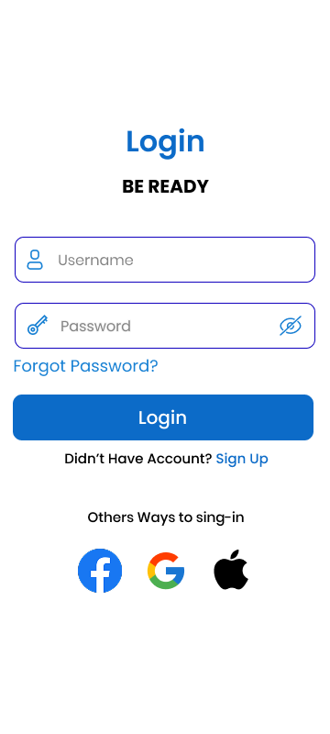
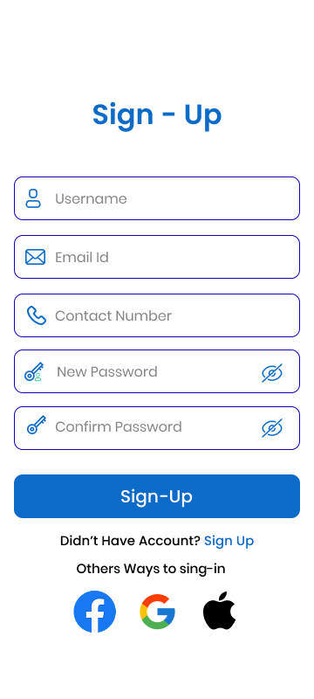 | 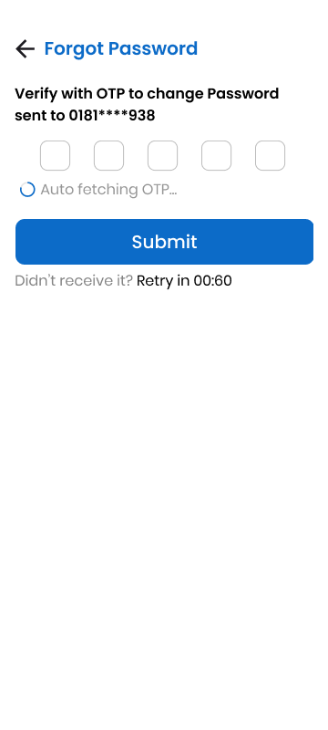
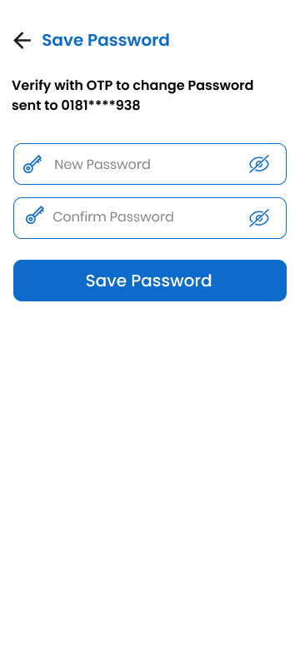 | 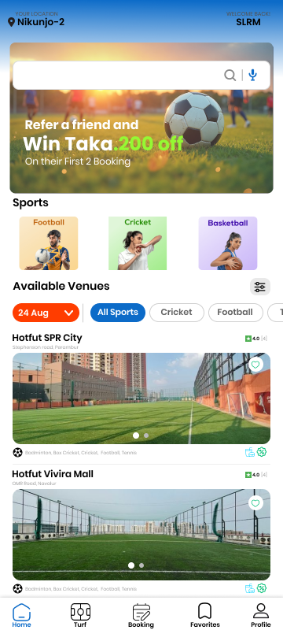
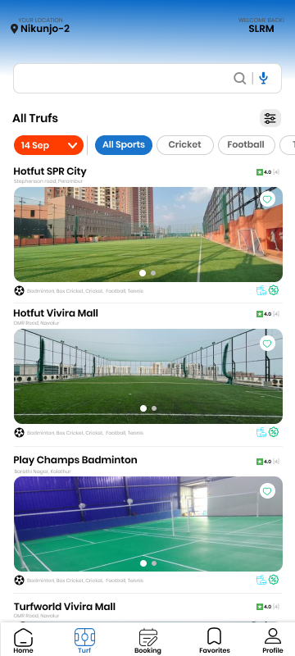 | 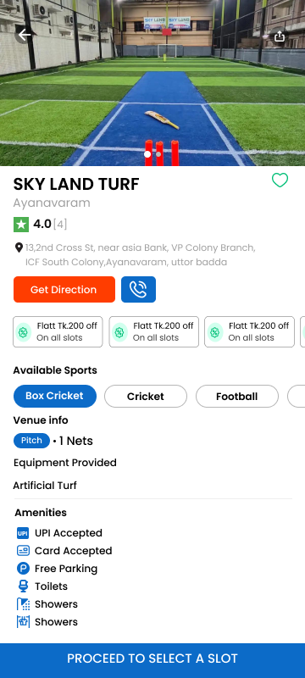
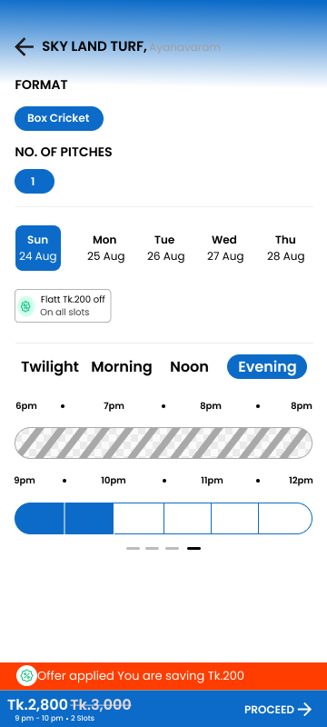 | 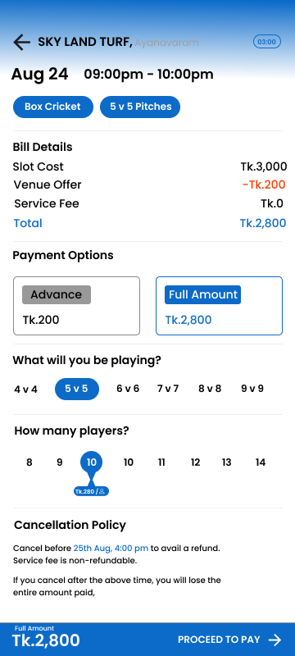
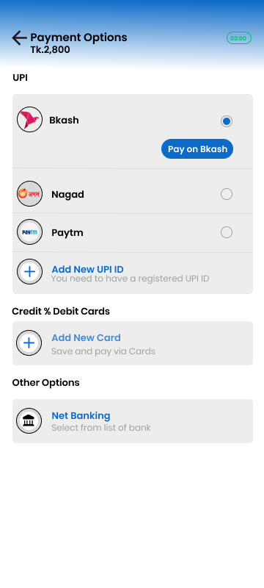 | 
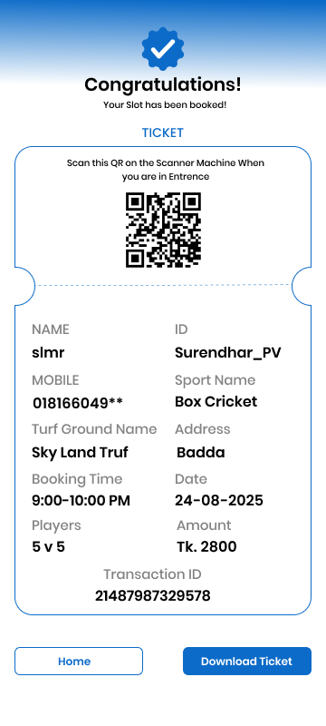 | 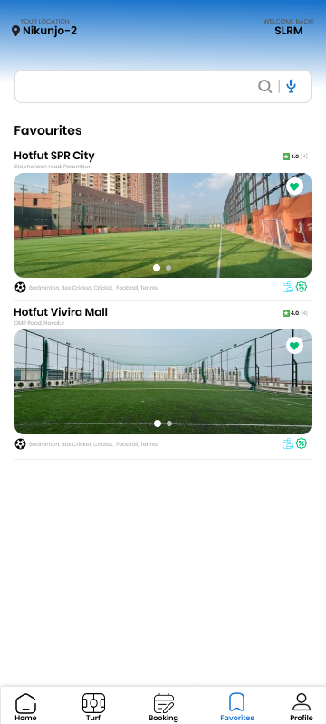
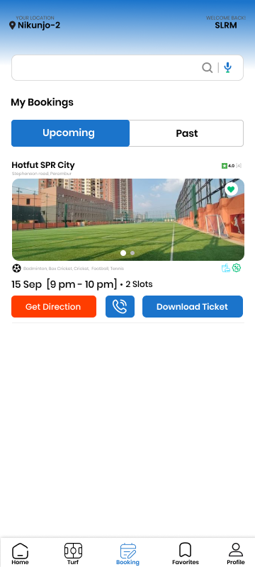 | 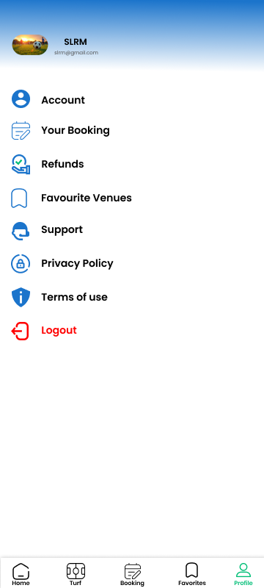

- SCENARIO DESCRIPTION:
In an Outdoor Sports Facility Management System, one Player can belong to only one Team. Each Player has a unique identification number (Player ID), Name, Date of Birth, and Phone Number. A Name is composed of First Name and Last Name.
Each Player has one Profile. A Profile has a unique identification number (Profile ID), Skill Level, and a record of Achievements.
One Team can make many Bookings, and one Booking is made by one Team. A Team has a unique identification number (Team ID), Team Name, and Sport Type.
One Player can also make many Bookings, and one Booking is made by one Player. A Booking has a unique identification number (Booking ID), Date, Start Time, End Time, and Status.
One Turf can be booked for many Bookings (at different times). A Turf has a unique identification number (Turf ID), Name, Location, Size, and Type (e.g., Grass, AstroTurf).
One Event requires one Turf, but one Turf can host many Events. An Event has a unique identification number (Event ID), Name, Date, and Rules.
Many Teams can participate in one Event, but for this system, we will model it as many Teams participating in one Event. An Event's details include its participating Teams.
One Staff Member manages many Events and also manages many Bookings. Each Staff Member has a unique identification number (Staff ID), Name, and Department. A Name is composed of First Name and Last Name.
One Booking can be paid for by many Payments (e.g., installment plans, multiple payment methods). A Payment has a unique identification number (Payment ID), Amount, and Payment Date.
Many Payments can be processed by one Staff Member. Each Payment is associated with one Payment Type (e.g., Credit Card, Debit Card, Cash). Each Payment Type has a unique code (Payment Type Code), a Payment Method, and a Description.

- ER DIAGRAM:

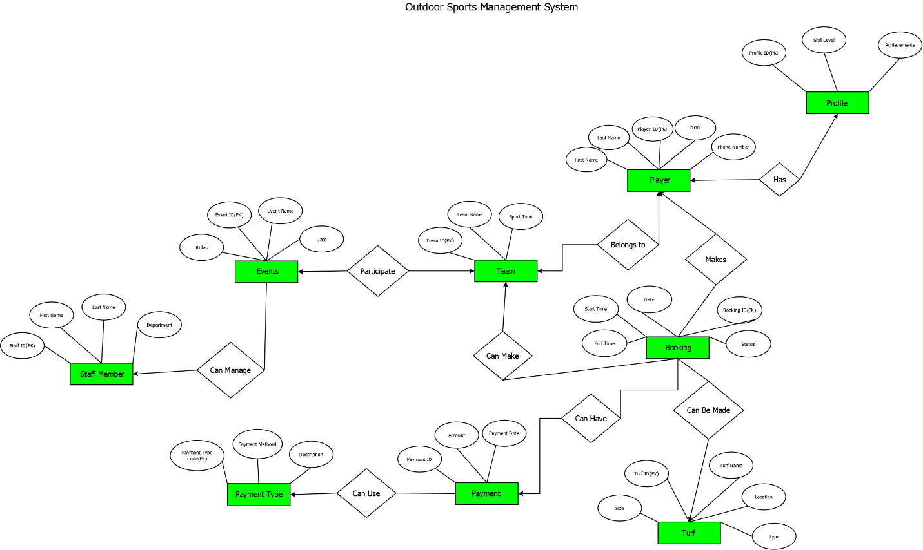

Fig-1: ER diagram

- NORMALIZATION:
Relation 1: Can Manage (Staff Member Can Manage Event)
UNF:
Can_Manage(Staff_ID, First_Name, Last_Name, Department, Event_ID, Event_Name, Date, Rules)
1NF:
No multivalued attributes, so it remains
1. Staff_ID, First_Name, Last_Name, Department, Event_ID, Event_Name, Date, Rules
2NF:
Staff details depend on Staff_ID
Event details depend on Event_ID.
1. Staff_ID, First_Name, Last_Name, Department
2. Event_ID, Event_Name, Date, Rules
3. Staff_ID, Event_ID
3NF:
No Transitive dependencies.
1. Staff_ID, First_Name, Last_Name, Department
2. Event_ID, Event_Name, Date, Rules
3. Staff_ID, Event_ID
Table Creation:
Staff_Member(Staff_ID, First_Name, Last_Name, Department)
Event(Event_ID, Event_Name, Date, Rules)
Can_Manage(Staff_ID, Event_ID)

- SCHEMA DIAGRAM:

Relation 2: Participates (Event Participates in Team)
UNF:
Participates(Event_ID, Event_Name, Date, Rules, Team_ID, Team_Name, Sport_Type)
1NF:
No multivalued attributes, so it remains
1. Event_ID, Event_Name, Date, Rules, Team_ID, Team_Name, Sport_Type

2NF:
Event details depend on Event_ID.
Team details depend on Team_ID.
1. Event_ID, Event_Name, Date, Rules
2. Team_ID, Team_Name, Sport_Type
3. Event_ID, Team_ID

3NF:
No Transitive dependencies.
1. Event_ID, Event_Name, Date, Rules
2. Team_ID, Team_Name, Sport_Type
3. Event_ID, Team_ID

Table Creation:
Event(Event_ID, Event_Name, Date, Rules)
Team(Team_ID, Team_Name, Sport_Type)
Participates(Event_ID, Team_ID)

Relation 3: Belongs To (Player Belongs to Team)
UNF:
Belongs_To(Player_ID, First_Name, Last_Name, DOB, Phone_Number, Team_ID, Team_Name, Sport_Type)
1NF:
No multivalued attributes, so it remains
1. Player_ID, First_Name, Last_Name, DOB, Phone_Number, Team_ID, Team_Name, Sport_Type

2NF:
Player details depend on Player_ID.
Team details depend on Team_ID.
1. Player_ID, First_Name, Last_Name, DOB, Phone_Number
2. Team_ID, Team_Name, Sport_Type
3. Player_ID, Team_ID

3NF:
No Transitive dependencies.
1. Player_ID, First_Name, Last_Name, DOB, Phone_Number
2. Team_ID, Team_Name, Sport_Type
3. Player_ID, Team_ID

Table Creation:
Player(Player_ID, First_Name, Last_Name, DOB, Phone_Number)
Team(Team_ID, Team_Name, Sport_Type)
Belongs_To(Player_ID, Team_ID)

Relation 4: Has (Player Has Profile)

UNF:
Has(Player_ID, First_Name, Last_Name, DOB, Phone_Number, Profile_ID, Skill_Level, Achievements)
1NF:
No multivalued attributes, so it remains
1. Player_ID, First_Name, Last_Name, DOB, Phone_Number, Profile_ID, Skill_Level, Achievements
2NF:
Player details depend on Player_ID.
Profile details depend on Profile_ID.
1. Player_ID, First_Name, Last_Name, DOB, Phone_Number
2. Profile_ID, Skill_Level, Achievements
3. Player_ID, Profile_ID

3NF:
No Transitive dependencies.
1. Player_ID, First_Name, Last_Name, DOB, Phone_Number
2. Profile_ID, Skill_Level, Achievements
3. Player_ID, Profile_ID

Table Creation:
Player(Player_ID, First_Name, Last_Name, DOB, Phone_Number)
Profile(Profile_ID, Skill_Level, Achievements)
Has(Player_ID, Profile_ID)

Relation 5: Can Make (Team Can Make Booking)
UNF:
Can_Make(Team_ID, Team_Name, Sport_Type, Booking_ID, Start_Time, End_Time, Date, Status)
1NF:
No multivalued attributes, so it remains
1. Team_ID, Team_Name, Sport_Type, Booking_ID, Start_Time, End_Time, Date, Status
2NF:
Team details depend on Team_ID
Booking details depend on Booking_ID
1. Team_ID, Team_Name, Sport_Type
2. Booking_ID, Start_Time, End_Time, Date, Status
3. Team_ID, Booking_ID

3NF:
No Transitive dependencies.
1. Team_ID, Team_Name, Sport_Type
2. Booking_ID, Start_Time, End_Time, Date, Status
3. Team_ID, Booking_ID

Table Creation:
Team(Team_ID, Team_Name, Sport_Type)
Booking(Booking_ID, Start_Time, End_Time, Date, Status)
Can_Make(Team_ID, Booking_ID)

Relation 6: Makes (Player Makes Booking)
UNF:
Makes(Player_ID, First_Name, Last_Name, DOB, Phone_Number, Booking_ID, Start_Time, End_Time, Date, Status)
1NF:
No multivalued attributes, so it remains
1. Player_ID, First_Name, Last_Name, DOB, Phone_Number, Booking_ID, Start_Time, End_Time, Date, Status
2NF:
Player details depend on Player_ID
Booking details depend on Booking_ID
1. Player_ID, First_Name, Last_Name, DOB, Phone_Number
2. Booking_ID, Start_Time, End_Time, Date, Status
3. Player_ID, Booking_ID

3NF:
No Transitive dependencies.
1. Player_ID, First_Name, Last_Name, DOB, Phone_Number
2. Booking_ID, Start_Time, End_Time, Date, Status
3. Player_ID, Booking_ID

Table Creation:
Player(Player_ID, First_Name, Last_Name, DOB, Phone_Number)
Booking(Booking_ID, Start_Time, End_Time, Date, Status)
Makes(Player_ID, Booking_ID)

Relation 7: Can Be Made (Booking Can Be Made On Turf)
UNF:
Can_Be_Made(Booking_ID, Start_Time, End_Time, Date, Status, Turf_ID, Turf_Name, Location, Size, Type)
1NF:
No multivalued attributes, so it remains
1. Booking_ID, Start_Time, End_Time, Date, Status, Turf_ID, Turf_Name, Location, Size, Type
2NF:
Booking details depend on Booking_ID
Turf details depend on Turf_ID
1. Booking_ID, Start_Time, End_Time, Date, Status
2. Turf_ID, Turf_Name, Location, Size, Type
3. Booking_ID, Turf_ID

3NF:
No Transitive dependencies.
1. Booking_ID, Start_Time, End_Time, Date, Status
2. Turf_ID, Turf_Name, Location, Size, Type
3. Booking_ID, Turf_ID

Table Creation:
Booking(Booking_ID, Start_Time, End_Time, Date, Status)
Turf(Turf_ID, Turf_Name, Location, Size, Type)
Can_Be_Made(Booking_ID, Turf_ID)

Relation 8: Can Have (Booking Can Have Payment)
UNF:
Can_Have(Booking_ID, Start_Time, End_Time, Date, Status, Payment_ID, Amount, Payment_Date)
1NF:
No multivalued attributes, so it remains
1. Booking_ID, Start_Time, End_Time, Date, Status, Payment_ID, Amount, Payment_Date

2NF:
Booking details depend on Booking_ID
Payment details depend on Payment_ID
1. Booking(Booking_ID, Start_Time, End_Time, Date, Status)
2. Payment(Payment_ID, Amount, Payment_Date)
3. Can_Have(Booking_ID, Payment_ID)

3NF:
No Transitive dependencies.
1. Booking(Booking_ID, Start_Time, End_Time, Date, Status)
2. Payment(Payment_ID, Amount, Payment_Date)
3. Can_Have(Booking_ID, Payment_ID)

Table Creation:
Booking(Booking_ID, Start_Time, End_Time, Date, Status)
Payment(Payment_ID, Amount, Payment_Date)
Can_Have(Booking_ID, Payment_ID)

Relation 9: Can Use (Payment Can use Payment Type)
UNF:
Can_Use(Payment_ID, Amount, Payment_Date, Payment_Type_Code, Payment_Method, Description)
1NF:
No multivalued attributes, so it remains
1. Payment_ID, Amount, Payment_Date, Payment_Type_Code, Payment_Method, Description
2NF:
Payment details depend on Payment_ID
Payment type details depend on Payment_Type_Code
1. Payment(Payment_ID, Amount, Payment_Date, Payment_Type_Code)
2. Payment_Type(Payment_Type_Code, Payment_Method, Description

3NF:
No Transitive dependencies.
1. Payment(Payment_ID, Amount, Payment_Date, Payment_Type_Code)
2. Payment_Type(Payment_Type_Code, Payment_Method, Description

Table Creation:
Payment(Payment_ID, Amount, Payment_Date, Payment_Type_Code)
Payment_Type(Payment_Type_Code, Payment_Method, Description)

Final Table:
Entity Tables
- Staff_Member(Staff_ID, First_Name, Last_Name, Department)
- Event(Event_ID, Event_Name, Date, Rules)
- Team(Team_ID, Team_Name, Sport_Type)
- Player(Player_ID, First_Name, Last_Name, DOB, Phone_Number)
- Profile(Profile_ID, Skill_Level, Achievements)
- Booking(Booking_ID, Start_Time, End_Time, Date, Status)
- Turf(Turf_ID, Turf_Name, Location, Size, Type)
- Payment(Payment_ID, Amount, Payment_Date, Payment_Type_Code)
- Payment_Type(Payment_Type_Code, Payment_Method, Description)
Relationship Tables
- Can_Manage(Staff_ID, Event_ID)
- Participates(Event_ID, Team_ID)
- Belongs_To(Player_ID, Team_ID)
- Has_Profile(Player_ID, Profile_ID)
- Can_Make(Team_ID, Booking_ID)
- Makes(Player_ID, Booking_ID)
- Can_Be_Made(Booking_ID, Turf_ID)
- Can_Have(Booking_ID, Payment_ID)
- Can_Use(Payment_ID, Payment_Type_Code)

7. SCHEMA DIAGRAM

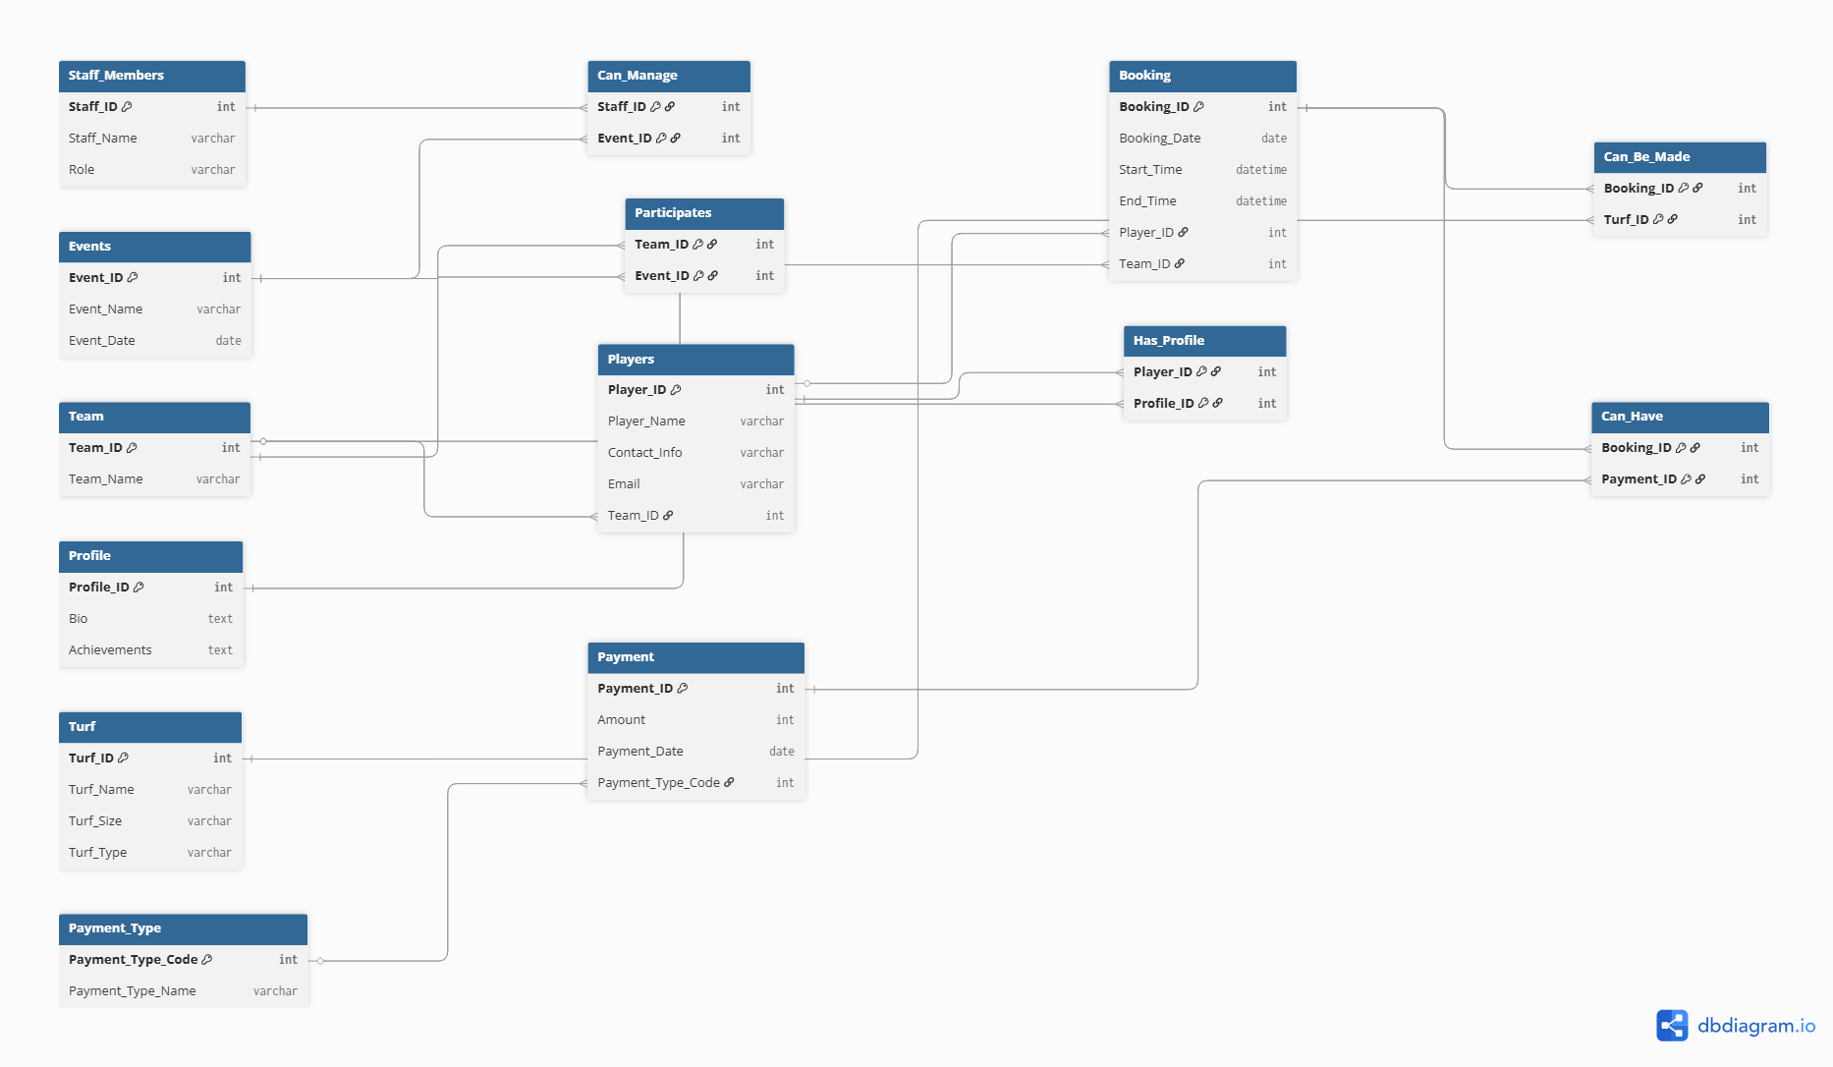

Fig-2: SCHEMA DIAGRAM

- TABLE CREATION:
Table Name: Staff_Members
CREATE SEQUENCE staff_member_seq START WITH 1 INCREMENT BY 1;
CREATE TABLE Staff_Members (
Staff_ID NUMBER PRIMARY KEY,
First_Name VARCHAR2(50),
Last_Name VARCHAR2(50),
Department VARCHAR2(50)
);
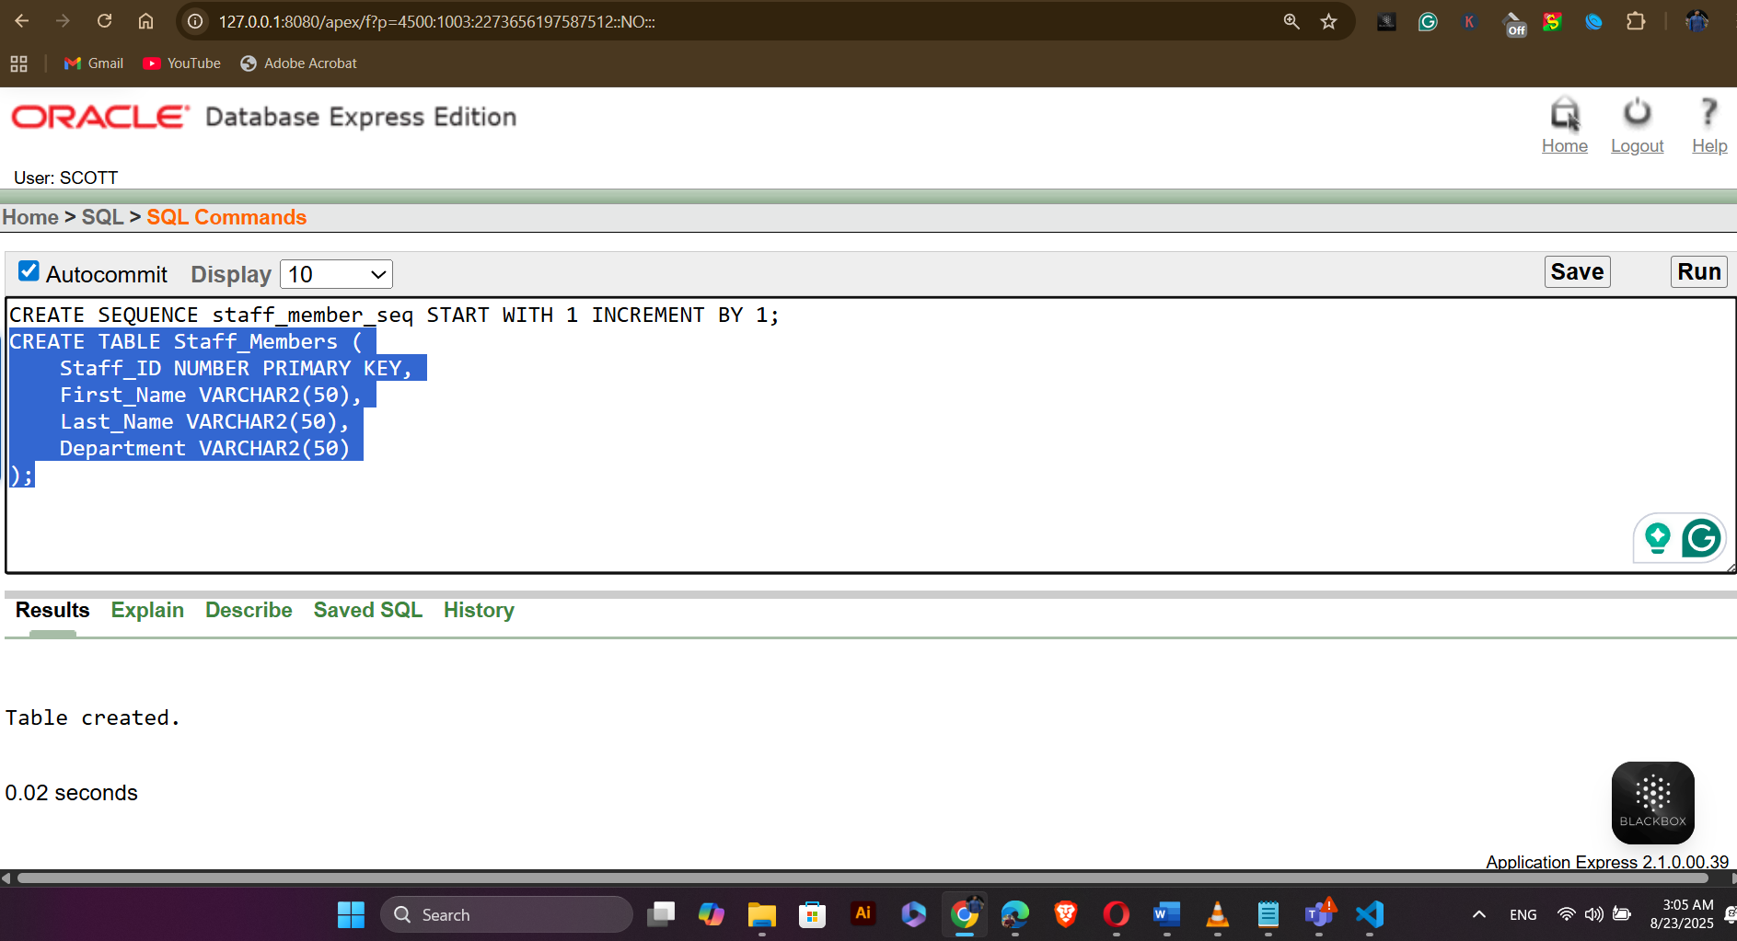
Table Name: Events
CREATE SEQUENCE event_seq START WITH 1 INCREMENT BY 1;
CREATE TABLE Events (
Event_ID NUMBER PRIMARY KEY,
Event_Name VARCHAR2(100),
Event_Date DATE,
Rules VARCHAR2(500)
);

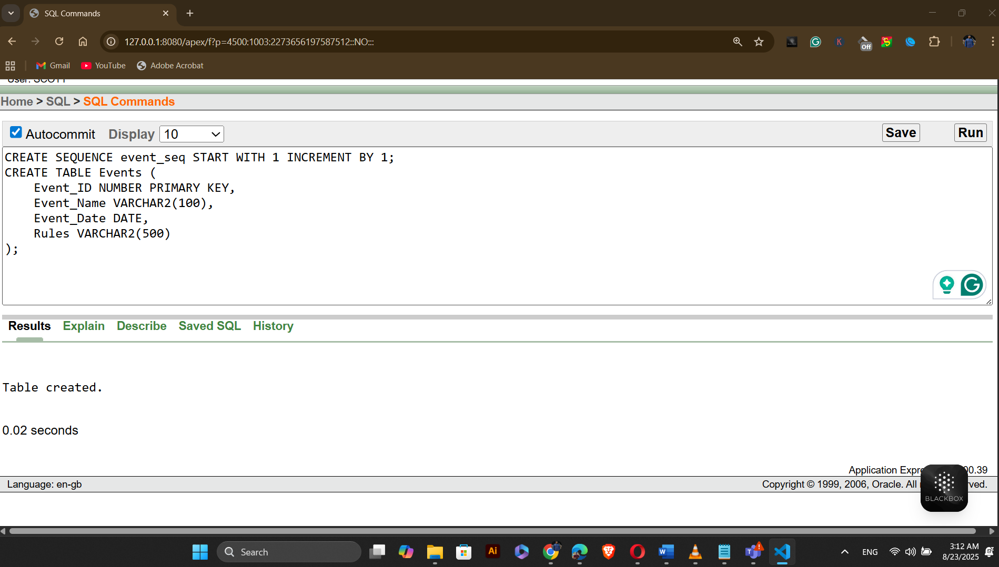
Table Name: Team
CREATE SEQUENCE team_seq START WITH 1 INCREMENT BY 1;
CREATE TABLE Team (
Team_ID NUMBER PRIMARY KEY,
Team_Name VARCHAR2(100),
Sport_Type VARCHAR2(50)
);
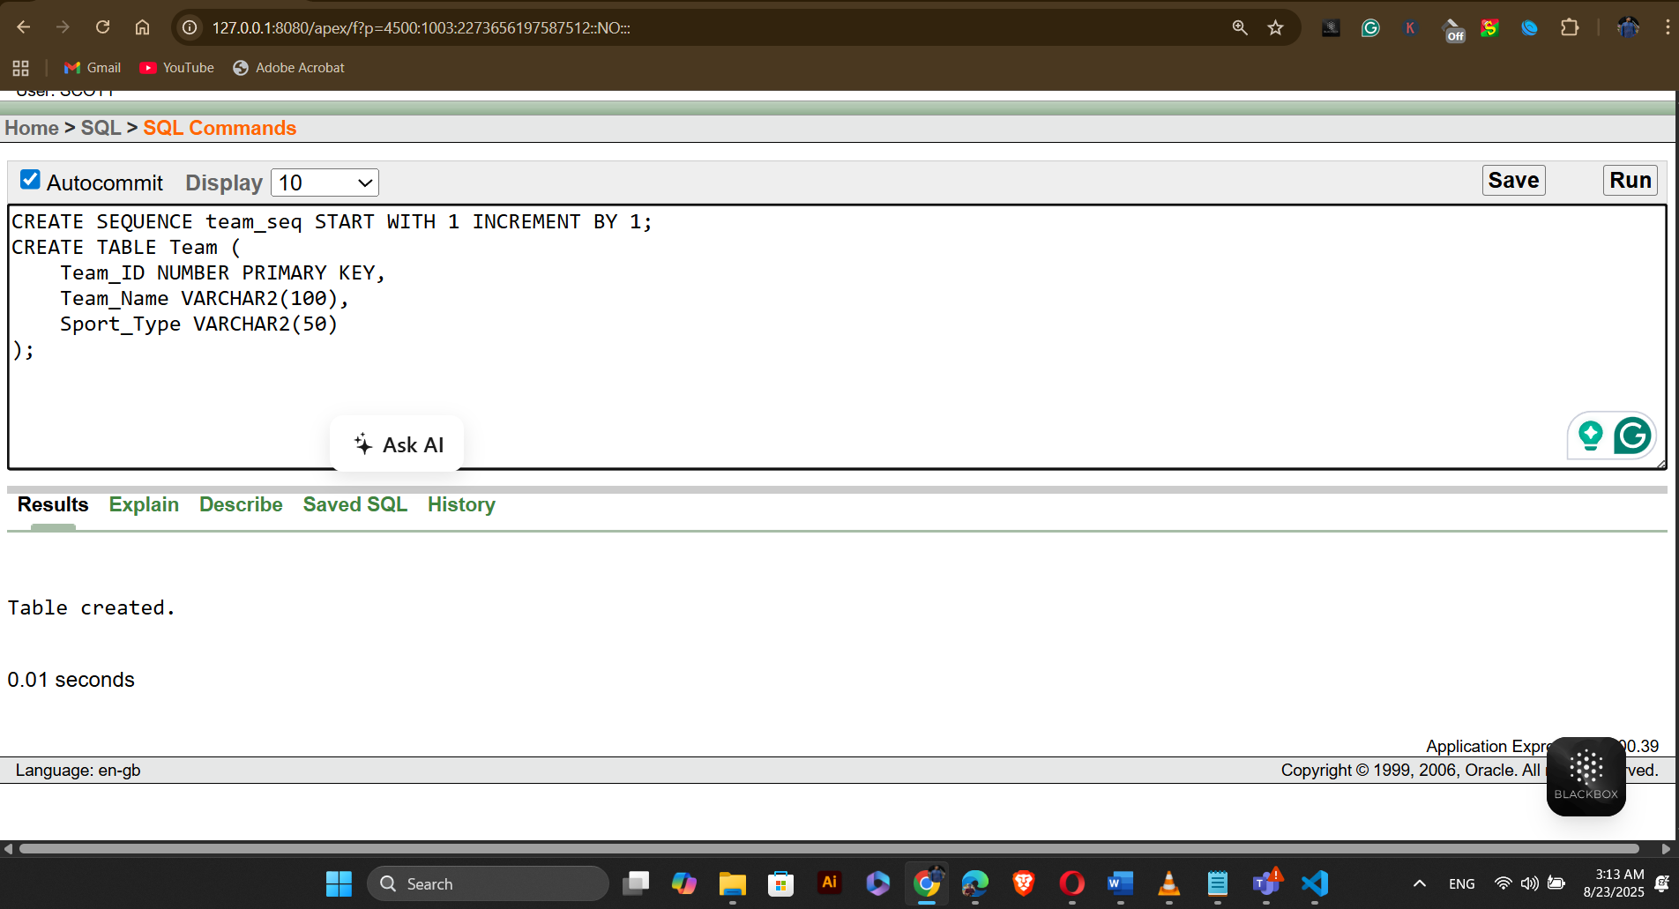
Table Name: Players
CREATE SEQUENCE players_seq START WITH 1 INCREMENT BY 1;
CREATE TABLE Players (
Player_ID NUMBER PRIMARY KEY,
First_Name VARCHAR2(50),
Last_Name VARCHAR2(50),
DOB DATE,
Phone_Number VARCHAR2(15)
);
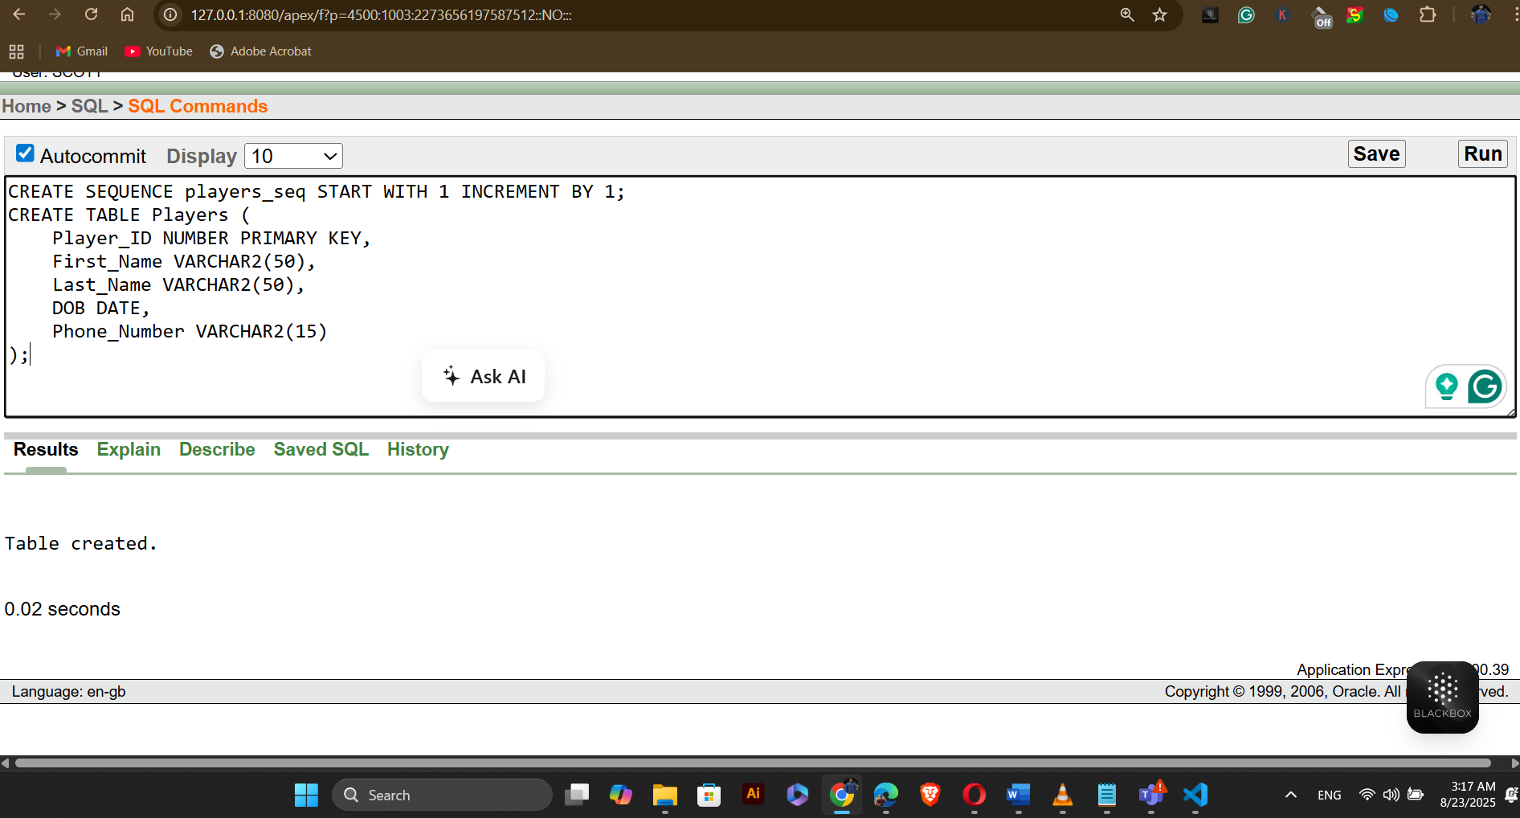
Table Name: Profile
CREATE SEQUENCE profile_seq START WITH 1 INCREMENT BY 1;
CREATE TABLE Profile (
Profile_ID NUMBER PRIMARY KEY,
Skill_Level VARCHAR2(50),
Achievements VARCHAR2(500)
);

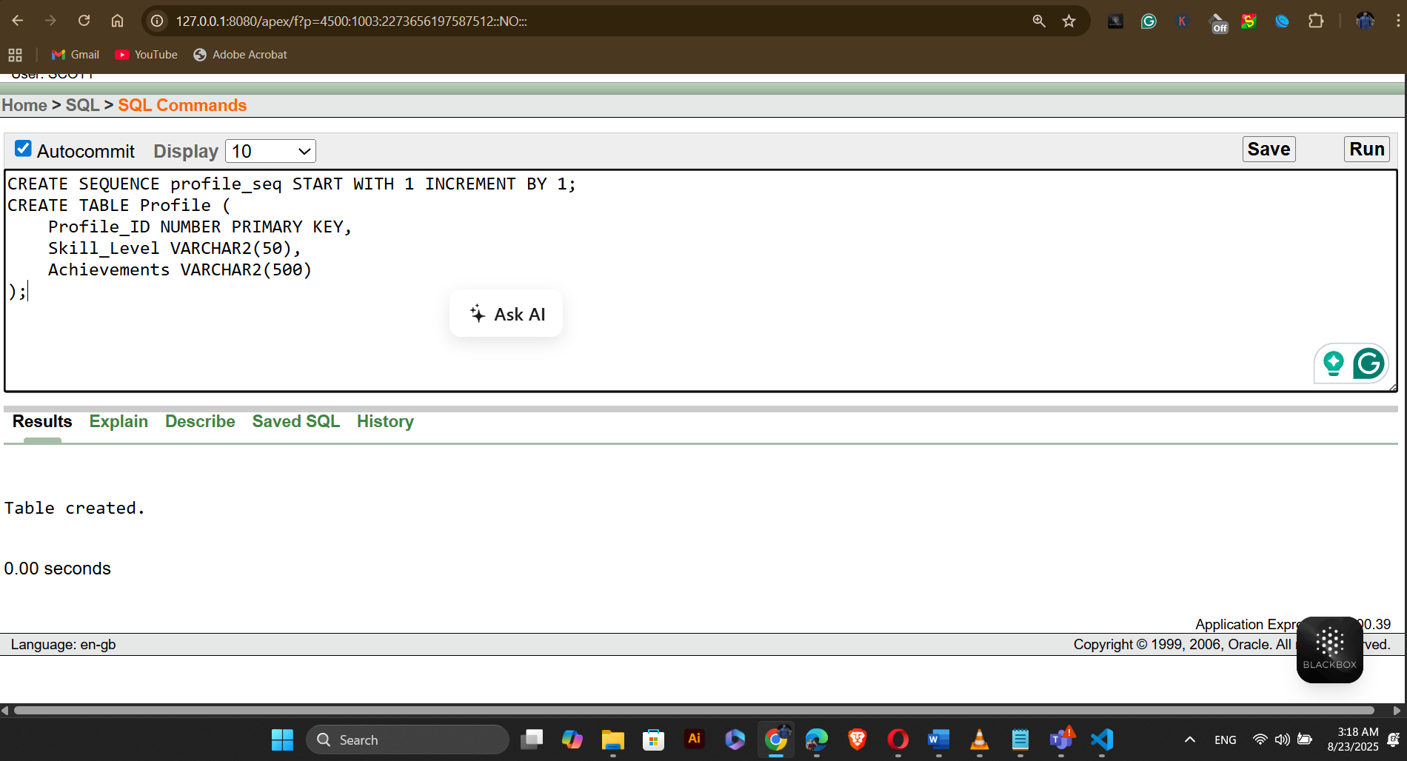
Table Name: Booking
CREATE SEQUENCE booking_seq START WITH 1 INCREMENT BY 1;
CREATE TABLE Booking (
Booking_ID NUMBER PRIMARY KEY,
Start_Time TIMESTAMP,
End_Time TIMESTAMP,
Booking_Date DATE,
Status VARCHAR2(50)
);
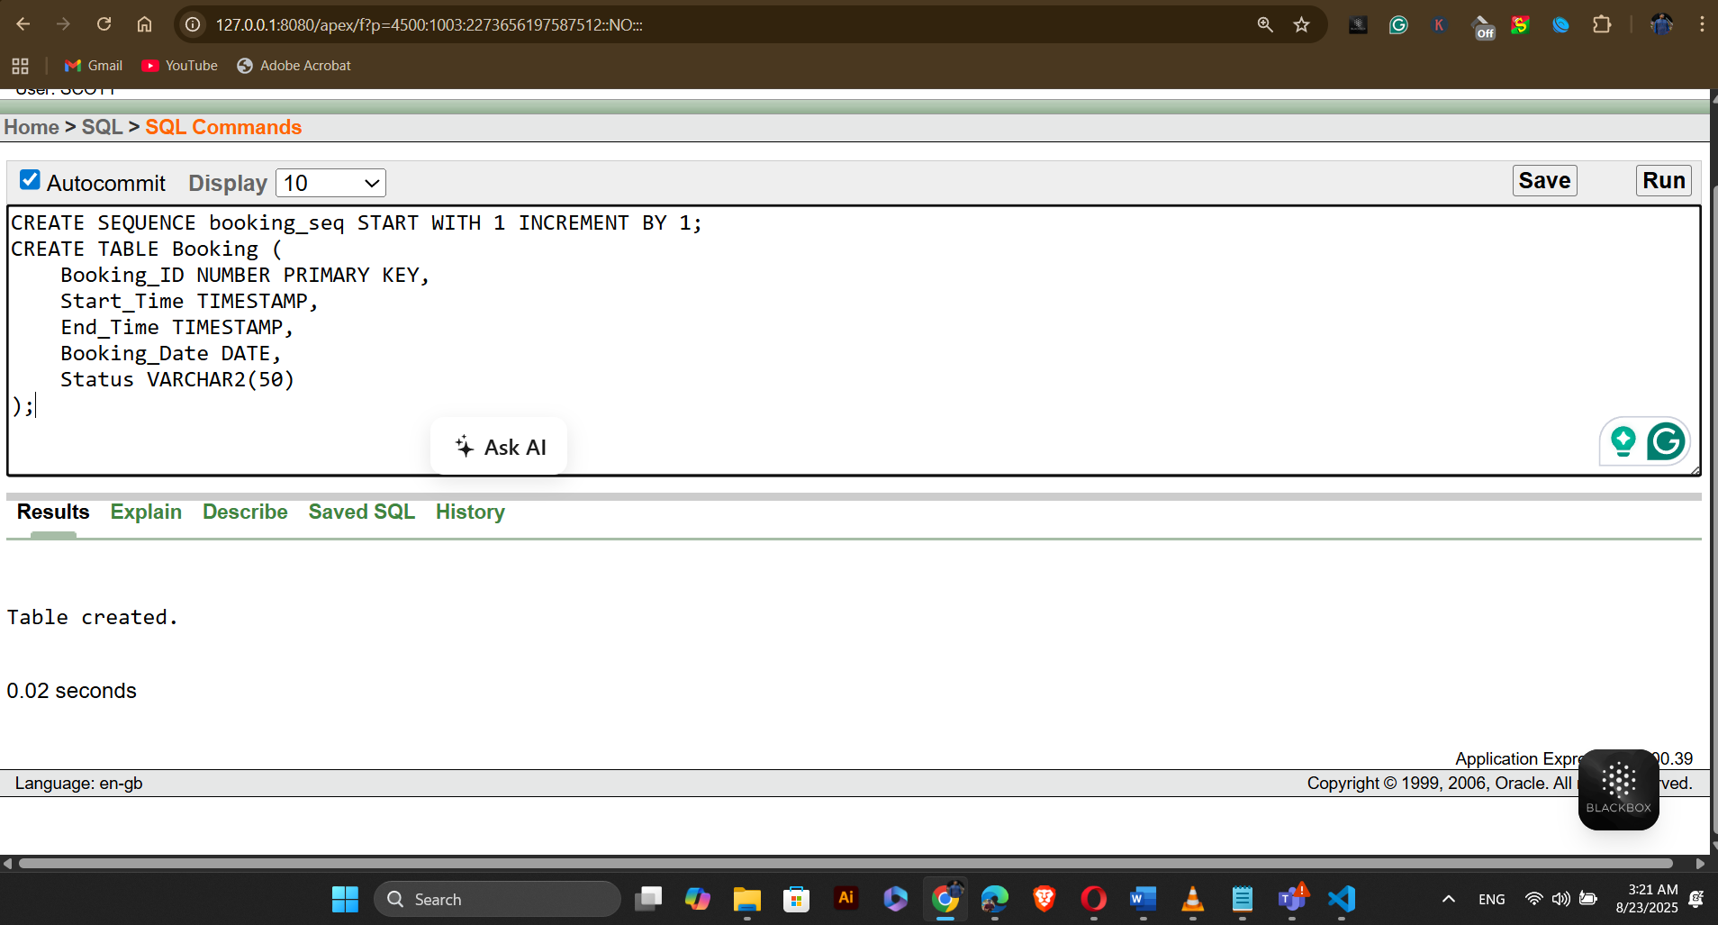
Table Name: Turf
CREATE SEQUENCE turfs_seq START WITH 1 INCREMENT BY 1;
CREATE TABLE Turf (
Turf_ID NUMBER PRIMARY KEY,
Turf_Name VARCHAR2(100),
Turf_location VARCHAR2(100),
Truf_size VARCHAR2(50),
Truf_type VARCHAR2(50)
);
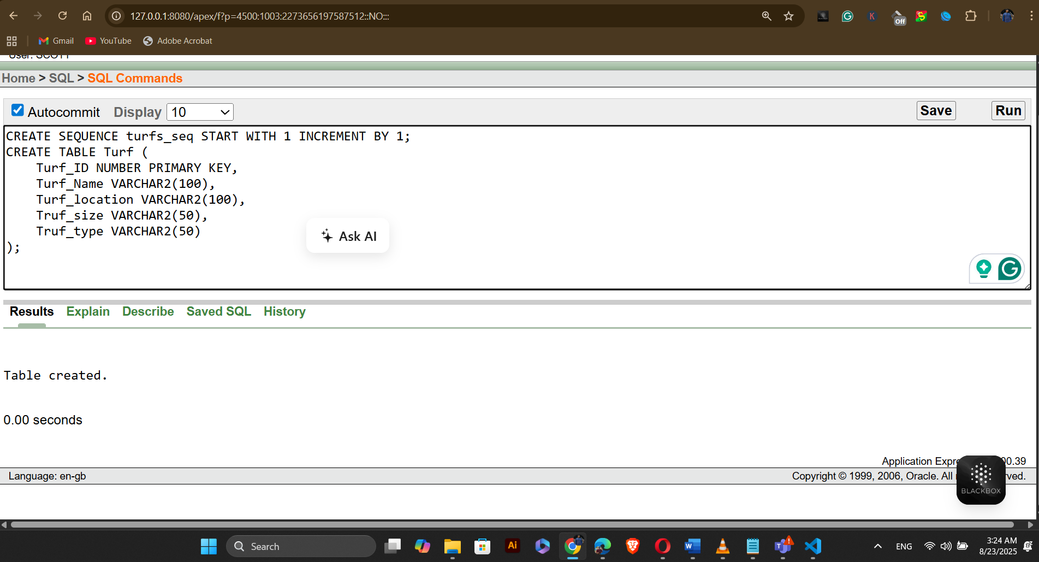
Table Name: Payment
CREATE SEQUENCE payment_seq START WITH 1 INCREMENT BY 1;
CREATE TABLE Payment (
Payment_ID NUMBER PRIMARY KEY,
Amount NUMBER(10,2),
Payment_Date DATE,
Payment_Type_Code NUMBER
);
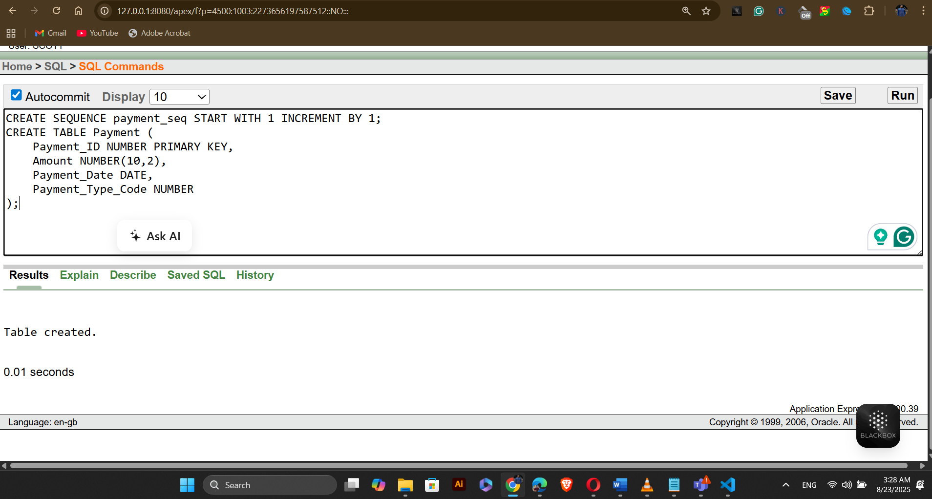
Table Name: Payment_Type
CREATE SEQUENCE payment_type_seq START WITH 1 INCREMENT BY 1;
CREATE TABLE Payment_Type (
Payment_Type_Code NUMBER PRIMARY KEY,
Payment_Method VARCHAR2(50),
Description VARCHAR2(200)
);
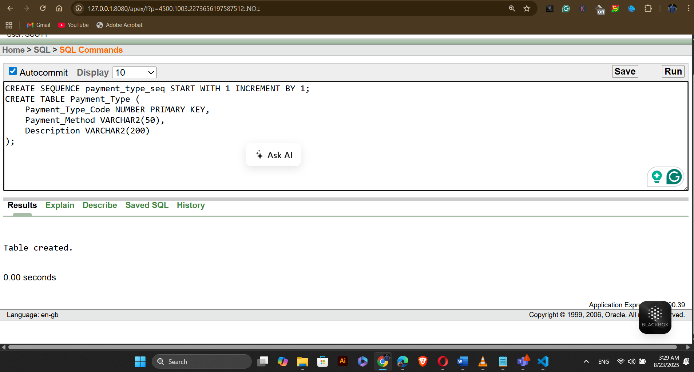
Relation Tables:
Table Name: Can_Manage
CREATE TABLE Can_Manage (
Staff_ID NUMBER,
Event_ID NUMBER,
PRIMARY KEY (Staff_ID, Event_ID),
FOREIGN KEY (Staff_ID) REFERENCES Staff_Members(Staff_ID),
FOREIGN KEY (Event_ID) REFERENCES Events(Event_ID)
);
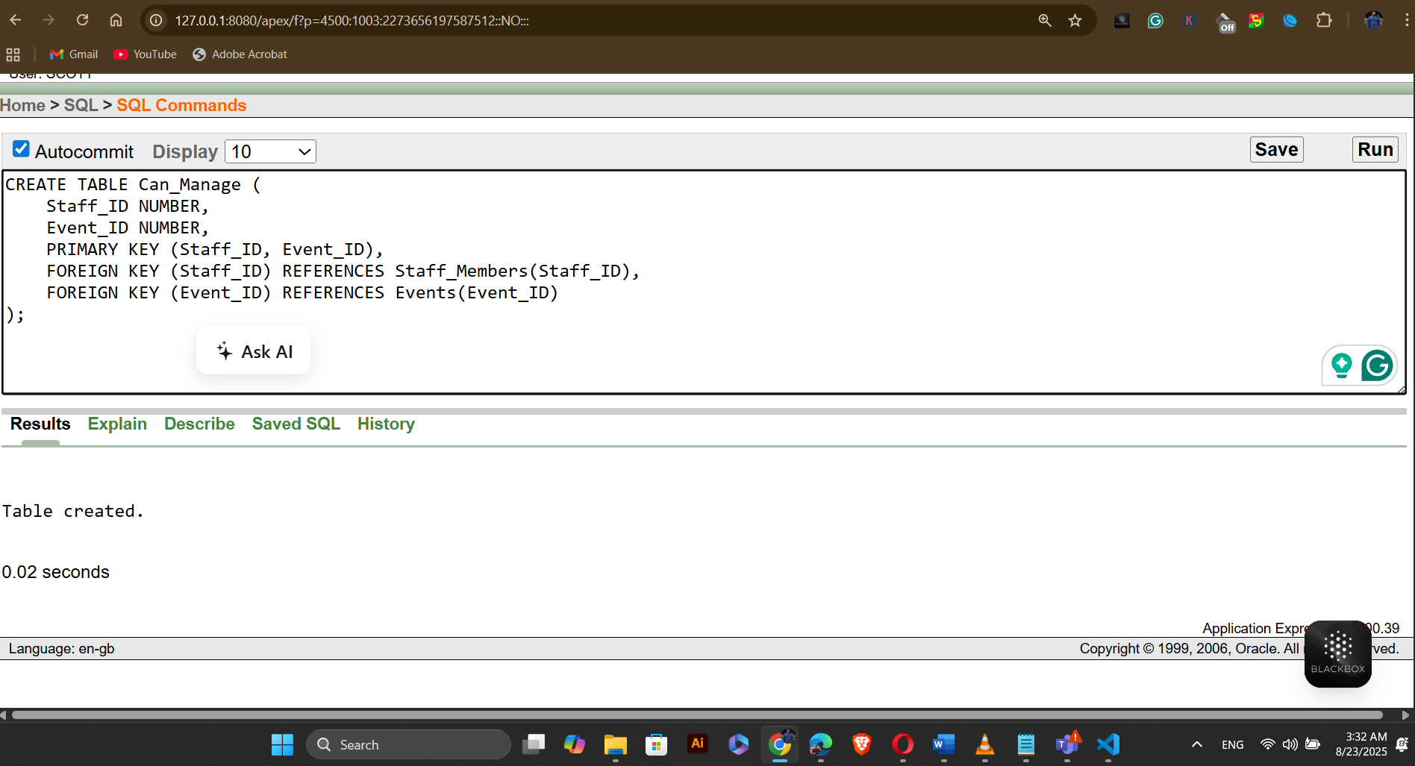
Table Name: Participates
CREATE TABLE Participates (
Event_ID NUMBER,
Team_ID NUMBER,
PRIMARY KEY (Event_ID, Team_ID),
FOREIGN KEY (Event_ID) REFERENCES Events(Event_ID),
FOREIGN KEY (Team_ID) REFERENCES Team(Team_ID)
);
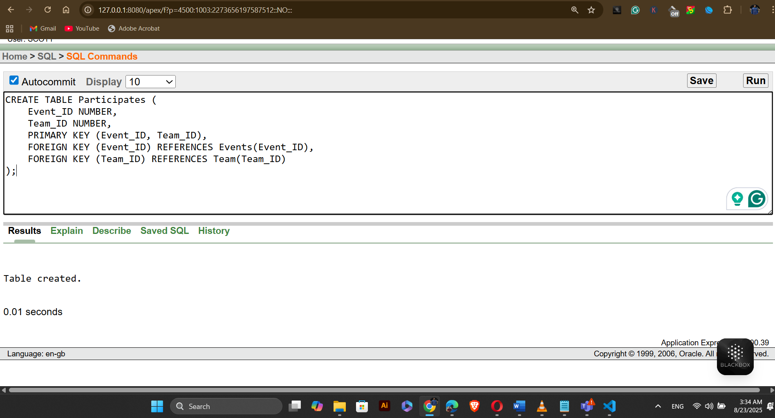
Table Name: Belongs_To
CREATE TABLE Belongs_To (
Player_ID NUMBER,
Team_ID NUMBER,
PRIMARY KEY (Player_ID, Team_ID),
FOREIGN KEY (Player_ID) REFERENCES Players(Player_ID),
FOREIGN KEY (Team_ID) REFERENCES Team(Team_ID)
);
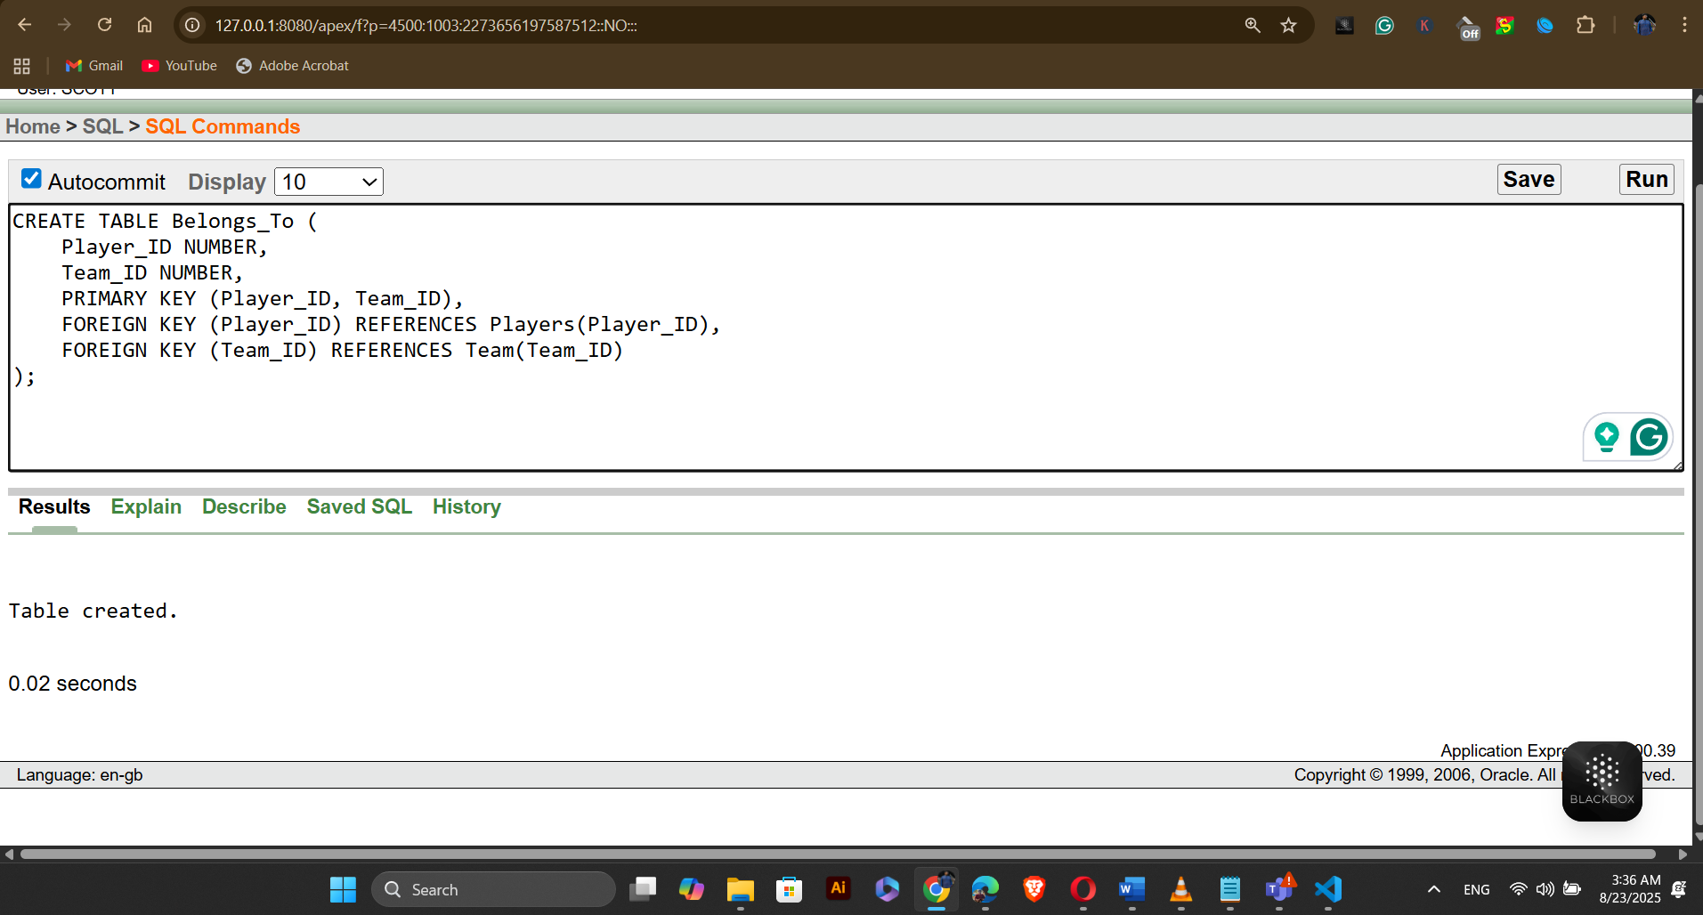
Table Name: Has_Profile
CREATE TABLE Has_Profile (
Player_ID NUMBER,
Profile_ID NUMBER,
PRIMARY KEY (Player_ID, Profile_ID),
FOREIGN KEY (Player_ID) REFERENCES Players(Player_ID),
FOREIGN KEY (Profile_ID) REFERENCES Profile(Profile_ID)
);
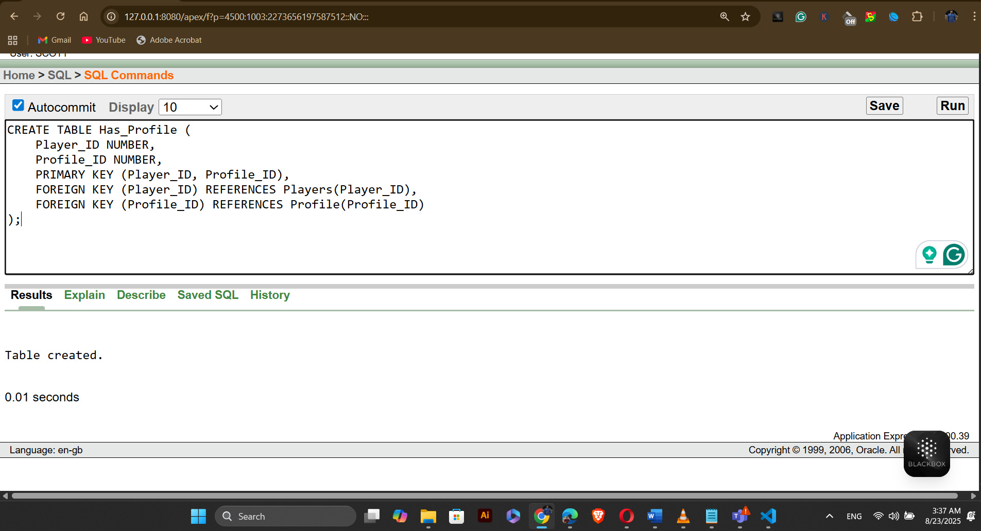
Table Name: Can_Make
CREATE TABLE Can_Make (
Team_ID NUMBER,
Booking_ID NUMBER,
PRIMARY KEY (Team_ID, Booking_ID),
FOREIGN KEY (Team_ID) REFERENCES Team(Team_ID),
FOREIGN KEY (Booking_ID) REFERENCES Booking(Booking_ID)
);

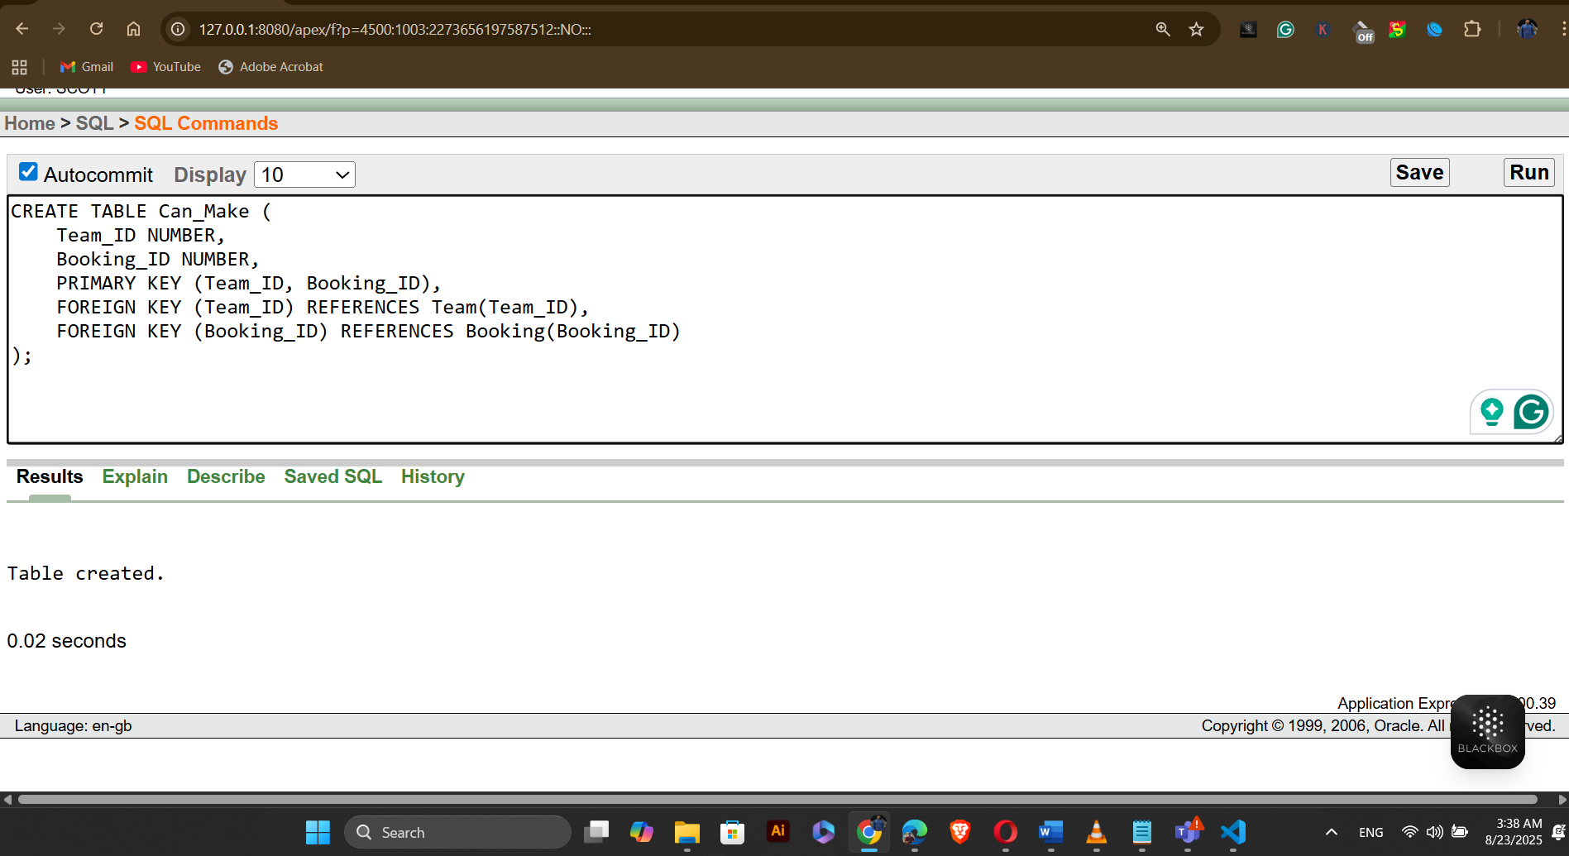
Table Name: Makes
CREATE TABLE Makes (
Player_ID NUMBER,
Booking_ID NUMBER,
PRIMARY KEY (Player_ID, Booking_ID),
FOREIGN KEY (Player_ID) REFERENCES Players(Player_ID),
FOREIGN KEY (Booking_ID) REFERENCES Booking(Booking_ID)
);
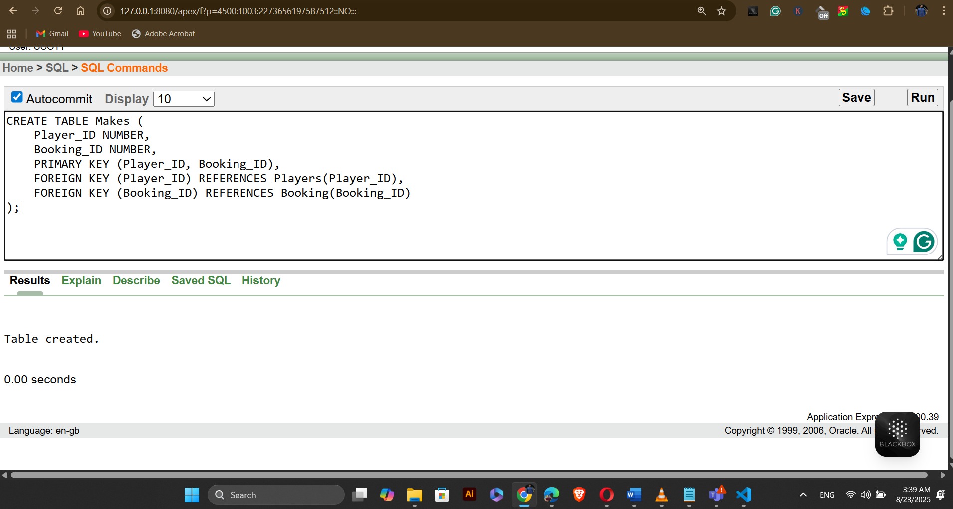
Table Name: Can_Be_Made
CREATE TABLE Can_Be_Made (
Booking_ID NUMBER,
Turf_ID NUMBER,
PRIMARY KEY (Booking_ID, Turf_ID),
FOREIGN KEY (Booking_ID) REFERENCES Booking(Booking_ID),
FOREIGN KEY (Turf_ID) REFERENCES Turf(Turf_ID)
);
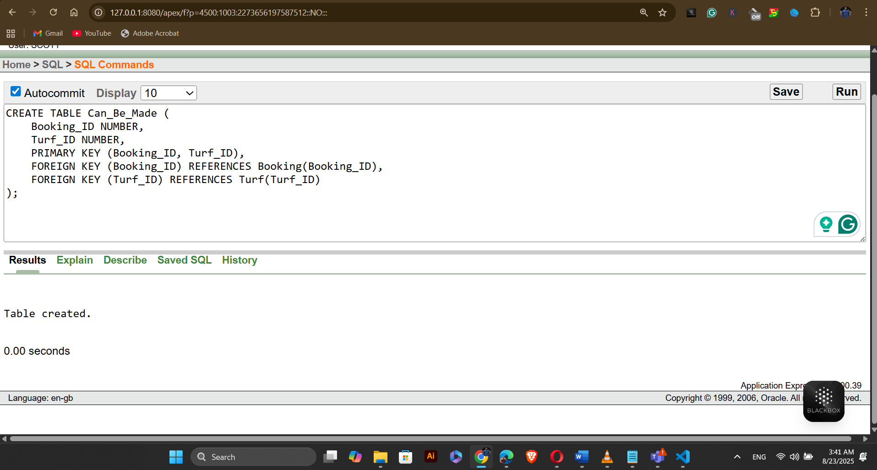
Table Name: Can_Have
CREATE TABLE Can_Have (
Booking_ID NUMBER,
Payment_ID NUMBER,
PRIMARY KEY (Booking_ID, Payment_ID),
FOREIGN KEY (Booking_ID) REFERENCES Booking(Booking_ID),
FOREIGN KEY (Payment_ID) REFERENCES Payment(Payment_ID)
);
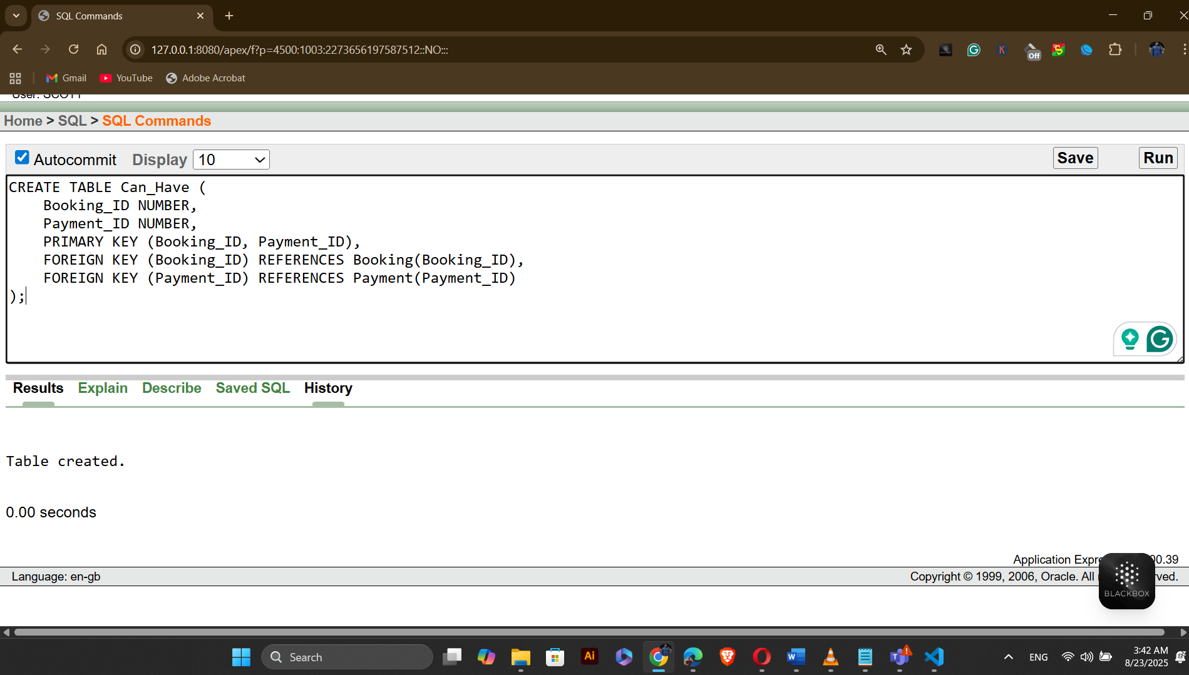

Table Name: Can_Use
CREATE TABLE Can_Use (
Payment_ID NUMBER,
Payment_Type_Code NUMBER,
PRIMARY KEY (Payment_ID, Payment_Type_Code),
FOREIGN KEY (Payment_ID) REFERENCES Payment(Payment_ID),
FOREIGN KEY (Payment_Type_Code) REFERENCES Payment_Type(Payment_Type_Code)
);
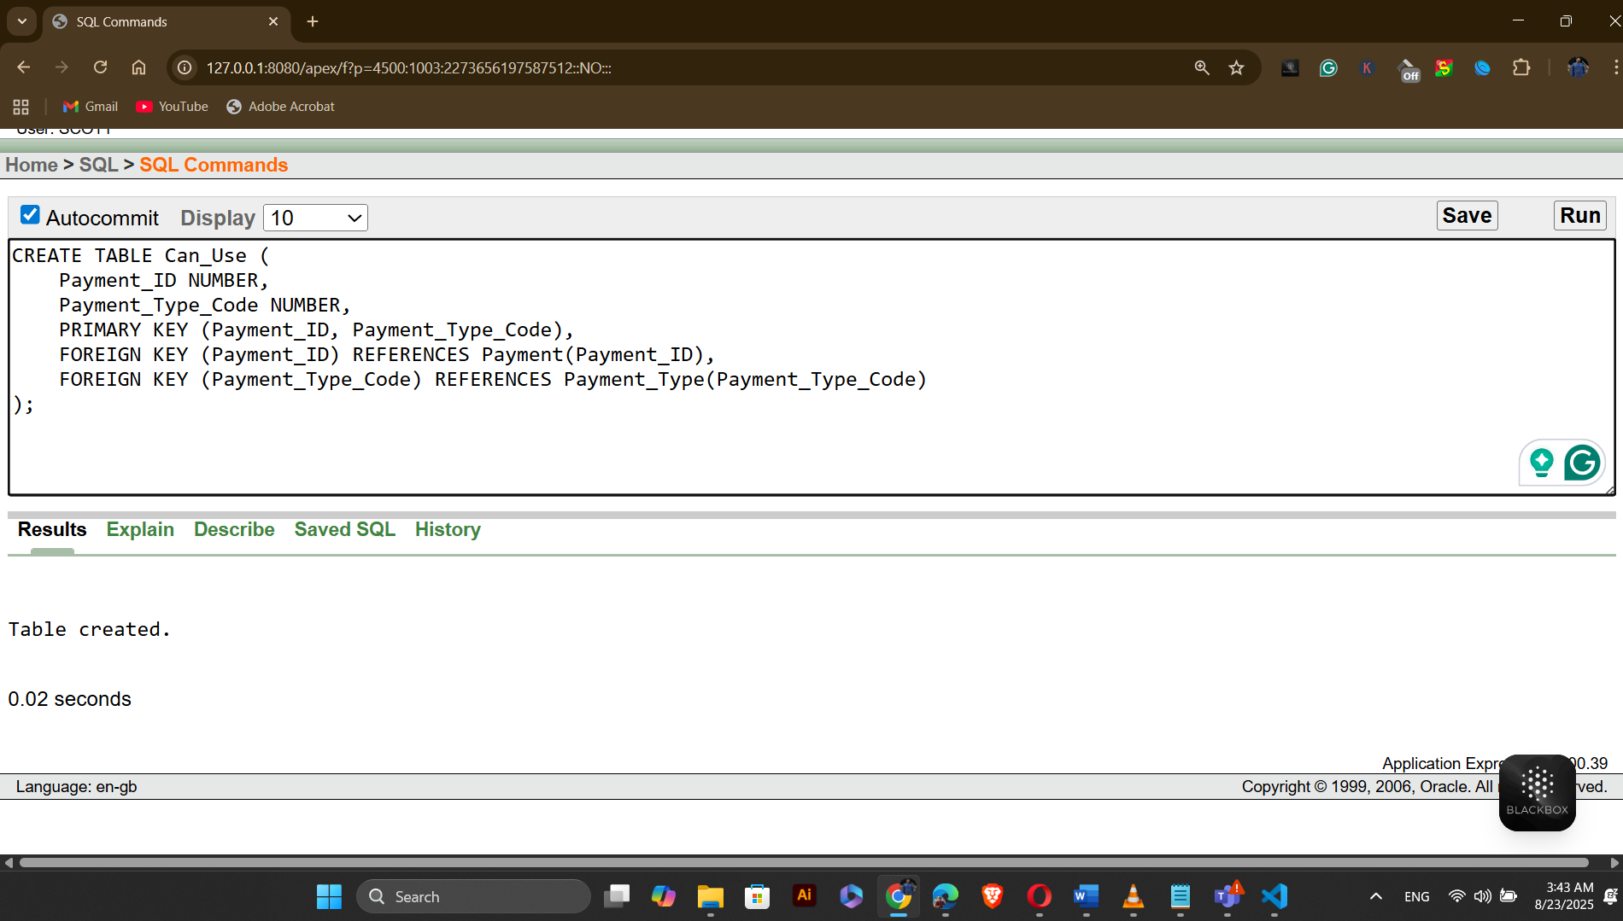
- DATA INSERTING:
Table Name: Staff_Members
INSERT INTO Staff_Members (Staff_ID, First_Name, Last_Name, Department) VALUES (staff_member_seq.NEXTVAL, 'alam', 'shakib', 'Operations');
INSERT INTO Staff_Members (Staff_ID, First_Name, Last_Name, Department) VALUES (staff_member_seq.NEXTVAL, 'rimon', 'promanik', 'Marketing');
INSERT INTO Staff_Members (Staff_ID, First_Name, Last_Name, Department) VALUES (staff_member_seq.NEXTVAL, 'maruf', 'maruf', 'Finance');
INSERT INTO Staff_Members (Staff_ID, First_Name, Last_Name, Department) VALUES (staff_member_seq.NEXTVAL, 'lamia', 'thahsin', 'HR');
INSERT INTO Staff_Members (Staff_ID, First_Name, Last_Name, Department) VALUES (staff_member_seq.NEXTVAL, 'shadman', 'shakib', 'IT');

SELECT * FROM Staff_Members
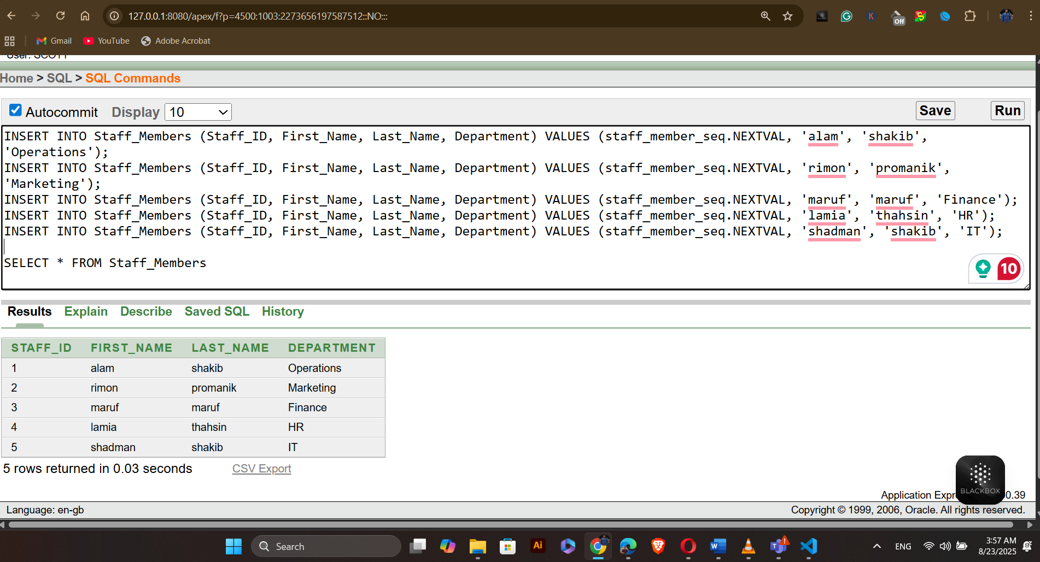

Table Name: Events
INSERT INTO Events (Event_ID, Event_Name, Event_Date, Rules) VALUES (event_seq.NEXTVAL, 'Football Championship', TO_DATE('2025-09-01', 'YYYY-MM-DD'), 'Standard FIFA rules');
INSERT INTO Events (Event_ID, Event_Name, Event_Date, Rules) VALUES (event_seq.NEXTVAL, 'Basketball Tournament', TO_DATE('2025-09-15', 'YYYY-MM-DD'), 'NBA rules');
INSERT INTO Events (Event_ID, Event_Name, Event_Date, Rules) VALUES (event_seq.NEXTVAL, 'Cricket League', TO_DATE('2025-10-10', 'YYYY-MM-DD'), 'ICC rules');
INSERT INTO Events (Event_ID, Event_Name, Event_Date, Rules) VALUES (event_seq.NEXTVAL, 'Tennis Open', TO_DATE('2025-11-05', 'YYYY-MM-DD'), 'ATP rules');
INSERT INTO Events (Event_ID, Event_Name, Event_Date, Rules) VALUES (event_seq.NEXTVAL, 'Hockey Cup', TO_DATE('2025-12-20', 'YYYY-MM-DD'), 'FIH rules');
SELECT * FROM Events
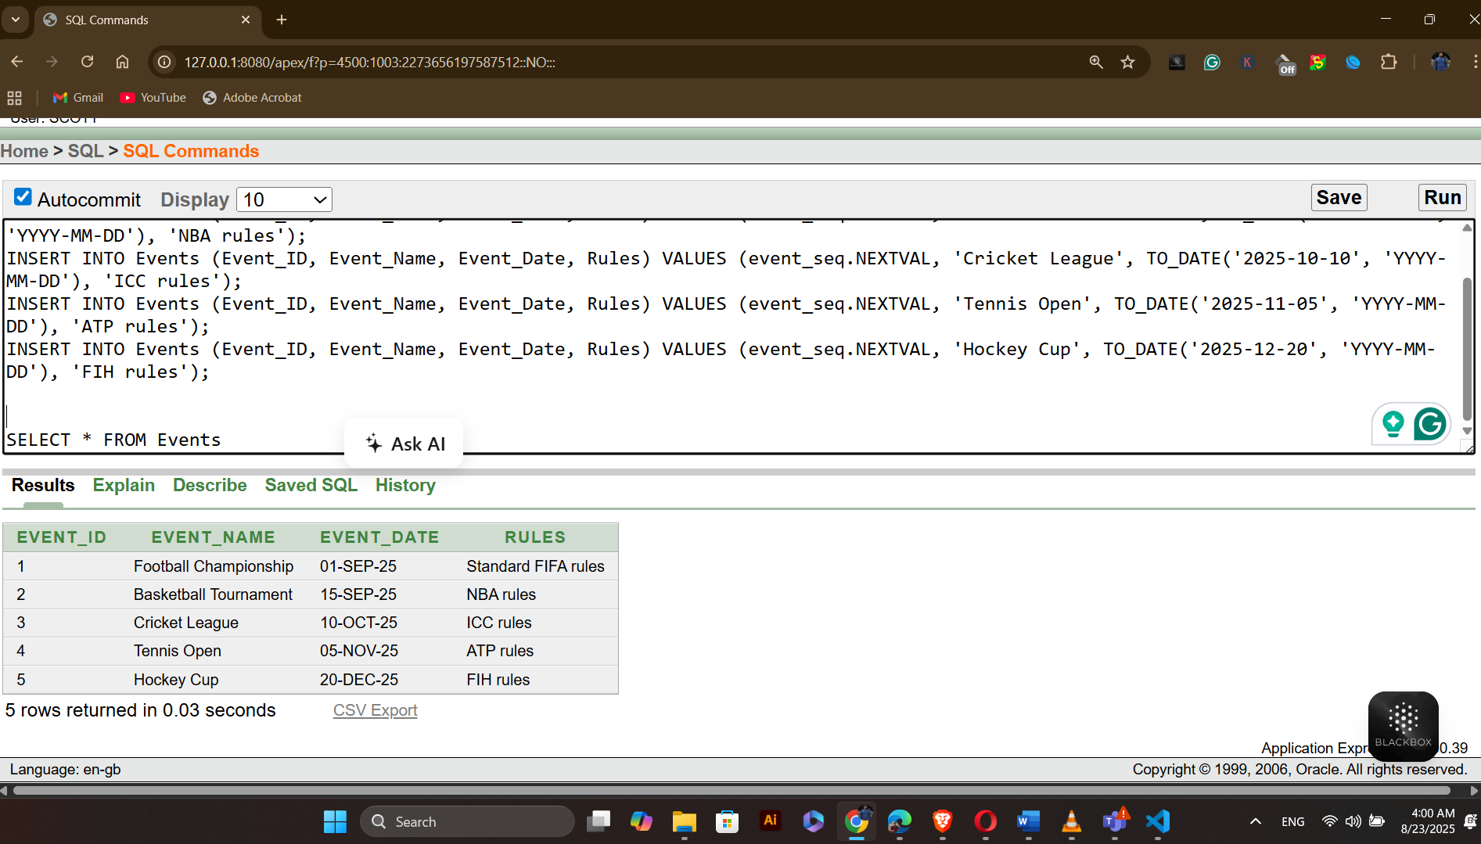

Table Name: Team
INSERT INTO Team (Team_ID, Team_Name, Sport_Type) VALUES (team_seq.NEXTVAL, 'Warriors', 'Football');
INSERT INTO Team (Team_ID, Team_Name, Sport_Type) VALUES (team_seq.NEXTVAL, 'Titans', 'Basketball');
INSERT INTO Team (Team_ID, Team_Name, Sport_Type) VALUES (team_seq.NEXTVAL, 'Strikers', 'Cricket');
INSERT INTO Team (Team_ID, Team_Name, Sport_Type) VALUES (team_seq.NEXTVAL, 'Aces', 'Tennis');
INSERT INTO Team (Team_ID, Team_Name, Sport_Type) VALUES (team_seq.NEXTVAL, 'Blazers', 'Hockey');

SELECT * FROM Team
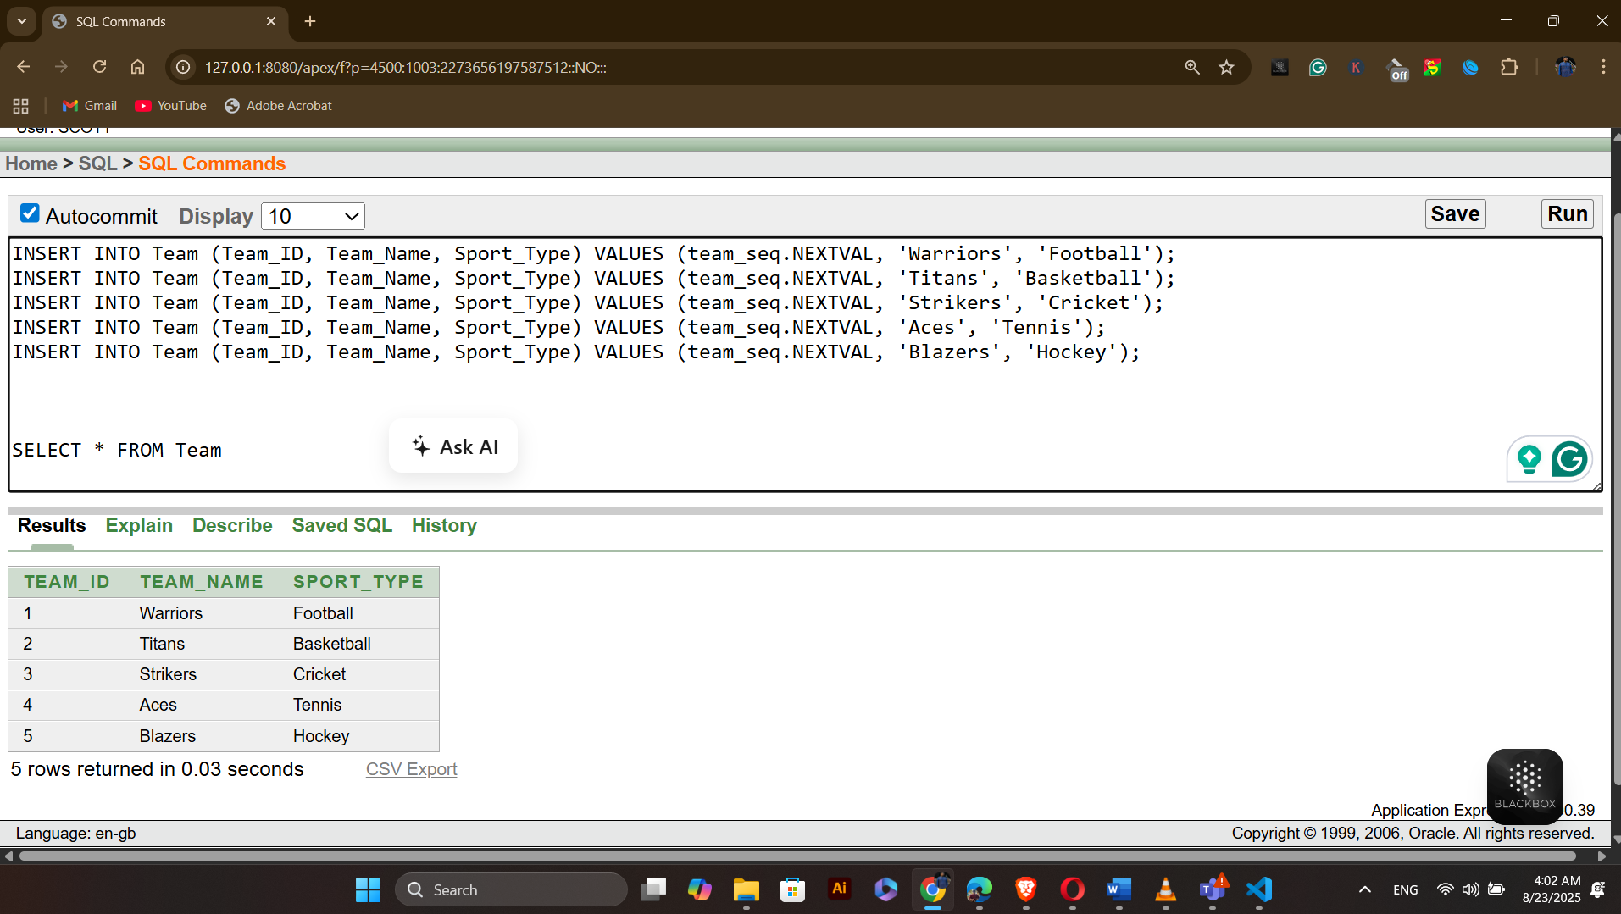

Table Name: Players
INSERT INTO Players (Player_ID, First_Name, Last_Name, DOB, Phone_Number) VALUES (players_seq.NEXTVAL, 'shadman', 'alam', TO_DATE('1990-01-01', 'YYYY-MM-DD'), '01888488409');
INSERT INTO Players (Player_ID, First_Name, Last_Name, DOB, Phone_Number) VALUES (players_seq.NEXTVAL, 'amin', 'ali', TO_DATE('1992-04-15', 'YYYY-MM-DD'), '01677747747');
INSERT INTO Players (Player_ID, First_Name, Last_Name, DOB, Phone_Number) VALUES (players_seq.NEXTVAL, 'arif', 'aslma', TO_DATE('1985-06-13', 'YYYY-MM-DD'), '0198787766');
INSERT INTO Players (Player_ID, First_Name, Last_Name, DOB, Phone_Number) VALUES (players_seq.NEXTVAL, 'tanvir', 'evan', TO_DATE('1984-11-22', 'YYYY-MM-DD'), '01715748774');
INSERT INTO Players (Player_ID, First_Name, Last_Name, DOB, Phone_Number) VALUES (players_seq.NEXTVAL, 'mainul', 'islam', TO_DATE('1965-04-04', 'YYYY-MM-DD'), '0181660948');

SELECT * FROM Players
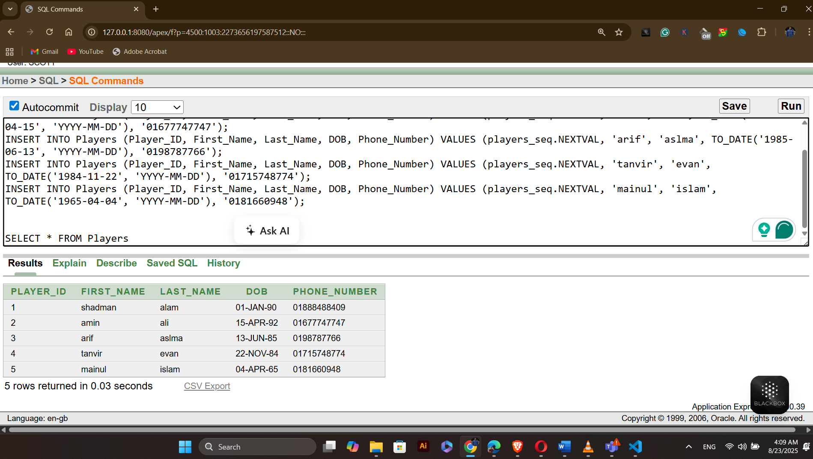

Table Name: Profile
INSERT INTO Profile (Profile_ID, Skill_Level, Achievements) VALUES (profile_seq.NEXTVAL, 'Advanced', 'MVP 2022');
INSERT INTO Profile (Profile_ID, Skill_Level, Achievements) VALUES (profile_seq.NEXTVAL, 'Intermediate', 'Best Player 2021');
INSERT INTO Profile (Profile_ID, Skill_Level, Achievements) VALUES (profile_seq.NEXTVAL, 'Beginner', 'Rookie of the Year');
INSERT INTO Profile (Profile_ID, Skill_Level, Achievements) VALUES (profile_seq.NEXTVAL, 'Advanced', 'Champion 2020');
INSERT INTO Profile (Profile_ID, Skill_Level, Achievements) VALUES (profile_seq.NEXTVAL, 'Intermediate', 'Top Scorer 2019');

SELECT * FROM Profile
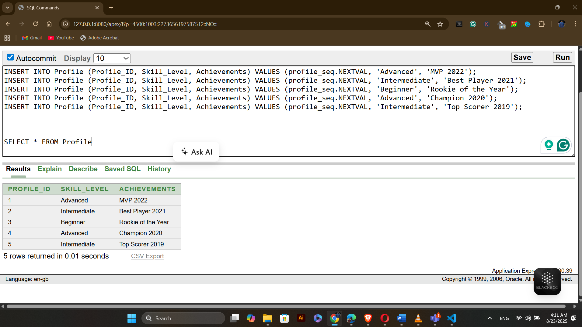

Table Name: Booking
INSERT INTO Booking (Booking_ID, Start_Time, End_Time, Booking_Date, Status) VALUES (booking_seq.NEXTVAL, TO_TIMESTAMP('2025-08-01 10:00:00', 'YYYY-MM-DD HH24:MI:SS'), TO_TIMESTAMP('2025-08-01 12:00:00', 'YYYY-MM-DD HH24:MI:SS'), TO_DATE('2025-08-01', 'YYYY-MM-DD'), 'Confirmed');
INSERT INTO Booking (Booking_ID, Start_Time, End_Time, Booking_Date, Status) VALUES (booking_seq.NEXTVAL, TO_TIMESTAMP('2025-08-02 14:00:00', 'YYYY-MM-DD HH24:MI:SS'), TO_TIMESTAMP('2025-08-02 16:00:00', 'YYYY-MM-DD HH24:MI:SS'), TO_DATE('2025-08-02', 'YYYY-MM-DD'), 'Pending');
INSERT INTO Booking (Booking_ID, Start_Time, End_Time, Booking_Date, Status) VALUES (booking_seq.NEXTVAL, TO_TIMESTAMP('2025-08-03 09:00:00', 'YYYY-MM-DD HH24:MI:SS'), TO_TIMESTAMP('2025-08-03 11:00:00', 'YYYY-MM-DD HH24:MI:SS'), TO_DATE('2025-08-03', 'YYYY-MM-DD'), 'Cancelled');
INSERT INTO Booking (Booking_ID, Start_Time, End_Time, Booking_Date, Status) VALUES (booking_seq.NEXTVAL, TO_TIMESTAMP('2025-08-04 13:00:00', 'YYYY-MM-DD HH24:MI:SS'), TO_TIMESTAMP('2025-08-04 15:00:00', 'YYYY-MM-DD HH24:MI:SS'), TO_DATE('2025-08-04', 'YYYY-MM-DD'), 'Confirmed');
INSERT INTO Booking (Booking_ID, Start_Time, End_Time, Booking_Date, Status) VALUES (booking_seq.NEXTVAL, TO_TIMESTAMP('2025-08-05 17:00:00', 'YYYY-MM-DD HH24:MI:SS'), TO_TIMESTAMP('2025-08-05 19:00:00', 'YYYY-MM-DD HH24:MI:SS'), TO_DATE('2025-08-05', 'YYYY-MM-DD'), 'Pending');
SELECT * FROM Booking
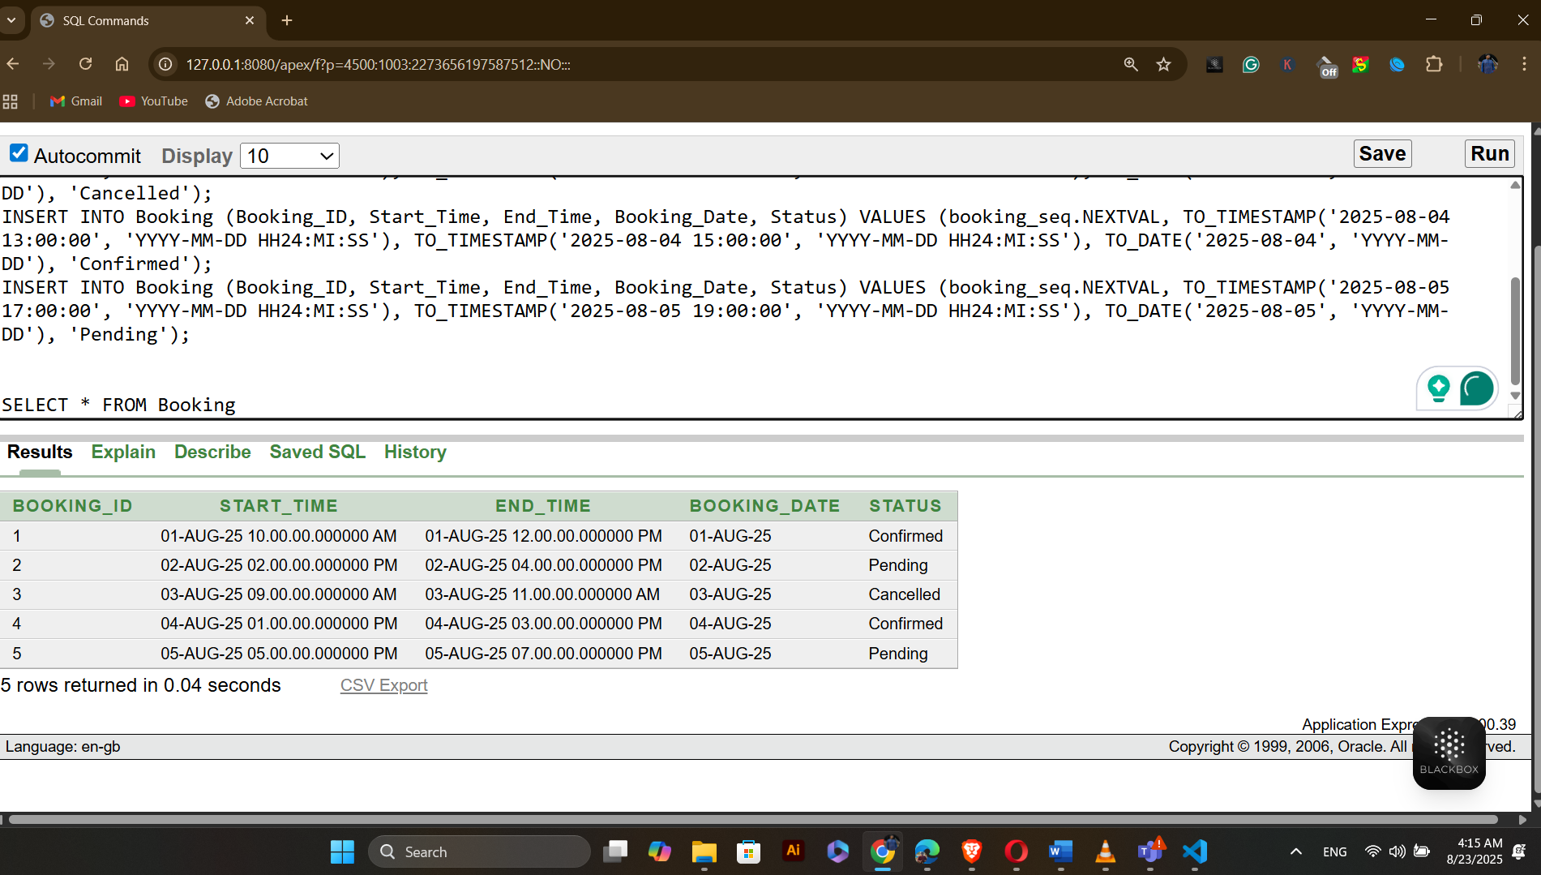

Table Name: Turf
INSERT INTO Turf (TURF_ID, TURF_NAME, TURF_LOCATION, TRUF_SIZE, TRUF_TYPE) VALUES (turfs_seq.NEXTVAL, 'Green Field', 'Mirpur-2', '100x50', 'Grass');
INSERT INTO Turf (Turf_ID, Turf_Name, Turf_location, Truf_size, Truf_type) VALUES (turfs_seq.NEXTVAL, 'Blue Arena', 'Mirpur-10', '80x40', 'Synthetic');
INSERT INTO Turf (Turf_ID, Turf_Name, Turf_location, Truf_size, Truf_type) VALUES (turfs_seq.NEXTVAL, 'Red Court', 'Badda', '60x30', 'Clay');
INSERT INTO Turf (Turf_ID, Turf_Name, Turf_location, Truf_size, Truf_type) VALUES (turfs_seq.NEXTVAL, 'Yellow Pitch', 'Uttora', '120x60', 'Artificial');
INSERT INTO Turf (Turf_ID, Turf_Name, Turf_location, Truf_size, Truf_type) VALUES (turfs_seq.NEXTVAL, 'White Ground', 'Nikunjo-2', '90x45', 'Hybrid');

SELECT * FROM Turf

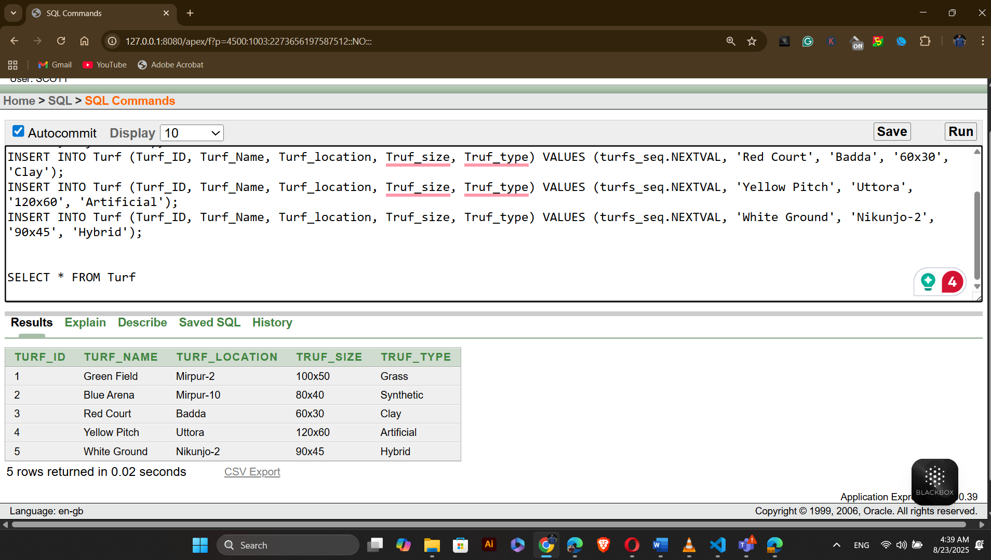

Table Name: Payment_Type
INSERT INTO Payment_Type (Payment_Type_Code, Payment_Method, Description) VALUES (payment_type_seq.NEXTVAL, 'Credit Card', 'Visa or MasterCard');
INSERT INTO Payment_Type (Payment_Type_Code, Payment_Method, Description) VALUES (payment_type_seq.NEXTVAL, 'Debit Card', 'Bank issued debit cards');
INSERT INTO Payment_Type (Payment_Type_Code, Payment_Method, Description) VALUES (payment_type_seq.NEXTVAL, 'Cash', 'Physical currency');
INSERT INTO Payment_Type (Payment_Type_Code, Payment_Method, Description) VALUES (payment_type_seq.NEXTVAL, 'Online Transfer', 'Bank to bank transfer');
INSERT INTO Payment_Type (Payment_Type_Code, Payment_Method, Description) VALUES (payment_type_seq.NEXTVAL, 'Mobile Payment', 'Payment via mobile apps');

SELECT * FROM Payment_Type
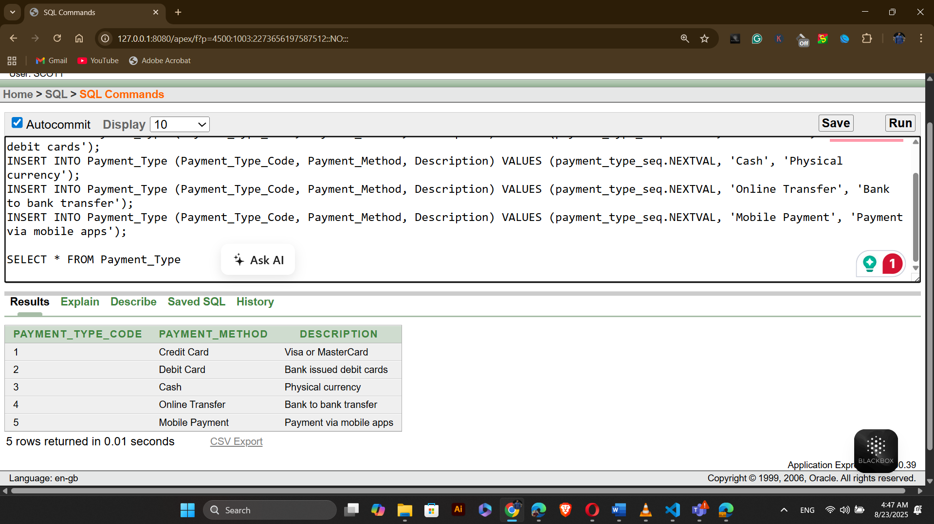

Table Name: Payment
INSERT INTO Payment (Payment_ID, Amount, Payment_Date, Payment_Type_Code) VALUES (payment_seq.NEXTVAL, 1000.00, TO_DATE('2025-08-01', 'YYYY-MM-DD'), 1);
INSERT INTO Payment (Payment_ID, Amount, Payment_Date, Payment_Type_Code) VALUES (payment_seq.NEXTVAL, 1500.00, TO_DATE('2025-08-02', 'YYYY-MM-DD'), 2);
INSERT INTO Payment (Payment_ID, Amount, Payment_Date, Payment_Type_Code) VALUES (payment_seq.NEXTVAL, 2000.00, TO_DATE('2025-08-03', 'YYYY-MM-DD'), 3);
INSERT INTO Payment (Payment_ID, Amount, Payment_Date, Payment_Type_Code) VALUES (payment_seq.NEXTVAL, 2500.00, TO_DATE('2025-08-04', 'YYYY-MM-DD'), 4);
INSERT INTO Payment (Payment_ID, Amount, Payment_Date, Payment_Type_Code) VALUES (payment_seq.NEXTVAL, 3000.00, TO_DATE('2025-08-05', 'YYYY-MM-DD'), 5);

SELECT * FROM Payment;
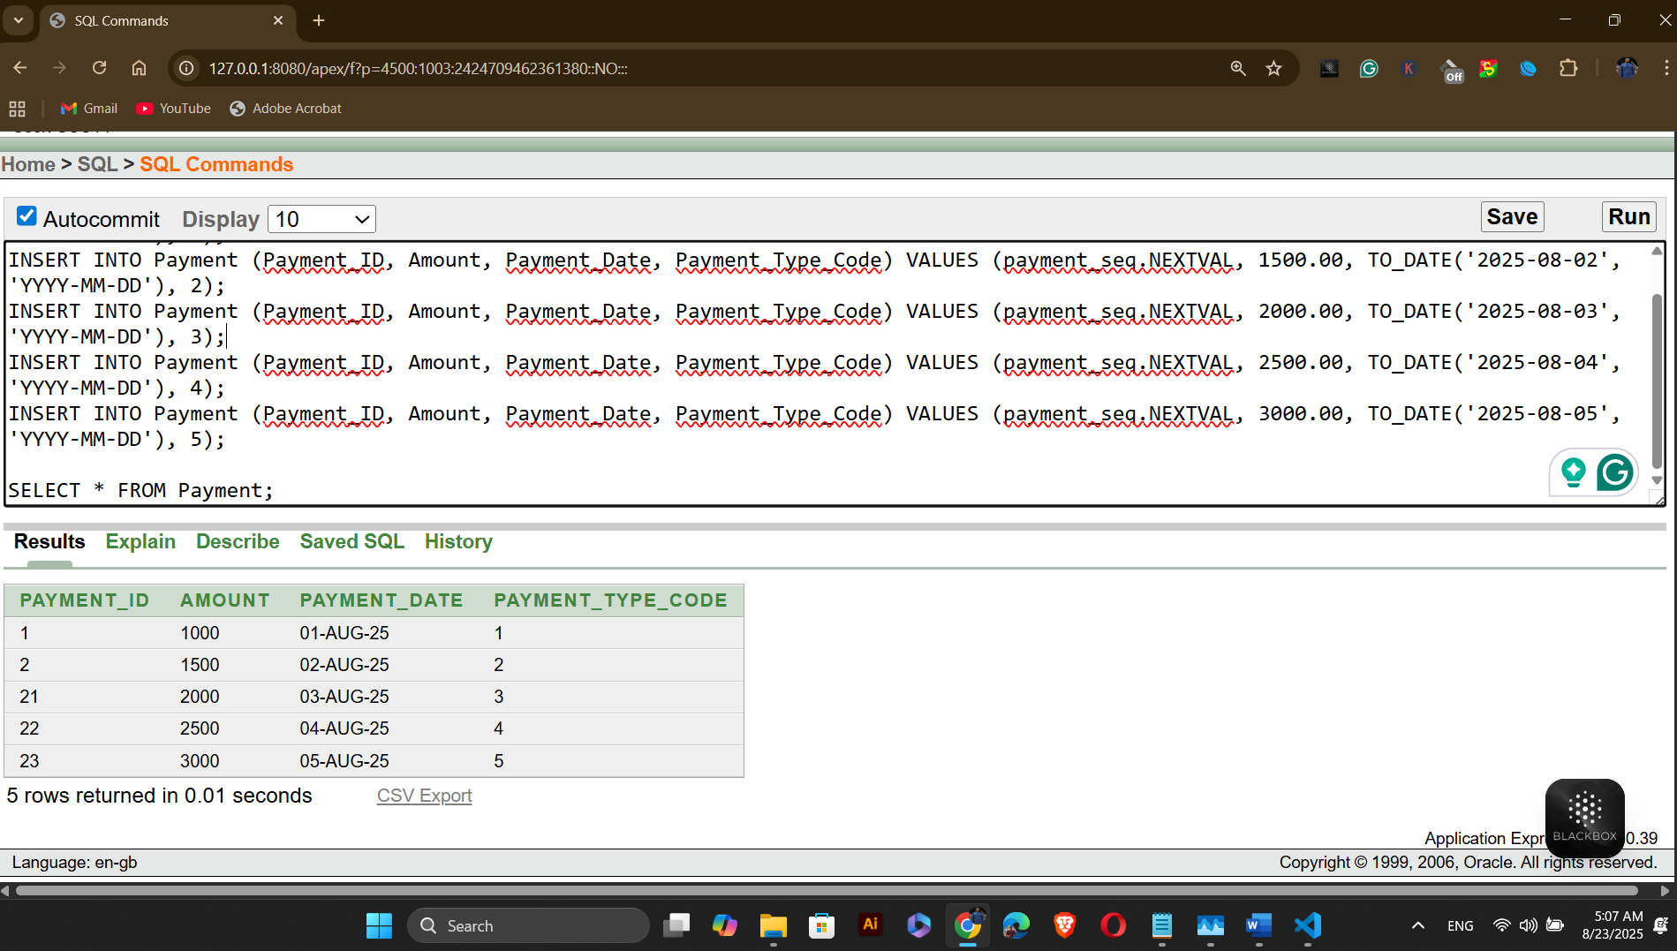

Table Name: Can_Manage
INSERT INTO Can_Manage (Staff_ID, Event_ID) VALUES (1, 1);
INSERT INTO Can_Manage (Staff_ID, Event_ID) VALUES (2, 2);
INSERT INTO Can_Manage (Staff_ID, Event_ID) VALUES (3, 3);
INSERT INTO Can_Manage (Staff_ID, Event_ID) VALUES (4, 4);
INSERT INTO Can_Manage (Staff_ID, Event_ID) VALUES (5, 5);
SELECT * FROM Can_Manage;
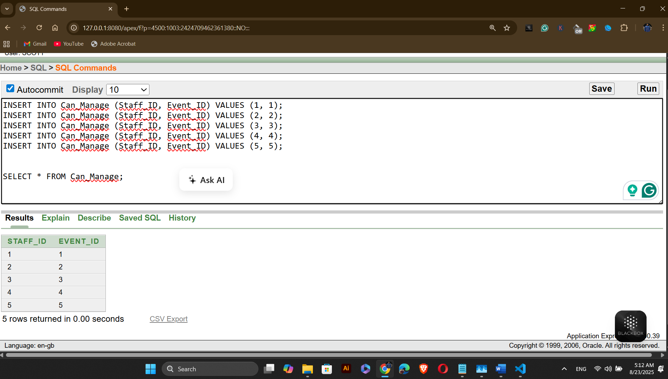
Table Name: Participates
INSERT INTO Participates (Event_ID, Team_ID) VALUES (1, 1);
INSERT INTO Participates (Event_ID, Team_ID) VALUES (2, 2);
INSERT INTO Participates (Event_ID, Team_ID) VALUES (3, 3);
INSERT INTO Participates (Event_ID, Team_ID) VALUES (4, 4);
INSERT INTO Participates (Event_ID, Team_ID) VALUES (5, 5);

SELECT * FROM Participates;

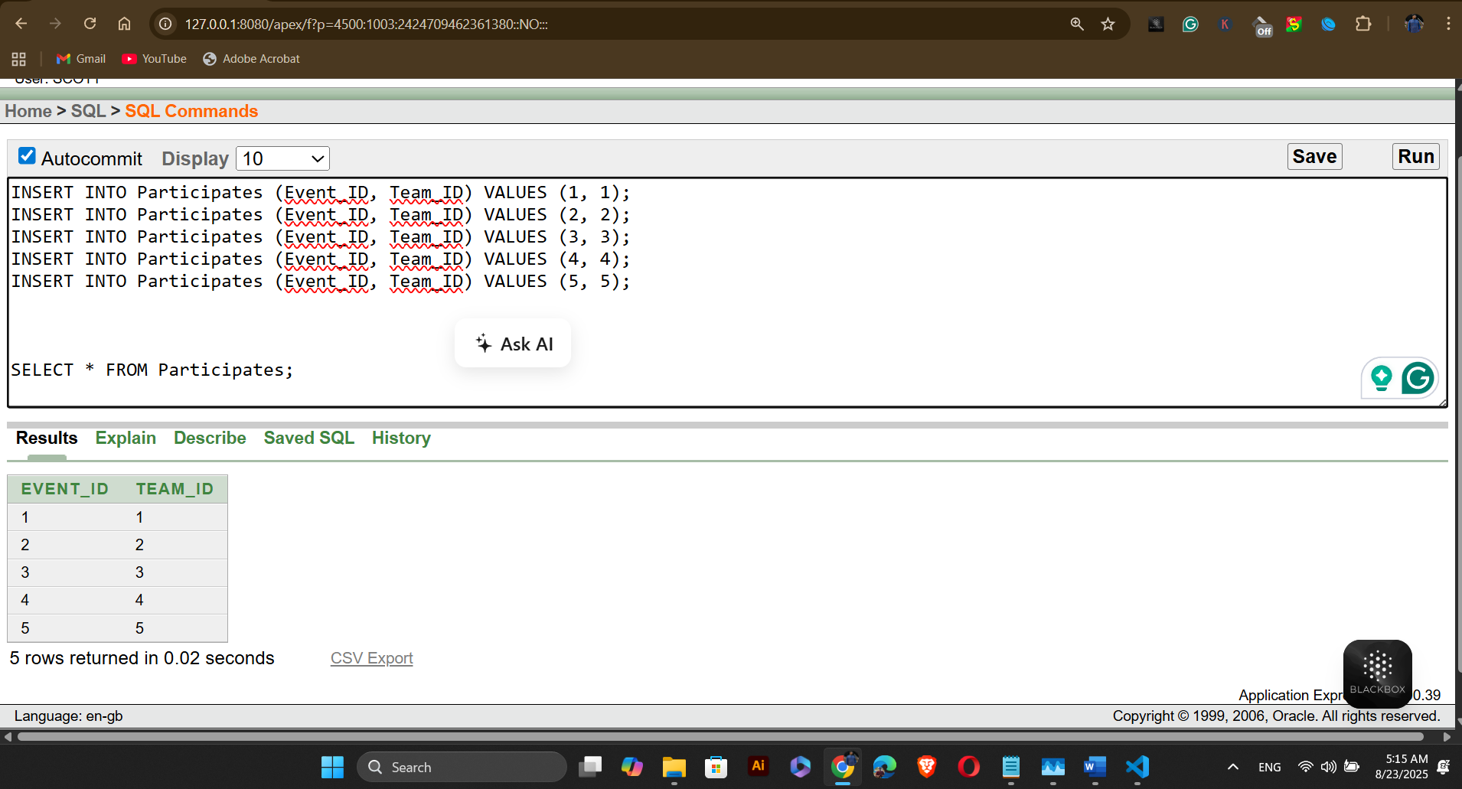
Table Name: Belongs_To
INSERT INTO Belongs_To (Player_ID, Team_ID) VALUES (1, 1);
INSERT INTO Belongs_To (Player_ID, Team_ID) VALUES (2, 2);
INSERT INTO Belongs_To (Player_ID, Team_ID) VALUES (3, 3);
INSERT INTO Belongs_To (Player_ID, Team_ID) VALUES (4, 4);
INSERT INTO Belongs_To (Player_ID, Team_ID) VALUES (5, 5);
SELECT * FROM Belongs_To ;
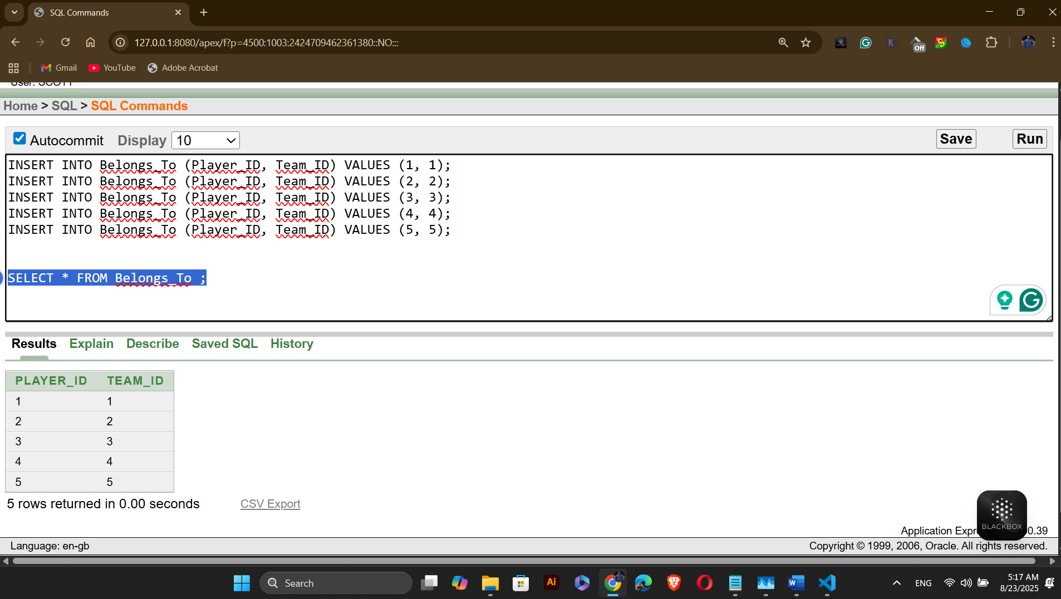

Table Name: Has_Profile
INSERT INTO Has_Profile (Player_ID, Profile_ID) VALUES (1, 1);
INSERT INTO Has_Profile (Player_ID, Profile_ID) VALUES (2, 2);
INSERT INTO Has_Profile (Player_ID, Profile_ID) VALUES (3, 3);
INSERT INTO Has_Profile (Player_ID, Profile_ID) VALUES (4, 4);
INSERT INTO Has_Profile (Player_ID, Profile_ID) VALUES (5, 5);
SELECT * FROM Has_Profile ;
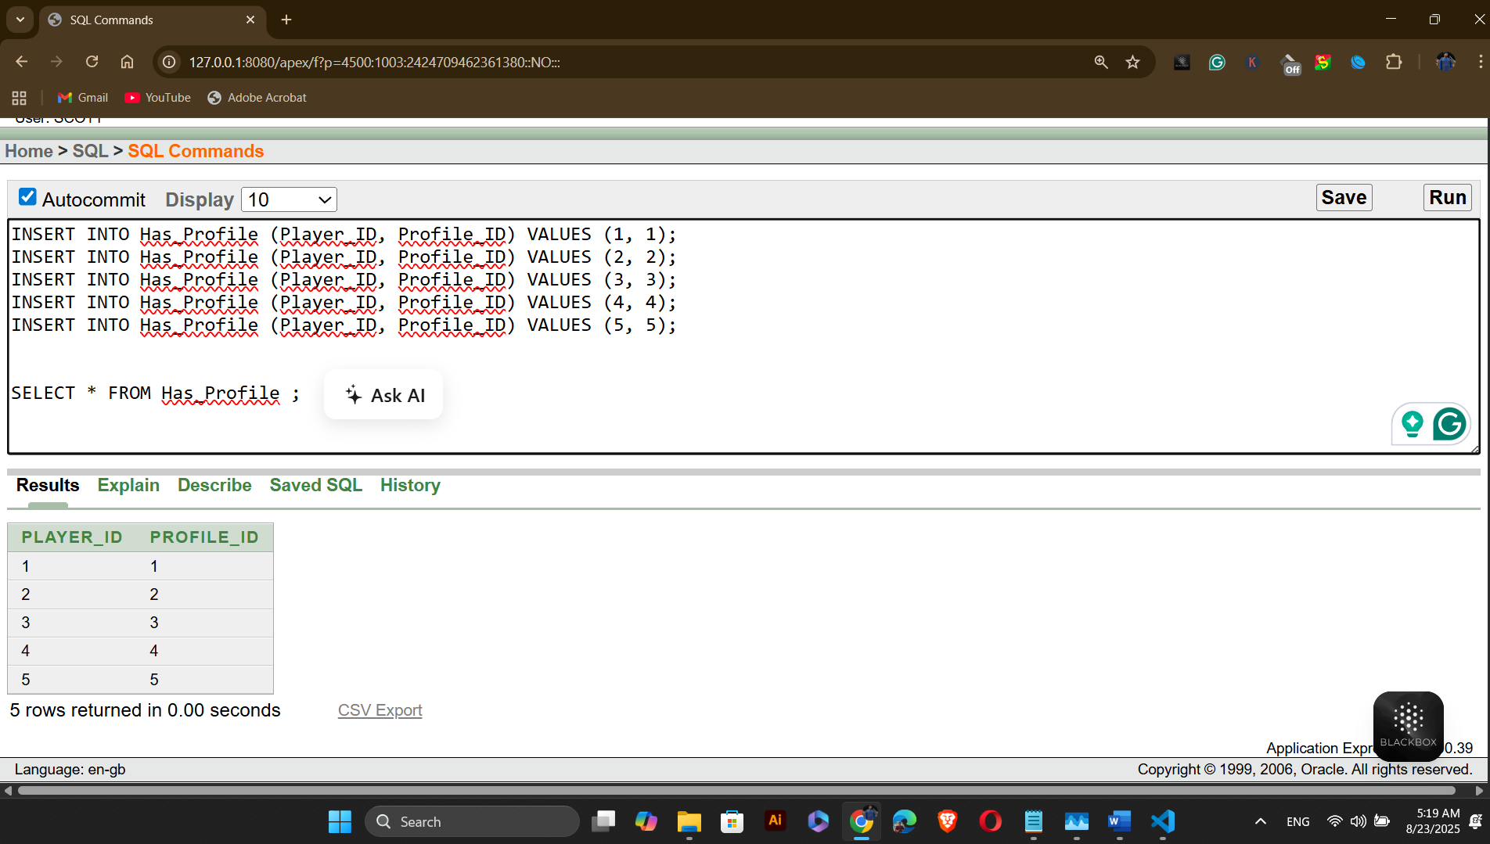
Table Name: Can_Make
INSERT INTO Can_Make (Team_ID, Booking_ID) VALUES (1, 1);
INSERT INTO Can_Make (Team_ID, Booking_ID) VALUES (2, 2);
INSERT INTO Can_Make (Team_ID, Booking_ID) VALUES (3, 3);
INSERT INTO Can_Make (Team_ID, Booking_ID) VALUES (4, 4);
INSERT INTO Can_Make (Team_ID, Booking_ID) VALUES (5, 5);

SELECT * FROM Can_Make ;
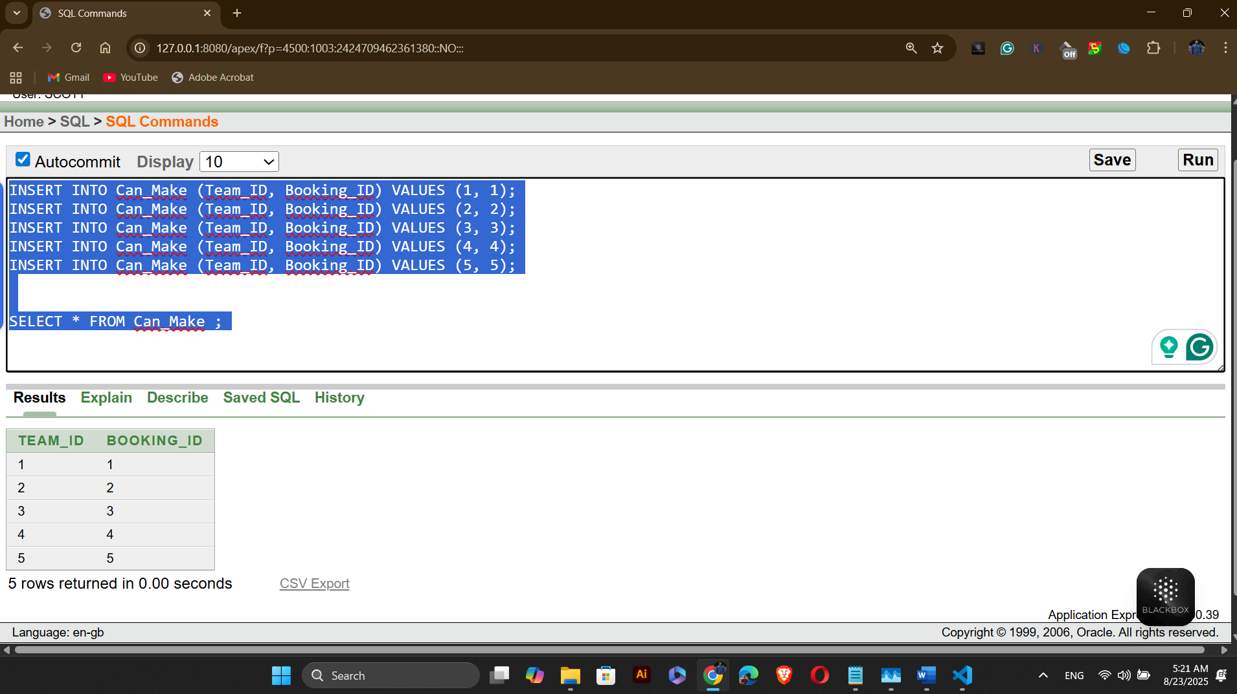

Table Name: Makes
INSERT INTO Makes (Player_ID, Booking_ID) VALUES (1, 1);
INSERT INTO Makes (Player_ID, Booking_ID) VALUES (2, 2);
INSERT INTO Makes (Player_ID, Booking_ID) VALUES (3, 3);
INSERT INTO Makes (Player_ID, Booking_ID) VALUES (4, 4);
INSERT INTO Makes (Player_ID, Booking_ID) VALUES (5, 5);
SELECT * FROM Makes ;
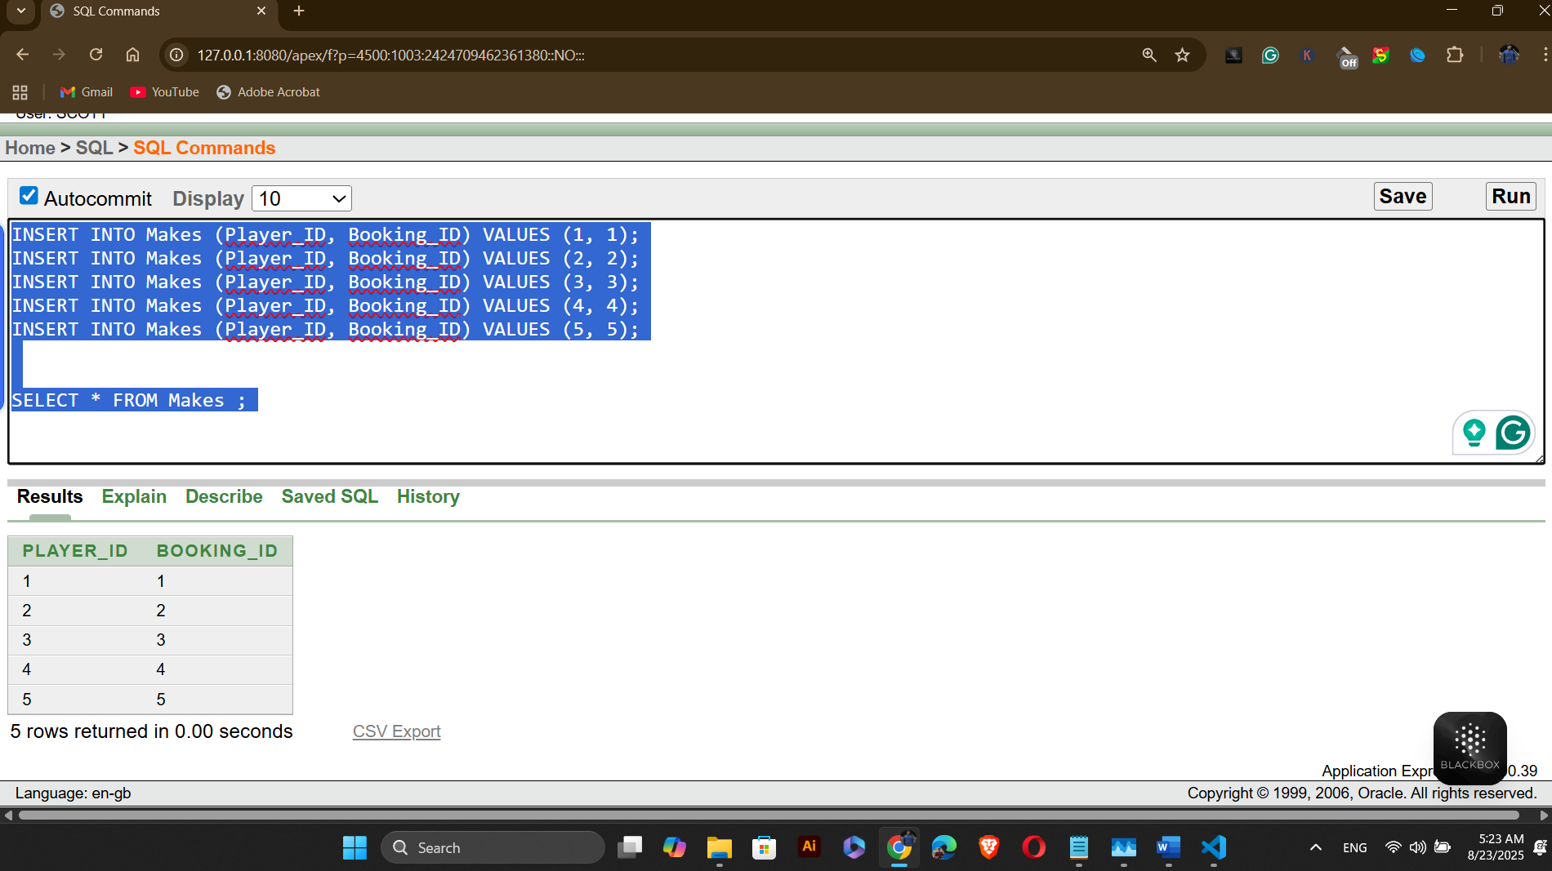

Table Name: Can_Be_Made
INSERT INTO Can_Be_Made (Booking_ID, Turf_ID) VALUES (1, 1);
INSERT INTO Can_Be_Made (Booking_ID, Turf_ID) VALUES (2, 2);
INSERT INTO Can_Be_Made (Booking_ID, Turf_ID) VALUES (3, 3);
INSERT INTO Can_Be_Made (Booking_ID, Turf_ID) VALUES (4, 4);
INSERT INTO Can_Be_Made (Booking_ID, Turf_ID) VALUES (5, 5);
SELECT * FROM Can_Be_Made ;
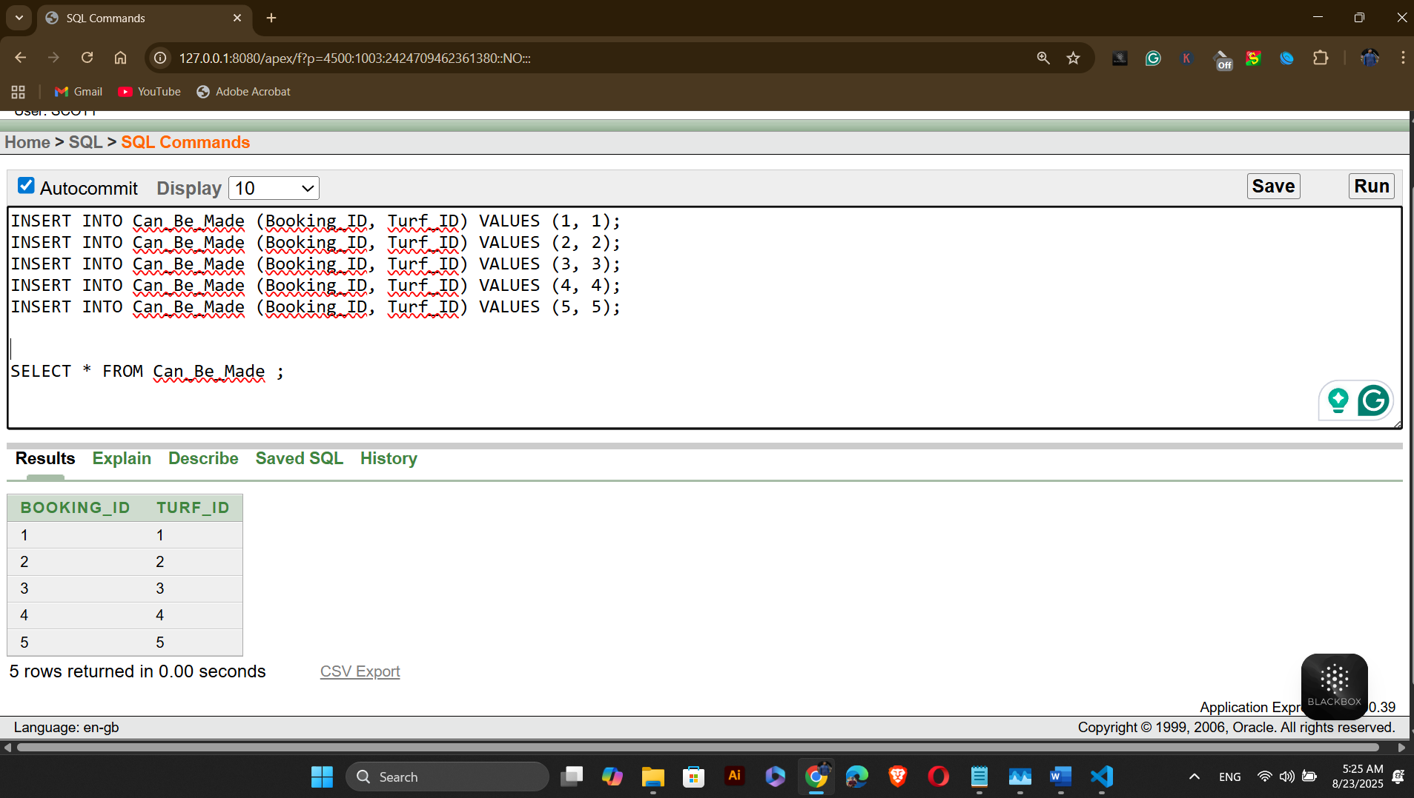

Table Name: Can_Have
INSERT INTO Can_Have (Booking_ID, Payment_ID) VALUES (1, 1);
INSERT INTO Can_Have (Booking_ID, Payment_ID) VALUES (2, 2);
INSERT INTO Can_Have (Booking_ID, Payment_ID) VALUES (3, 21);
INSERT INTO Can_Have (Booking_ID, Payment_ID) VALUES (4, 22);
INSERT INTO Can_Have (Booking_ID, Payment_ID) VALUES (5, 23);
SELECT * FROM Can_Have ;
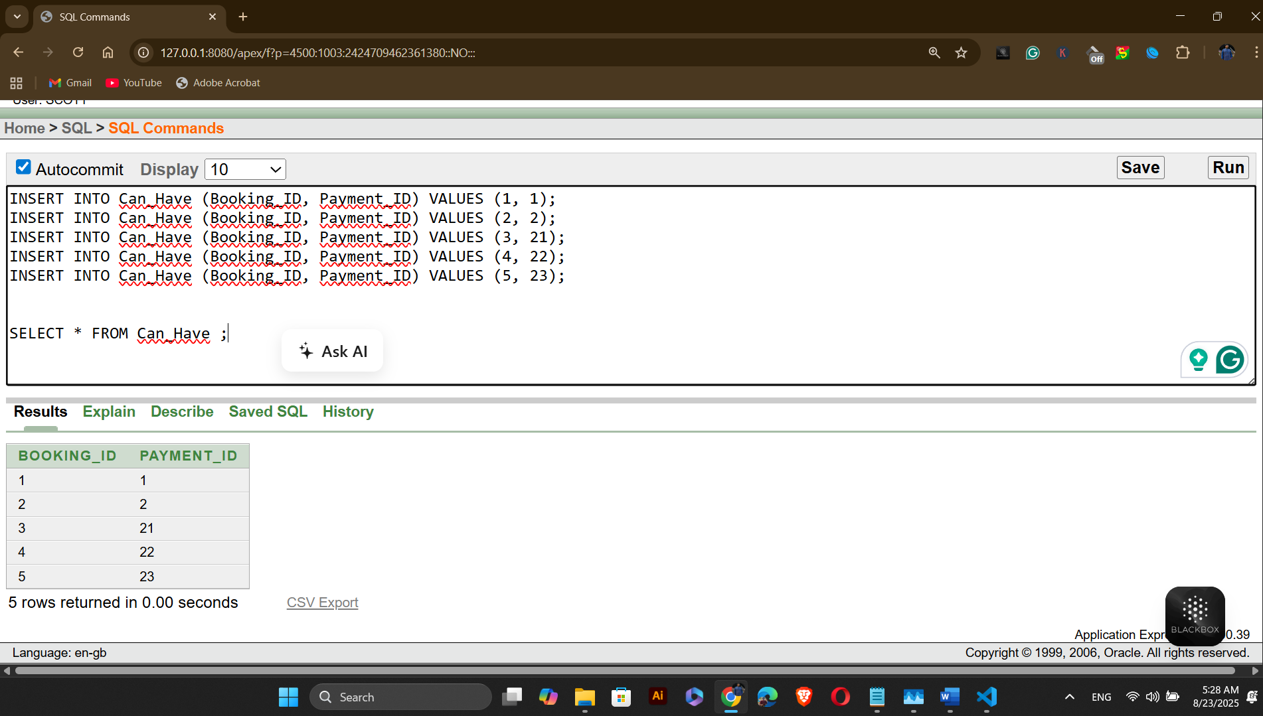

Table Name: Can_Use
INSERT INTO Can_Use (Payment_ID, Payment_Type_Code) VALUES (1, 1);
INSERT INTO Can_Use (Payment_ID, Payment_Type_Code) VALUES (2, 2);
INSERT INTO Can_Use (Payment_ID, Payment_Type_Code) VALUES (21, 3);
INSERT INTO Can_Use (Payment_ID, Payment_Type_Code) VALUES (22, 4);
INSERT INTO Can_Use (Payment_ID, Payment_Type_Code) VALUES (23, 5);
SELECT * FROM Can_Use ;
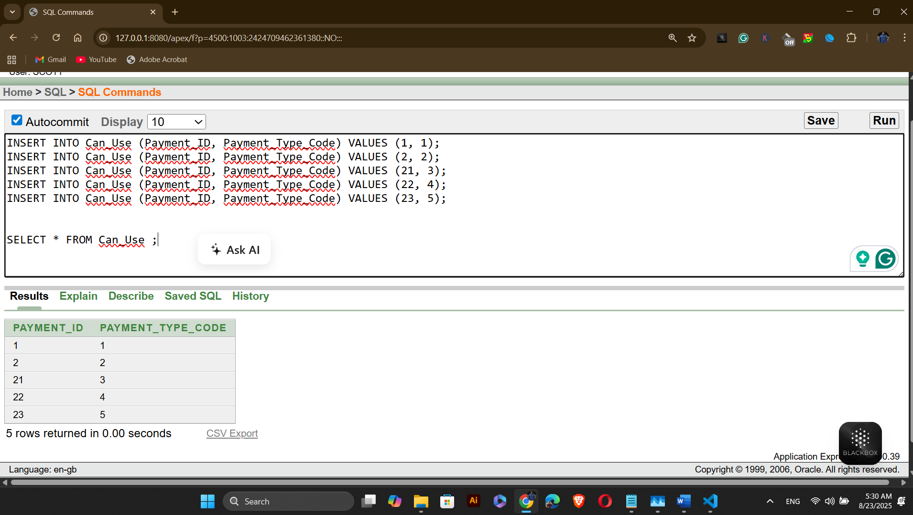

- BASIC PL/SQL:

2- variables type questions:
Question-1: Calculate Total Payment Amount for a Specific Player
Answer:
-- Project: Outdoor Sports Management System
-- Semester: Summer 2025
-- Course Name: Advance Database Management Systems
-- Section: A
DECLARE
v_total_amount NUMBER(10, 2);
BEGIN
SELECT SUM(p.Amount) INTO v_total_amount
FROM Payment p
JOIN Can_Have ch ON p.Payment_ID = ch.Payment_ID
JOIN Makes m ON ch.Booking_ID = m.Booking_ID
WHERE m.Player_ID = 1;
IF v_total_amount IS NULL THEN
v_total_amount := 0;
END IF;
DBMS_OUTPUT.PUT_LINE('Total payment amount for Player ID 1: Tk' || v_total_amount);
END;
/
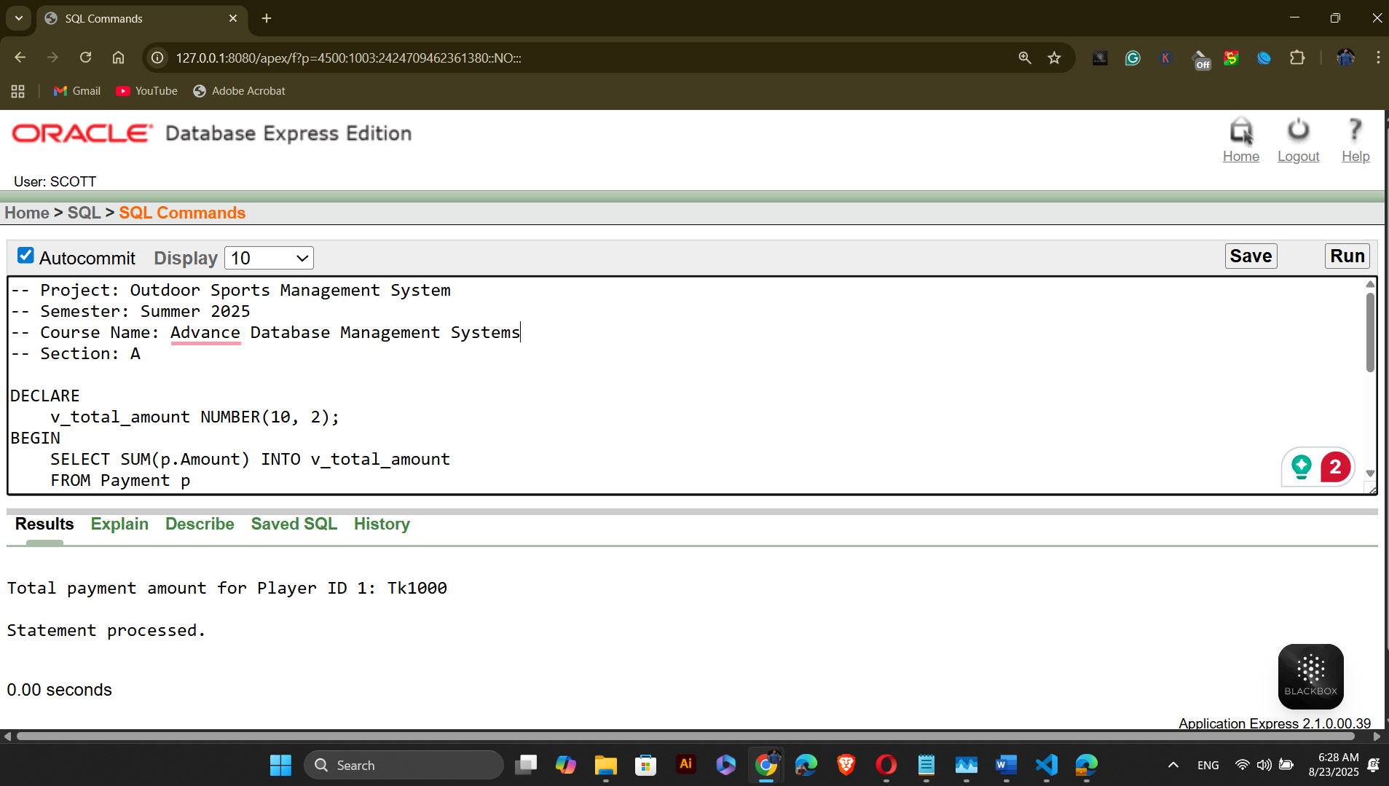
Question-2: Count Number of Bookings for a Specific Turf
Answer:
-- Project: Outdoor Sports Management System
-- Semester: Summer 2025
-- Course Name: Advance Database Management Systems
-- Section: A
DECLARE
v_turf_name VARCHAR2(100);
v_booking_count NUMBER;
BEGIN
SELECT t.Turf_Name, COUNT(cbm.Booking_ID)
INTO v_turf_name, v_booking_count
FROM Turf t
LEFT JOIN Can_Be_Made cbm ON t.Turf_ID = cbm.Turf_ID
WHERE t.Turf_ID = 1
GROUP BY t.Turf_Name;

DBMS_OUTPUT.PUT_LINE('Turf Name: ' || v_turf_name);
DBMS_OUTPUT.PUT_LINE('Number of bookings: ' || v_booking_count);
END;
/
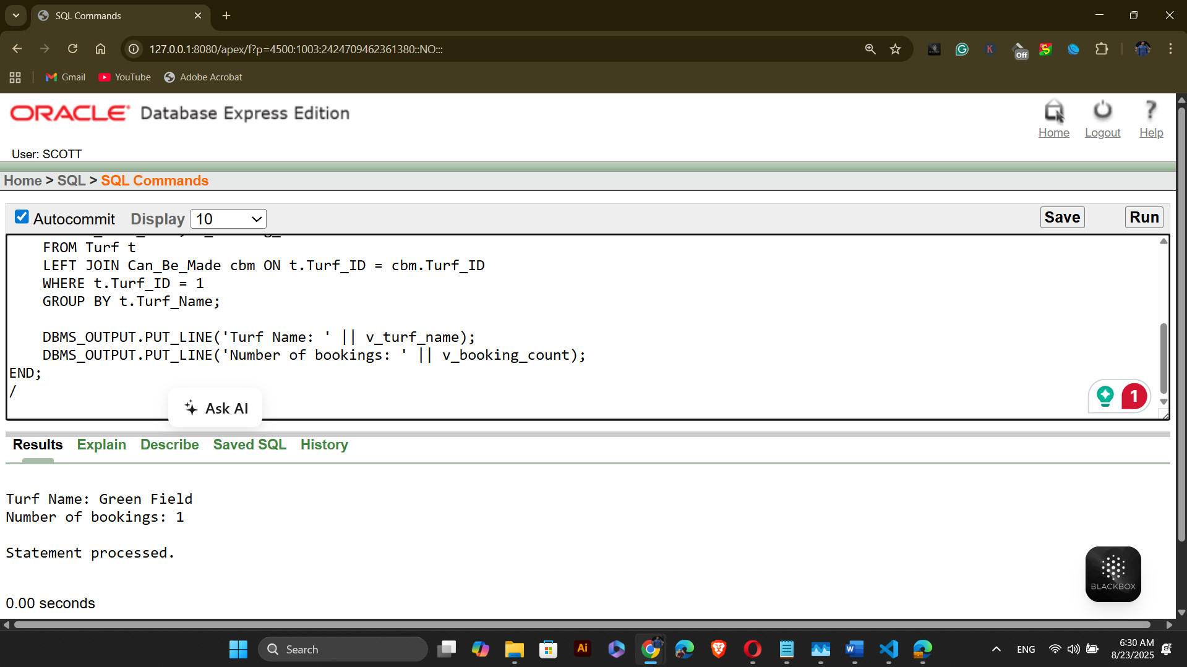

2- operators type questions:
Question-1: Calculate Booking Duration and Apply Late Fees
Answer:
-- Project: Outdoor Sports Management System
-- Semester: Summer 2025
-- Course Name: Advance Database Management Systems
-- Section: A
DECLARE
v_booking_id NUMBER := 1;
v_start_time TIMESTAMP;
v_end_time TIMESTAMP;
v_scheduled_duration NUMBER;
v_actual_duration NUMBER;
v_overtime_minutes NUMBER;
v_late_fee NUMBER := 0;
BEGIN
SELECT Start_Time, End_Time
INTO v_start_time, v_end_time
FROM Booking
WHERE Booking_ID = v_booking_id;

v_scheduled_duration := (EXTRACT(HOUR FROM (v_end_time - v_start_time)) * 60) +
EXTRACT(MINUTE FROM (v_end_time - v_start_time));

v_actual_duration := (EXTRACT(HOUR FROM (SYSTIMESTAMP - v_start_time)) * 60) +
EXTRACT(MINUTE FROM (SYSTIMESTAMP - v_start_time));

-- Calculate overtime and late fee
IF v_actual_duration > v_scheduled_duration THEN
v_overtime_minutes := v_actual_duration - v_scheduled_duration;
-- Tk120 per hour or part thereof
v_late_fee := CEIL(v_overtime_minutes / 60) * 100;
END IF;

-- Output results
DBMS_OUTPUT.PUT_LINE('Booking ID: ' || v_booking_id);
DBMS_OUTPUT.PUT_LINE('Scheduled Duration: ' || v_scheduled_duration || ' minutes');
DBMS_OUTPUT.PUT_LINE('Actual Duration: ' || v_actual_duration || ' minutes');
DBMS_OUTPUT.PUT_LINE('Overtime Minutes: ' || NVL(v_overtime_minutes, 0));
DBMS_OUTPUT.PUT_LINE('Late Fee: Tk' || v_late_fee);
END;
/
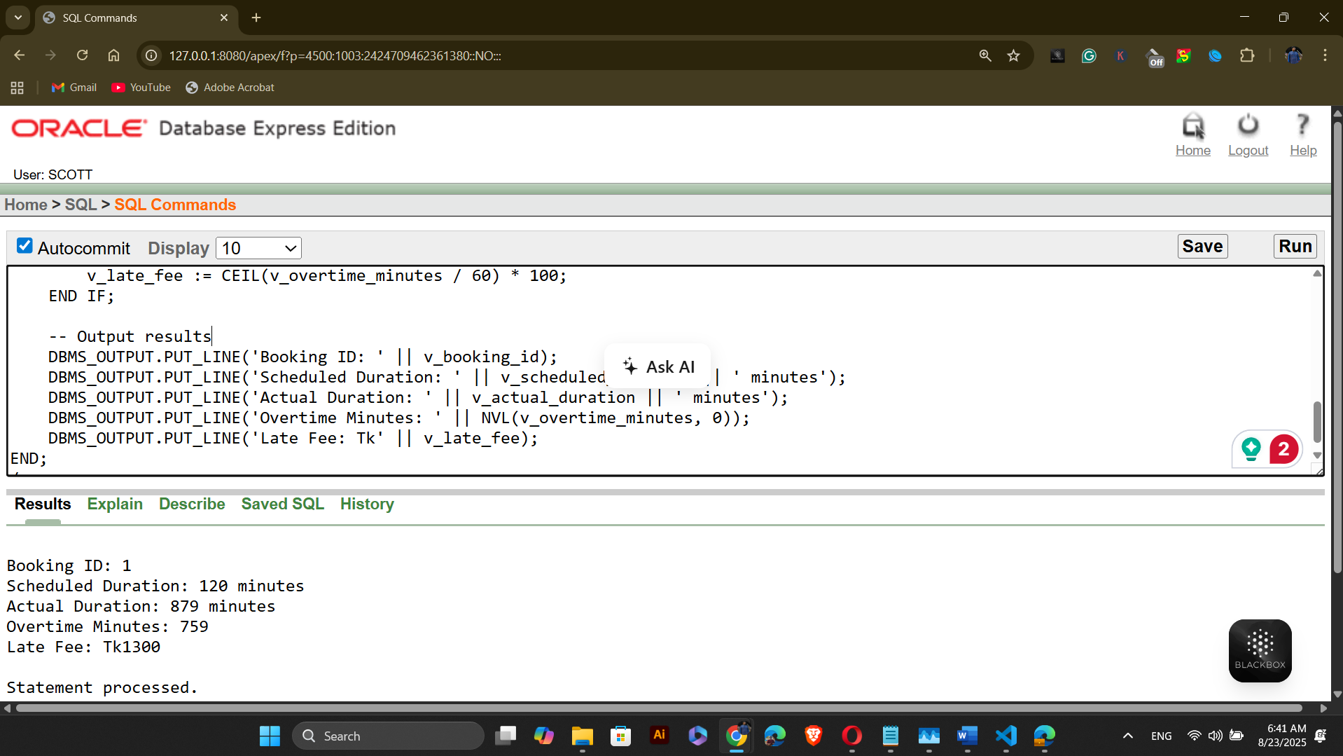

Question-2: Calculate Event Revenue and Apply Seasonal Discount
Answer:
-- Project: Outdoor Sports Management System
-- Semester: Summer 2025
-- Course Name: Advance Database Management Systems
-- Section: A

DECLARE
v_event_id NUMBER := 1;
v_event_name VARCHAR2(100);
v_event_date DATE;
v_event_month NUMBER;
v_total_revenue NUMBER(10,2) := 0;
v_discount_percent NUMBER := 0;
v_discounted_revenue NUMBER(10,2);
BEGIN
SELECT Event_Name, Event_Date
INTO v_event_name, v_event_date
FROM Events
WHERE Event_ID = v_event_id;

v_event_month := EXTRACT(MONTH FROM v_event_date);

SELECT SUM(p.Amount)
INTO v_total_revenue
FROM Payment p
JOIN Can_Have ch ON p.Payment_ID = ch.Payment_ID
JOIN Can_Be_Made cbm ON ch.Booking_ID = cbm.Booking_ID
JOIN Participates part ON cbm.Booking_ID = part.Event_ID
WHERE part.Event_ID = v_event_id;

IF v_event_month = 9 THEN
v_discount_percent := 15;
ELSIF v_event_month = 10 THEN
v_discount_percent := 10;
ELSE
v_discount_percent := 0;
END IF;

v_discounted_revenue := v_total_revenue - (v_total_revenue * v_discount_percent / 100);

IF v_total_revenue IS NULL THEN
v_total_revenue := 0;
v_discounted_revenue := 0;
END IF;

DBMS_OUTPUT.PUT_LINE('Event: ' || v_event_name);
DBMS_OUTPUT.PUT_LINE('Event Date: ' || TO_CHAR(v_event_date, 'DD-MON-YYYY'));
DBMS_OUTPUT.PUT_LINE('Event Month: ' || v_event_month);
DBMS_OUTPUT.PUT_LINE('Total Revenue: Tk' || v_total_revenue);
DBMS_OUTPUT.PUT_LINE('Discount Percentage: ' || v_discount_percent || '%');
DBMS_OUTPUT.PUT_LINE('Discounted Revenue: TK' || v_discounted_revenue);
END;
/
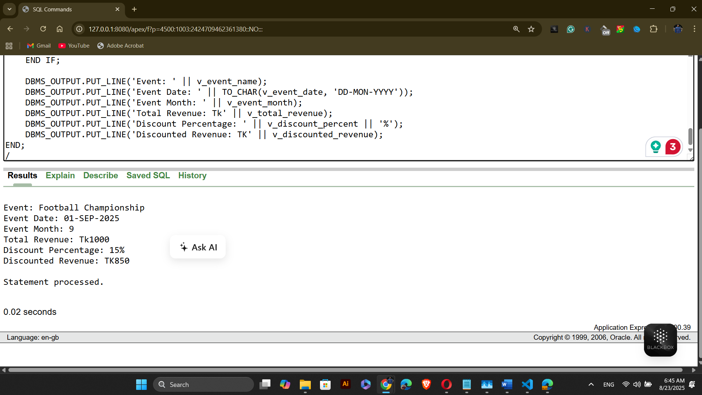

2- single-row function type questions:
Question-1: Retrieve the player's full name (concatenated first and last names) in uppercase.
Answer:
-- Project: Outdoor Sports Management System
-- Semester: Summer 2025
-- Course Name: Advance Database Management Systems
-- Section: A

DECLARE
v_player_name VARCHAR2(100);
BEGIN

SELECT UPPER(First_Name || ' ' || Last_Name)
INTO v_player_name
FROM Players
WHERE Player_ID = 1;

DBMS_OUTPUT.PUT_LINE('Uppercase Player Name: ' || v_player_name);
END;
/
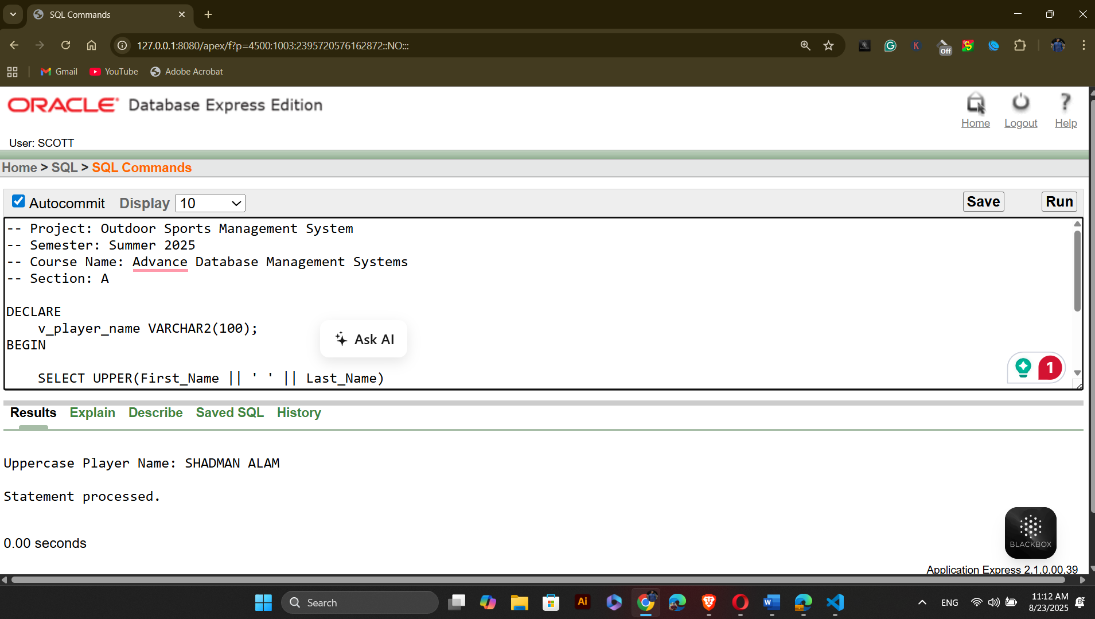

Question-2: Retrieve the player's age (calculated from their date of birth) and round it to the nearest whole number.
Answer:
-- Project: Outdoor Sports Management System
-- Semester: Summer 2025
-- Course Name: Advance Database Management Systems
-- Section: A
DECLARE
v_player_age NUMBER;
BEGIN
SELECT ROUND(MONTHS_BETWEEN(SYSDATE, DOB) / 12)
INTO v_player_age
FROM Players
WHERE Player_ID = 1;
DBMS_OUTPUT.PUT_LINE('Rounded Player Age: ' || v_player_age);
END;
/

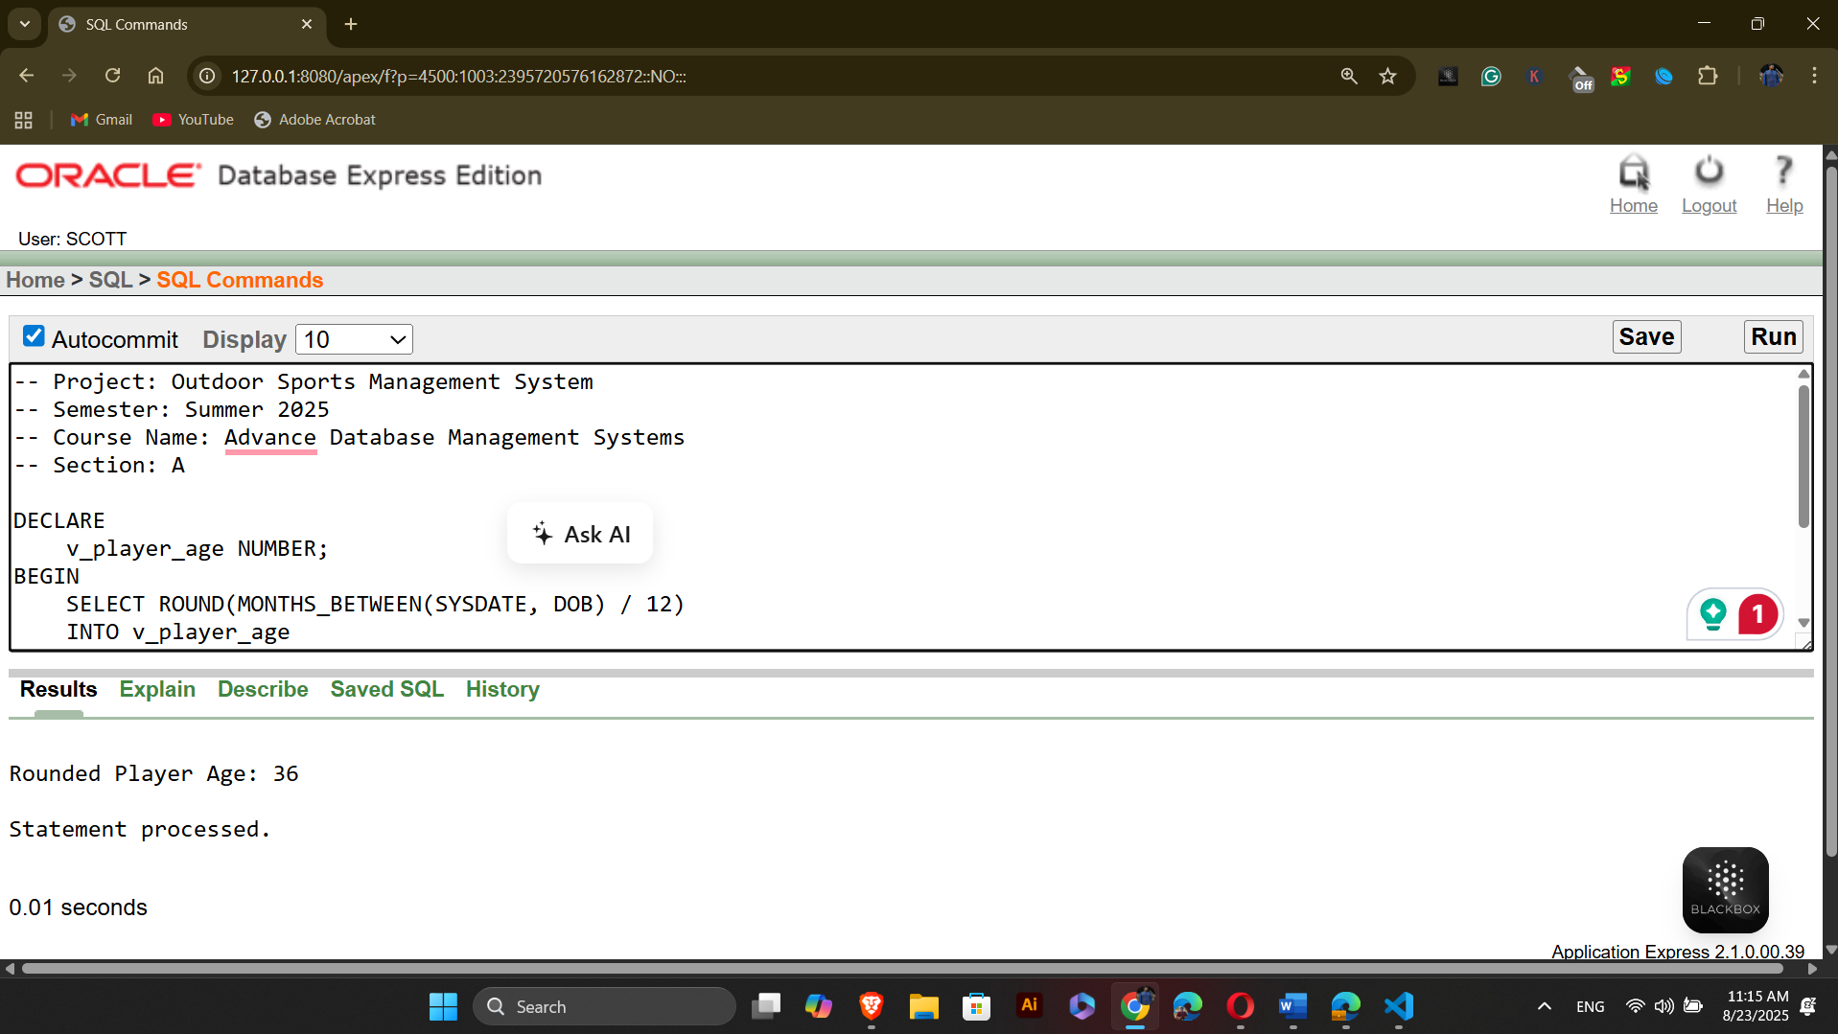

2- Group function type questions:
Question-1: Find the average number of players in all teams.
Answer:
-- Project: Outdoor Sports Management System
-- Semester: Summer 2025
-- Course Name: Advance Database Management Systems
-- Section: A

DECLARE
v_avg_players NUMBER;
BEGIN

SELECT AVG(player_count)
INTO v_avg_players
FROM (SELECT Team_ID, COUNT(*) AS player_count
FROM Belongs_To
GROUP BY Team_ID);
DBMS_OUTPUT.PUT_LINE('Average Number of Players in All Teams: ' || v_avg_players);
END;
/
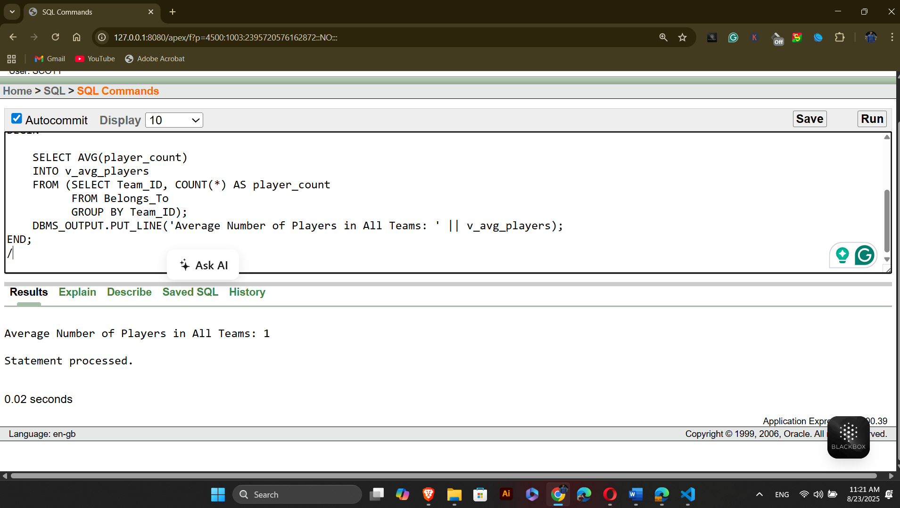
Question-2: Find the total number of bookings that have a status of 'Confirmed'.
Answer:
-- Project: Outdoor Sports Management System
-- Semester: Summer 2025
-- Course Name: Advance Database Management Systems
-- Section: A
DECLARE
v_total_confirmed NUMBER;
BEGIN
SELECT COUNT(*)
INTO v_total_confirmed
FROM Booking
WHERE Status = 'Confirmed';
DBMS_OUTPUT.PUT_LINE('Total Confirmed Bookings: ' || v_total_confirmed);
END;
/
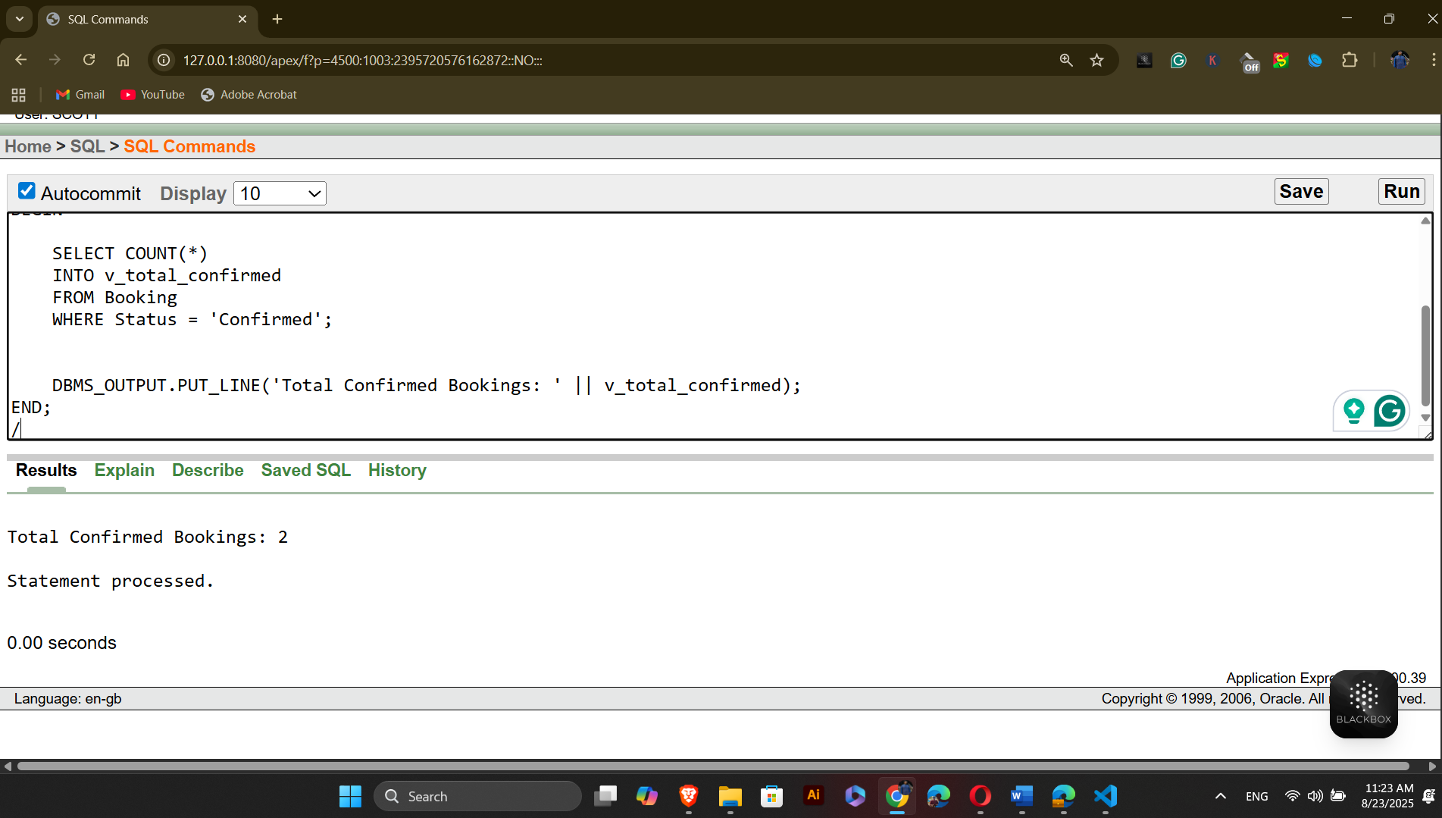

2- Loop type questions:
Question-1: Write a PL/SQL block that uses a FOR loop to display the names of all players in the 'Warriors' team.
Answer:
-- Project: Outdoor Sports Management System
-- Semester: Summer 2025
-- Course Name: Advance Database Management Systems
-- Section: A
DECLARE
CURSOR c_players IS
SELECT p.First_Name || ' ' || p.Last_Name AS player_name
FROM Players p
JOIN Belongs_To bt ON p.Player_ID = bt.Player_ID
JOIN Team t ON bt.Team_ID = t.Team_ID
WHERE t.Team_Name = 'Warriors';

BEGIN
FOR player IN c_players LOOP
DBMS_OUTPUT.PUT_LINE('Player Name: ' || player.player_name);
END LOOP;
END;
/
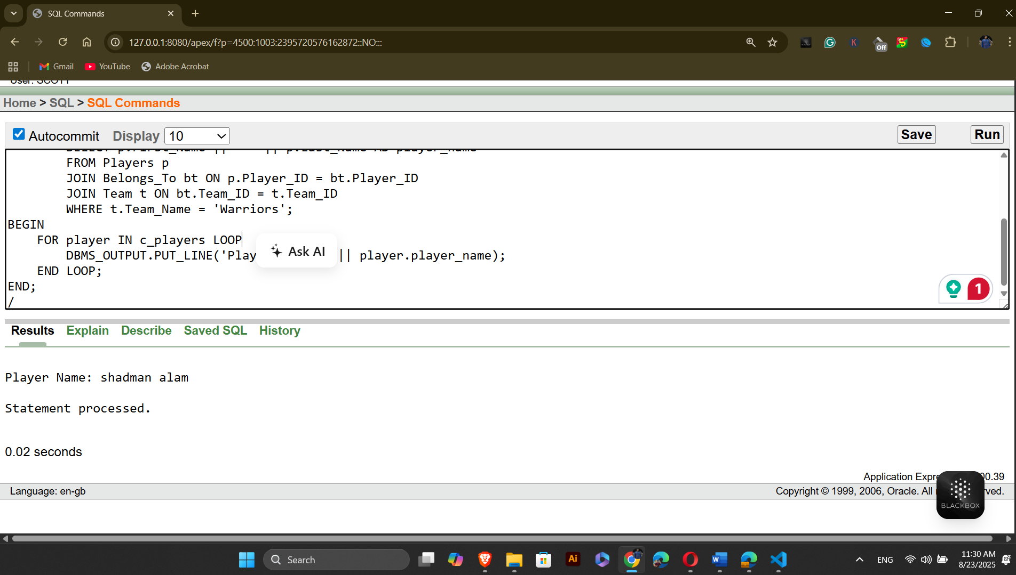
Question-2: Write a PL/SQL block that uses a WHILE loop to display all booking IDs and their corresponding statuses for bookings made on '2025-08-01'.
Answer:
-- Project: Outdoor Sports Management System
-- Semester: Summer 2025
-- Course Name: Advance Database Management Systems
-- Section: A

DECLARE
v_booking_id NUMBER;
v_booking_status VARCHAR2(50);
CURSOR c_bookings IS
SELECT Booking_ID, Status
FROM Booking
WHERE Booking_Date = TO_DATE('2025-08-01', 'YYYY-MM-DD');
BEGIN
OPEN c_bookings;

FETCH c_bookings INTO v_booking_id, v_booking_status;

WHILE c_bookings%FOUND LOOP
DBMS_OUTPUT.PUT_LINE('Booking ID: ' || v_booking_id || ', Status: ' || v_booking_status);
FETCH c_bookings INTO v_booking_id, v_booking_status;
END LOOP;
CLOSE c_bookings;
END;
/
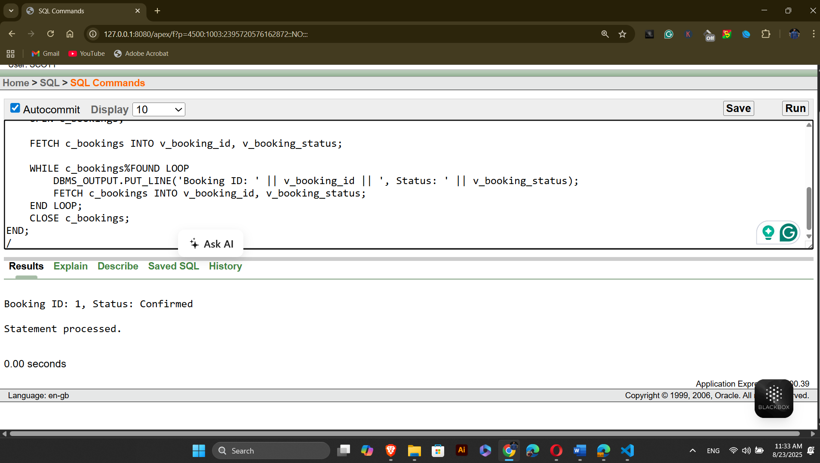

2- Conditional type questions:
Question-1: Check if the player is eligible for a specific event based on their skill level.
Answer:
-- Project: Outdoor Sports Management System
-- Semester: Summer 2025
-- Course Name: Advance Database Management Systems
-- Section: A

DECLARE
v_skill_level VARCHAR2(50); -- Variable to store the player's skill level
BEGIN
-- Retrieve the player's skill level
SELECT Skill_Level
INTO v_skill_level
FROM Profile
JOIN Has_Profile hp ON Profile.Profile_ID = hp.Profile_ID
WHERE hp.Player_ID = 1;

-- Check if the player's skill level qualifies for the event
IF v_skill_level = 'Advanced' THEN
DBMS_OUTPUT.PUT_LINE('Player is eligible for the event.');
ELSE
DBMS_OUTPUT.PUT_LINE('Player is not eligible for the event.');
END IF;
END;
/

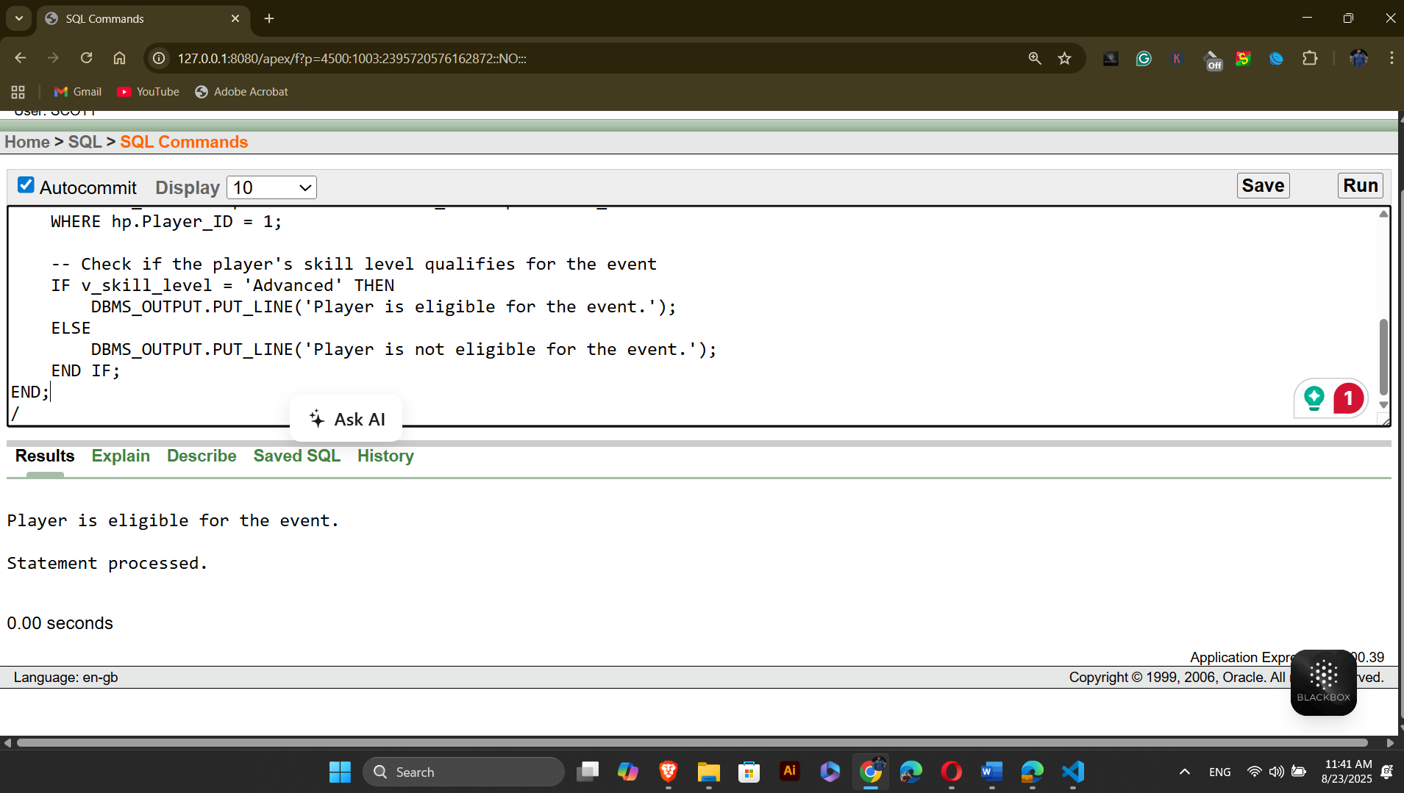
Question-2: Check if a booking is confirmed for a specific date. If the status is 'Confirmed', display the booking details. Otherwise, display a message saying the booking is not confirmed.
Answer:
-- Project: Outdoor Sports Management System
-- Semester: Summer 2025
-- Course Name: Advance Database Management Systems
-- Section: A

DECLARE
v_booking_status VARCHAR2(50);
v_booking_date DATE := TO_DATE('2025-08-01', 'YYYY-MM-DD');
BEGIN

SELECT Status
INTO v_booking_status
FROM Booking
WHERE Booking_Date = v_booking_date;

IF v_booking_status = 'Confirmed' THEN
DBMS_OUTPUT.PUT_LINE('Booking for ' || TO_CHAR(v_booking_date, 'YYYY-MM-DD') || ' is confirmed.');
ELSE
DBMS_OUTPUT.PUT_LINE('Booking for ' || TO_CHAR(v_booking_date, 'YYYY-MM-DD') || ' is not confirmed.');
END IF;
END;
/
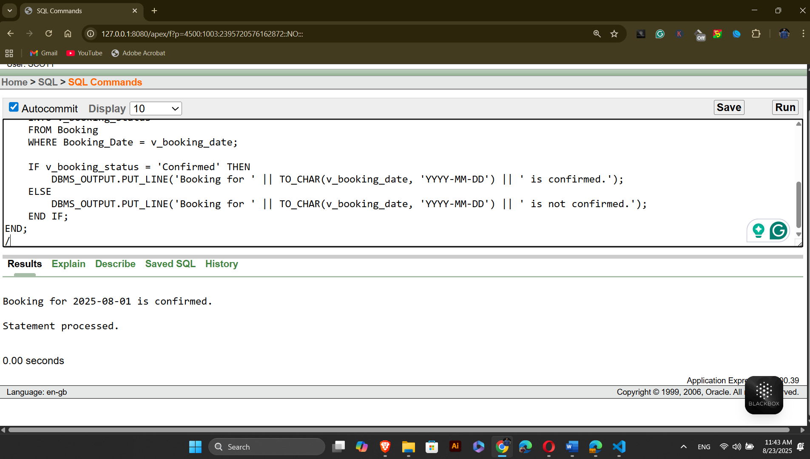

2- subquery questions:
Question-1: Retrieve the Player ID of the player who has participated in the most number of events.
Answer:
-- Project: Outdoor Sports Management System
-- Semester: Summer 2025
-- Course Name: Advance Database Management Systems
-- Section: A

DECLARE
v_top_player_id NUMBER;
BEGIN

SELECT Player_ID
INTO v_top_player_id
FROM (
SELECT Player_ID
FROM Belongs_To
GROUP BY Player_ID
HAVING COUNT(*) = (
SELECT MAX(event_count)
FROM (
SELECT Player_ID, COUNT(*) AS event_count
FROM Belongs_To
GROUP BY Player_ID
)
)
ORDER BY COUNT(*) DESC
) WHERE ROWNUM = 1; --only one row is selected

DBMS_OUTPUT.PUT_LINE('Top Player ID (Most Event Participation): ' || v_top_player_id);
END;
/
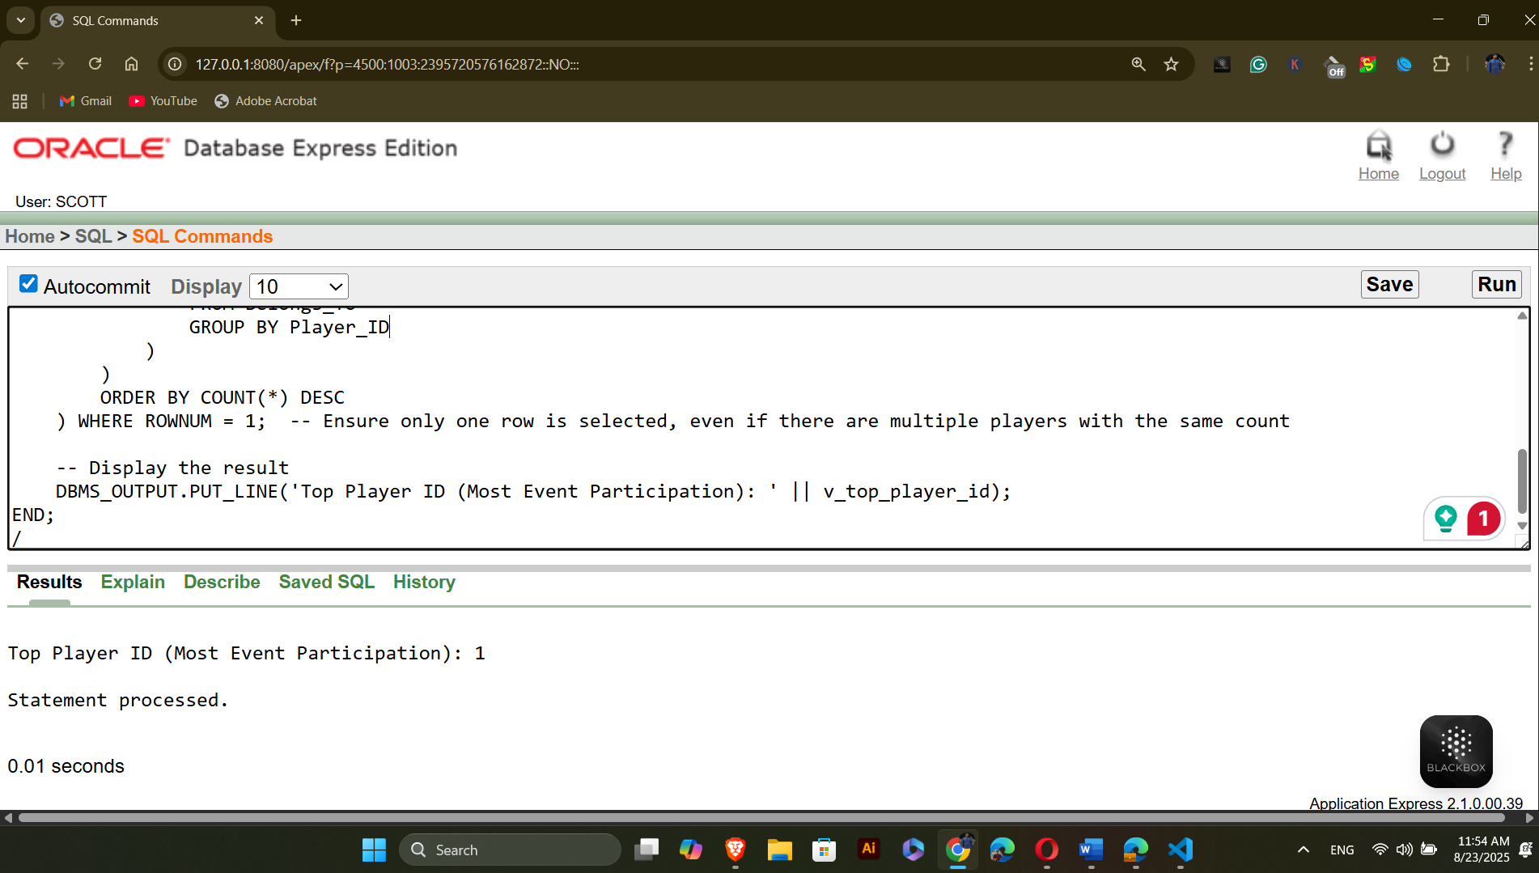

Question-2: Retrieve the Booking ID of the booking with the highest payment amount.
Answer:
-- Project: Outdoor Sports Management System
-- Semester: Summer 2025
-- Course Name: Advance Database Management Systems
-- Section: A

DECLARE
v_top_booking_id NUMBER;
BEGIN

SELECT Booking_ID
INTO v_top_booking_id
FROM (
SELECT Booking_ID, Amount
FROM Can_Have ch
JOIN Payment p ON ch.Payment_ID = p.Payment_ID
WHERE Amount = (SELECT MAX(Amount) FROM Payment)
) WHERE ROWNUM = 1;

DBMS_OUTPUT.PUT_LINE('Booking ID (Highest Payment): ' || v_top_booking_id);
END;
/
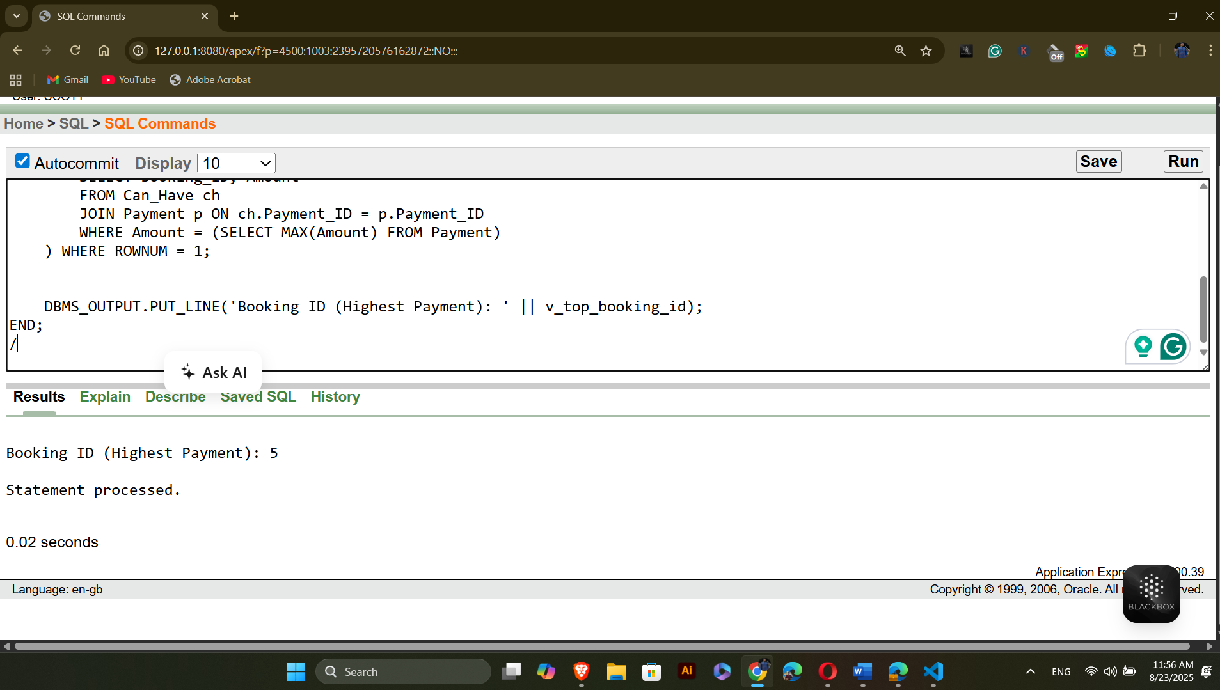

2- Joining questions:
Question-1: Join the Players and Profile tables to display the player's name and their skill level.
Answer:
-- Project: Outdoor Sports Management System
-- Semester: Summer 2025
-- Course Name: Advance Database Management Systems
-- Section: A

BEGIN
FOR r IN (
SELECT p.First_Name || ' ' || p.Last_Name AS player_name, pr.Skill_Level
FROM Players p
JOIN Has_Profile hp ON p.Player_ID = hp.Player_ID
JOIN Profile pr ON hp.Profile_ID = pr.Profile_ID
) LOOP
DBMS_OUTPUT.PUT_LINE('Player: ' || r.player_name || ' - Skill Level: ' || r.Skill_Level);
END LOOP;
END;
/
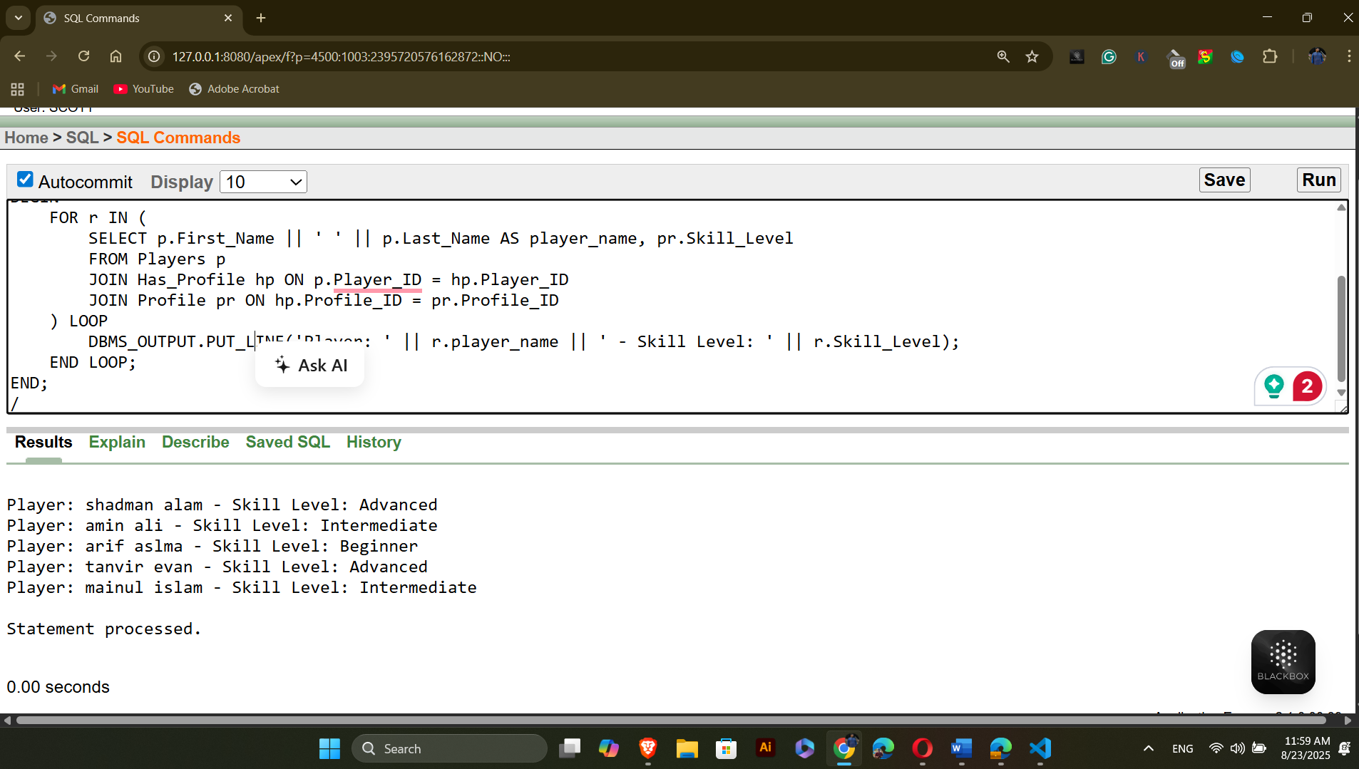

Question-2: Join the Booking and Turf tables to display the booking ID and turf location.
Answer:
-- Project: Outdoor Sports Management System
-- Semester: Summer 2025
-- Course Name: Advance Database Management Systems
-- Section: A

BEGIN
FOR r IN (
SELECT b.Booking_ID, t.Turf_location
FROM Booking b
JOIN Can_Be_Made cbm ON b.Booking_ID = cbm.Booking_ID
JOIN Turf t ON cbm.Turf_ID = t.Turf_ID
) LOOP
DBMS_OUTPUT.PUT_LINE('Booking ID: ' || r.Booking_ID || ' - Turf Location: ' || r.Turf_location);
END LOOP;
END;
/
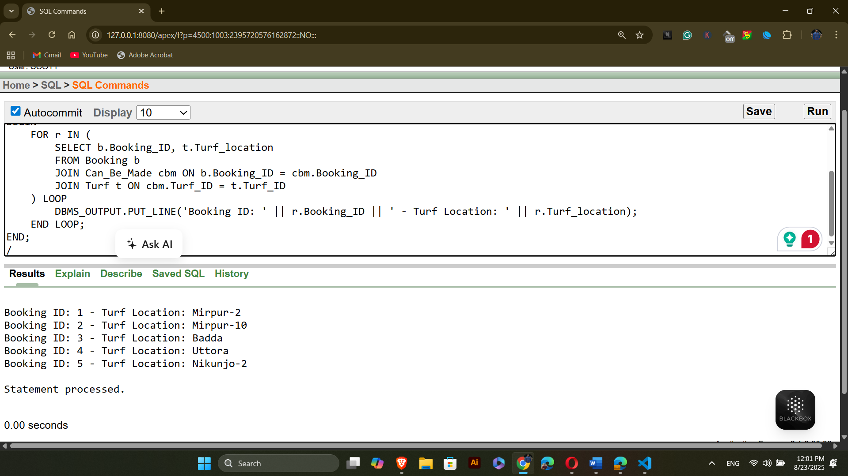

11.Advance PL/SQL:
  - Stored function
Question-1: Create a function to retrieve the skill level of a player based on their Player_ID.
Answer:
-- Project: Outdoor Sports Management System
-- Semester: Summer 2025
-- Course Name: Advance Database Management Systems
-- Section: A

CREATE OR REPLACE FUNCTION get_skill_level (p_player_id IN NUMBER)
RETURN VARCHAR2 IS
v_skill_level VARCHAR2(50);
BEGIN

SELECT pr.Skill_Level
INTO v_skill_level
FROM Profile pr
JOIN Has_Profile hp ON pr.Profile_ID = hp.Profile_ID
WHERE hp.Player_ID = p_player_id;

RETURN v_skill_level;
END get_skill_level;
/
To see the answer
-- Project: Outdoor Sports Management System
-- Semester: Summer 2025
-- Course Name: Advance Database Management Systems
-- Section: A
DECLARE
v_player_id NUMBER := 1;
v_skill_level VARCHAR2(50);
BEGIN
v_skill_level := get_skill_level(v_player_id);
DBMS_OUTPUT.PUT_LINE('Skill Level of Player ' || v_player_id || ': ' || v_skill_level);
END;
/
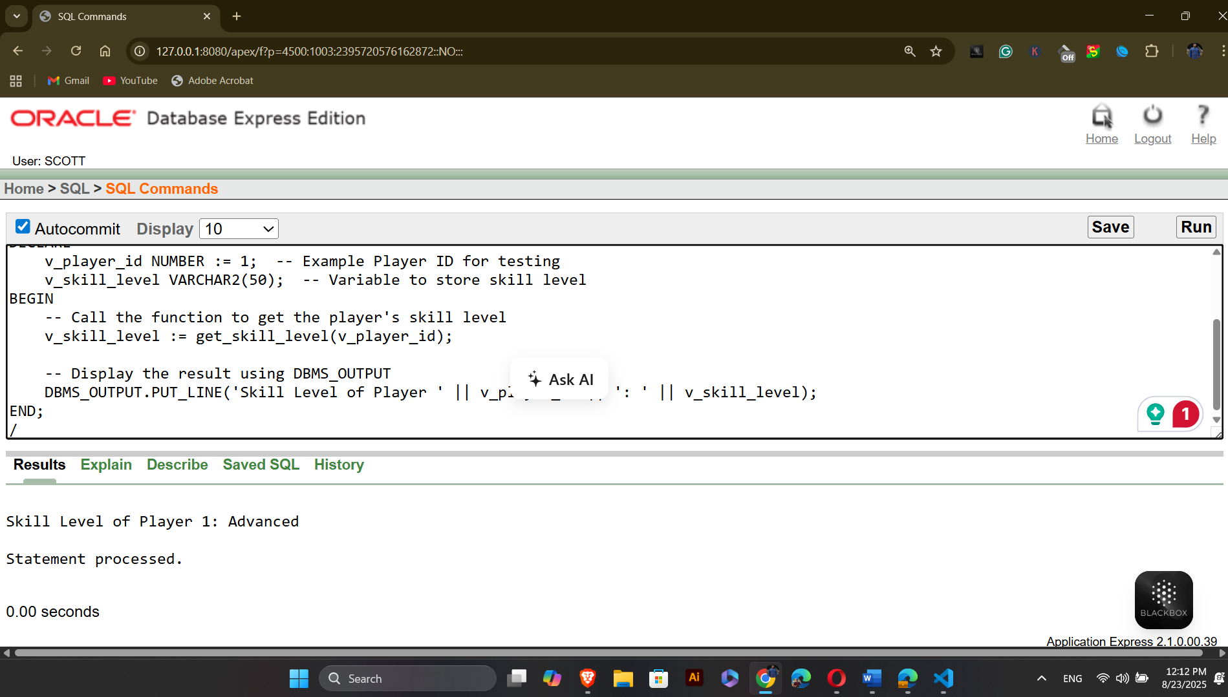
Question-2: Create a function to retrieve the turf location based on the Booking_ID.
Answer:
-- Project: Outdoor Sports Management System
-- Semester: Summer 2025
-- Course Name: Advance Database Management Systems
-- Section: A
CREATE OR REPLACE FUNCTION get_turf_location (p_booking_id IN NUMBER)
RETURN VARCHAR2 IS
v_turf_location VARCHAR2(100);
BEGIN

SELECT t.Turf_location
INTO v_turf_location
FROM Turf t
JOIN Can_Be_Made cbm ON t.Turf_ID = cbm.Turf_ID
WHERE cbm.Booking_ID = p_booking_id;
RETURN v_turf_location;
END get_turf_location;
/
To see the answer:
-- to see the function
-- Project: Outdoor Sports Management System
-- Semester: Summer 2025
-- Course Name: Advance Database Management Systems
-- Section: A
DECLARE
v_booking_id NUMBER := 2;
v_turf_location VARCHAR2(100);
BEGIN
v_turf_location := get_turf_location(v_booking_id);
DBMS_OUTPUT.PUT_LINE('Turf Location for Booking ' || v_booking_id || ': ' || v_turf_location);
END;
/
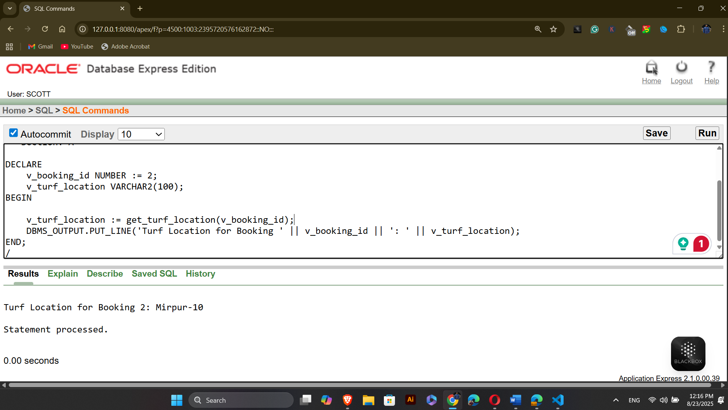

  - Stored procedure
Question-1: Create a stored procedure to update the skill level of a player based on their Player_ID
Answer:
-- to see the function
-- Project: Outdoor Sports Management System
-- Semester: Summer 2025
-- Course Name: Advance Database Management Systems
-- Section: A

CREATE OR REPLACE PROCEDURE update_skill_level (p_player_id IN NUMBER, p_skill_level IN VARCHAR2)
IS
BEGIN

UPDATE Profile
SET Skill_Level = p_skill_level
WHERE Profile_ID = (SELECT Profile_ID FROM Has_Profile WHERE Player_ID = p_player_id);

COMMIT;
END update_skill_level;
/
To test the procedure:
-- to see the function
-- Project: Outdoor Sports Management System
-- Semester: Summer 2025
-- Course Name: Advance Database Management Systems
-- Section: A

BEGIN
-- Call the procedure to update the skill level of a player
update_skill_level(1, 'Advanced');
END;
/
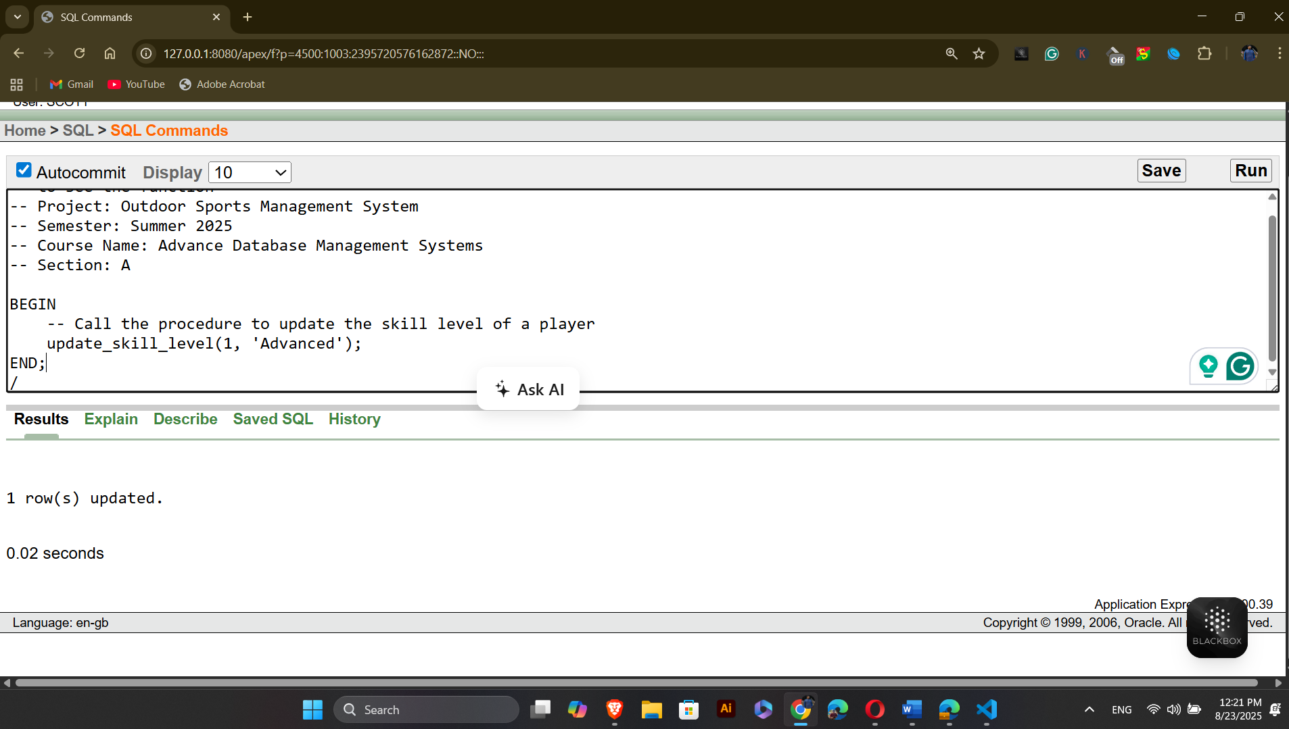
Question-2: Create a stored procedure to update the booking status of a specific booking based on the Booking_ID.
Answer:
-- Project: Outdoor Sports Management System
-- Semester: Summer 2025
-- Course Name: Advance Database Management Systems
-- Section: A
CREATE OR REPLACE PROCEDURE update_booking_status (p_booking_id IN NUMBER, p_status IN VARCHAR2)
IS
BEGIN

UPDATE Booking
SET Status = p_status
WHERE Booking_ID = p_booking_id;

COMMIT;
END update_booking_status;
/
To test the procedure:
-- Project: Outdoor Sports Management System
-- Semester: Summer 2025
-- Course Name: Advance Database Management Systems
-- Section: A
BEGIN
update_booking_status(4, 'Confirmed');
END;
/
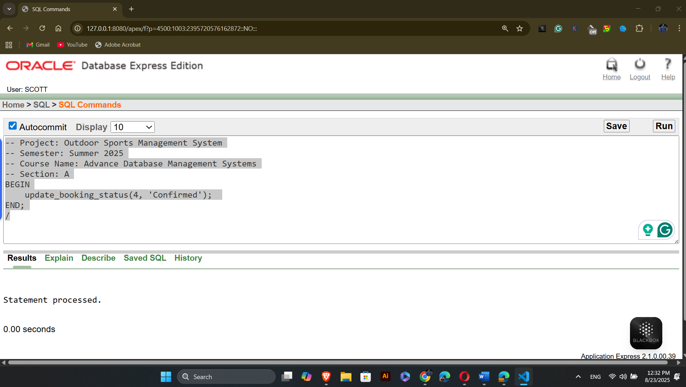

  - Table record
Question-1: Create a table-based record type to store player data and loop through it.
Answer:
-- Project: Outdoor Sports Management System
-- Semester: Summer 2025
-- Course Name: Advance Database Management Systems
-- Section: A
DECLARE
TYPE player_record_type IS TABLE OF Players%ROWTYPE;
v_players player_record_type;
BEGIN
SELECT * BULK COLLECT INTO v_players FROM Players;
FOR i IN 1..v_players.COUNT LOOP
DBMS_OUTPUT.PUT_LINE('Player Name: ' || v_players(i).First_Name || ' ' || v_players(i).Last_Name);
END LOOP;
END;
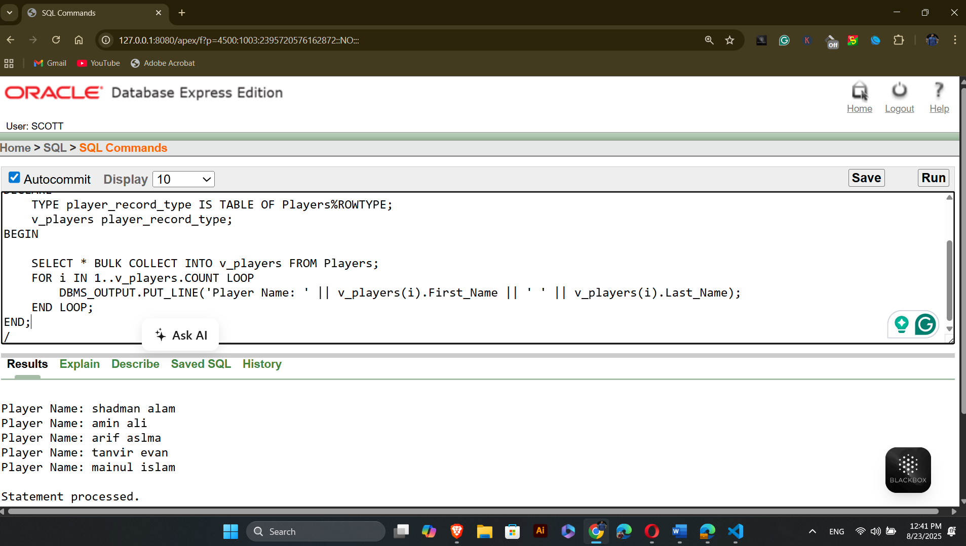
Question-2: Create a table-based record type to store booking data and loop through it.
Answer:
-- Project: Outdoor Sports Management System
-- Semester: Summer 2025
-- Course Name: Advance Database Management Systems
-- Section: A
DECLARE
TYPE booking_record_type IS TABLE OF Booking%ROWTYPE;
v_bookings booking_record_type;
BEGIN
SELECT * BULK COLLECT INTO v_bookings FROM Booking;
FOR i IN 1..v_bookings.COUNT LOOP
DBMS_OUTPUT.PUT_LINE('Booking ID: ' || v_bookings(i).Booking_ID || ' - Status: ' || v_bookings(i).Status);
END LOOP;
END;
/
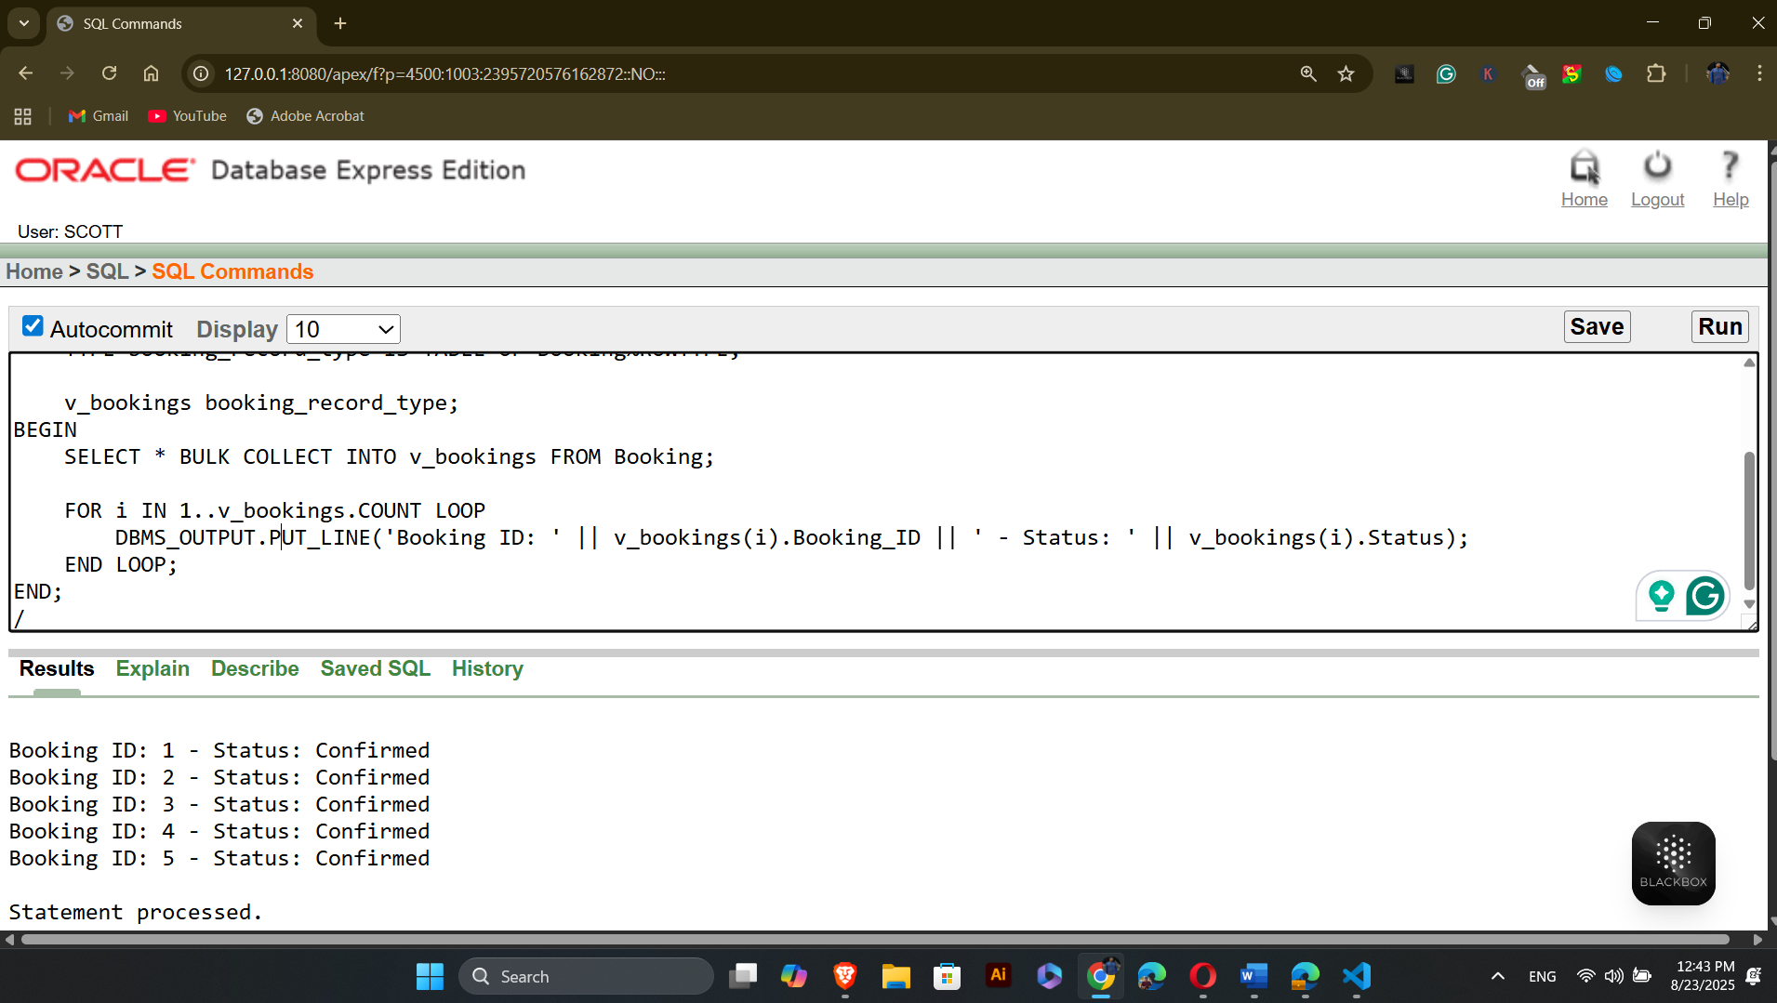
  - Explicit cursor
Question-1: Create an explicit cursor to fetch players with their booking details.
Answer:
-- Project: Outdoor Sports Management System
-- Semester: Summer 2025
-- Course Name: Advance Database Management Systems
-- Section: A
DECLARE

CURSOR c_player_bookings IS
SELECT p.Player_ID, b.Booking_ID, b.Status
FROM Players p
JOIN Belongs_To bt ON p.Player_ID = bt.Player_ID
JOIN Can_Make cm ON bt.Team_ID = cm.Team_ID
JOIN Booking b ON cm.Booking_ID = b.Booking_ID;
v_player_booking c_player_bookings%ROWTYPE;
BEGIN
OPEN c_player_bookings;
LOOP
FETCH c_player_bookings INTO v_player_booking;
EXIT WHEN c_player_bookings%NOTFOUND;
DBMS_OUTPUT.PUT_LINE('Player ID: ' || v_player_booking.Player_ID || ', Booking ID: ' || v_player_booking.Booking_ID || ', Status: ' || v_player_booking.Status);
END LOOP;

CLOSE c_player_bookings;
END;
/
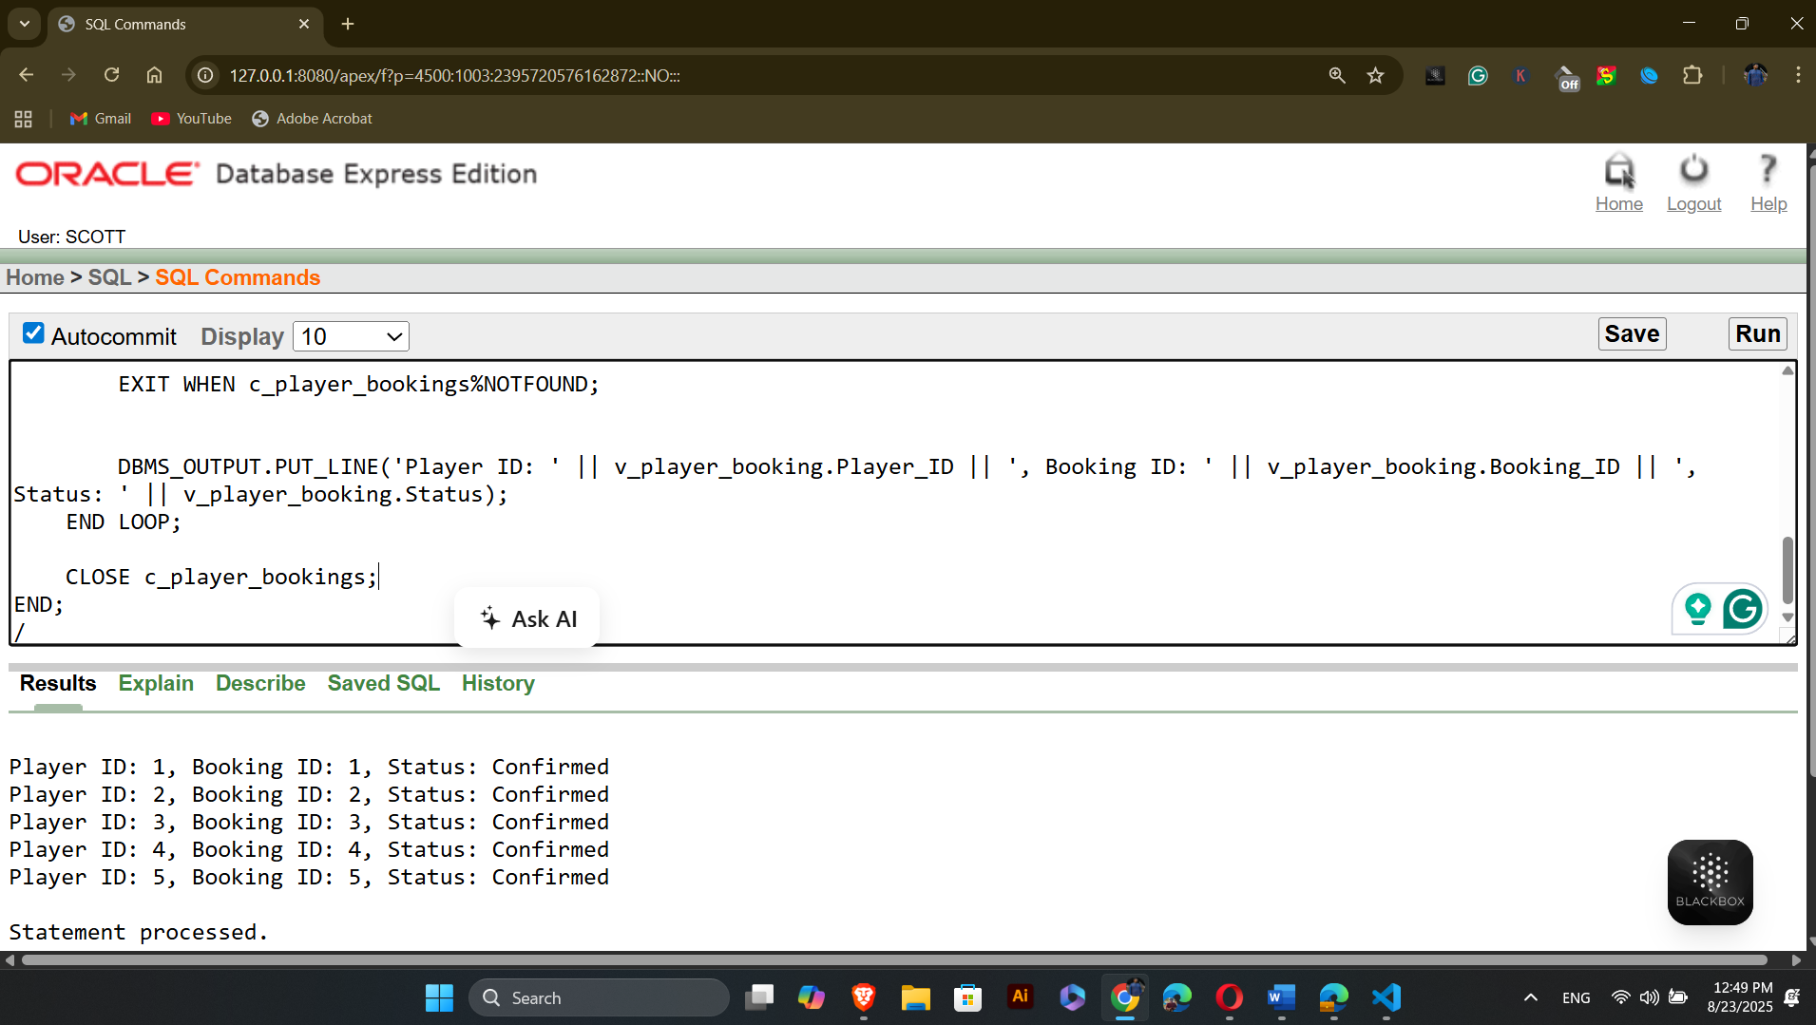

Question-2: Create an explicit cursor to fetch the booking details (Booking ID, Start Time, and End Time) for a specific team.
Answer:
-- Project: Outdoor Sports Management System
-- Semester: Summer 2025
-- Course Name: Advance Database Management Systems
-- Section: A
DECLARE

CURSOR c_team_bookings IS
SELECT b.Booking_ID, b.Start_Time, b.End_Time
FROM Booking b
JOIN Can_Make cm ON b.Booking_ID = cm.Booking_ID
WHERE cm.Team_ID = 1;

v_team_booking c_team_bookings%ROWTYPE;
BEGIN

OPEN c_team_bookings;

LOOP
FETCH c_team_bookings INTO v_team_booking;
EXIT WHEN c_team_bookings%NOTFOUND;

DBMS_OUTPUT.PUT_LINE('Booking ID: ' || v_team_booking.Booking_ID || ', Start Time: ' || v_team_booking.Start_Time || ', End Time: ' || v_team_booking.End_Time);

END LOOP;
CLOSE c_team_bookings;
END;
/
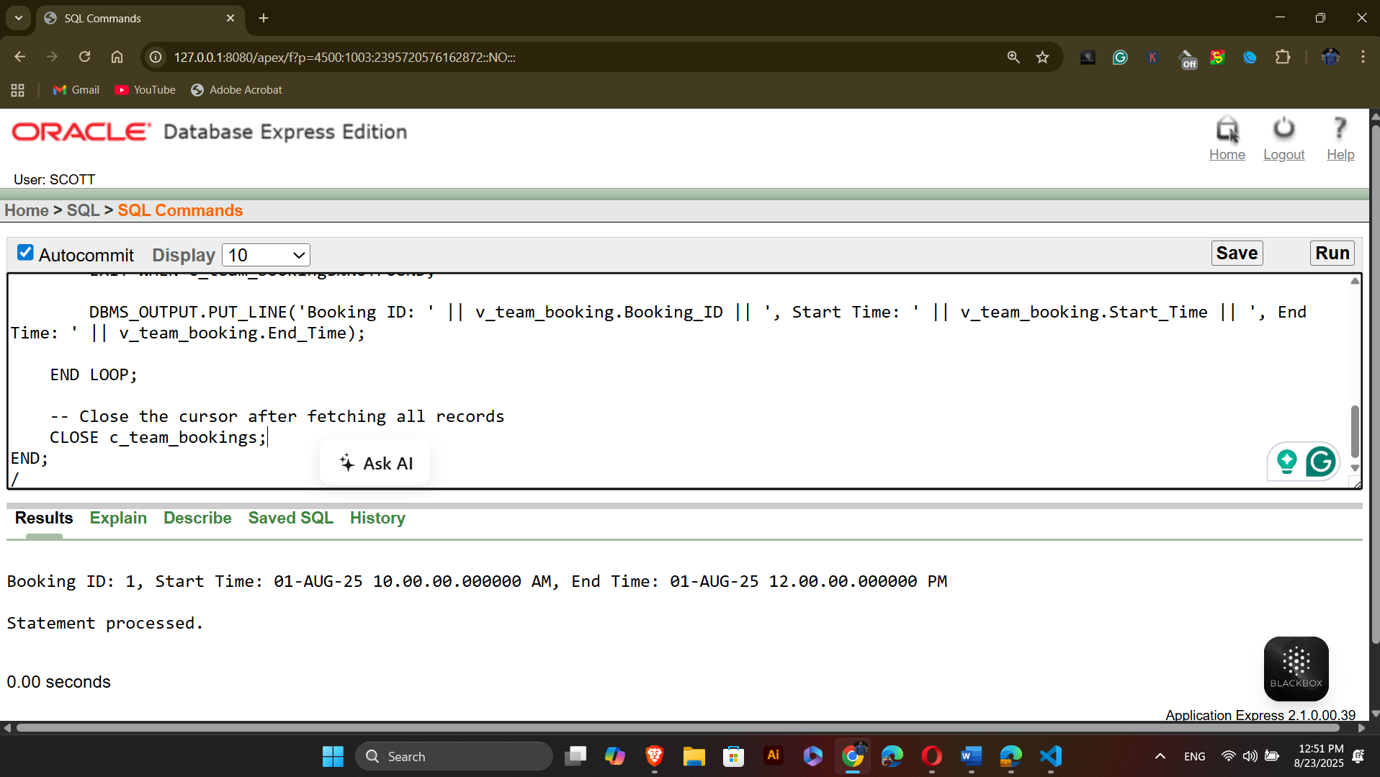

  - Cursor-based-record
Question-1: Use a cursor-based record to print the names of players who have confirmed bookings.
Answer:
-- Project: Outdoor Sports Management System
-- Semester: Summer 2025
-- Course Name: Advance Database Management Systems
-- Section: A
DECLARE

TYPE player_rec_type IS RECORD (
player_id NUMBER,
first_name VARCHAR2(100),
last_name VARCHAR2(100)
);

TYPE player_tab_type IS TABLE OF player_rec_type;

v_players player_tab_type;
BEGIN
SELECT p.Player_ID, p.First_Name, p.Last_Name
BULK COLLECT INTO v_players
FROM Players p
JOIN Belongs_To bt ON p.Player_ID = bt.Player_ID
JOIN Can_Make cm ON bt.Team_ID = cm.Team_ID
JOIN Booking b ON cm.Booking_ID = b.Booking_ID
WHERE b.Status = 'Confirmed';
FOR i IN 1..v_players.COUNT LOOP
DBMS_OUTPUT.PUT_LINE('Player Name: ' || v_players(i).first_name || ' ' || v_players(i).last_name);
END LOOP;
END;
/
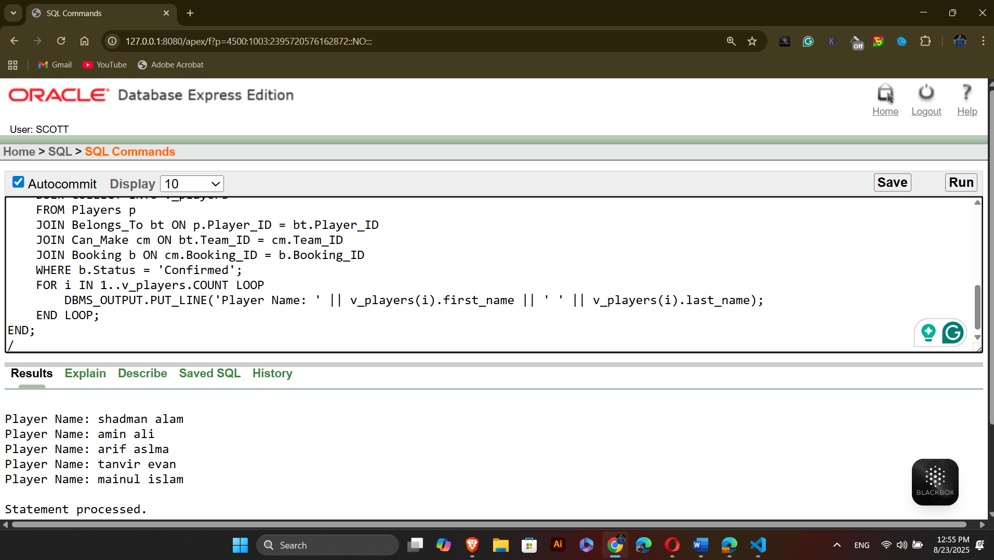
Question-2: Use a cursor-based record to print the player names and their associated team names.
Answer:
-- Project: Outdoor Sports Management System
-- Semester: Summer 2025
-- Course Name: Advance Database Management Systems
-- Section: A
DECLARE

TYPE player_team_rec_type IS RECORD (
player_name VARCHAR2(100),
team_name VARCHAR2(100)
);

TYPE player_team_tab_type IS TABLE OF player_team_rec_type;

v_player_teams player_team_tab_type;
BEGIN

SELECT p.First_Name || ' ' || p.Last_Name AS player_name, t.Team_Name
BULK COLLECT INTO v_player_teams
FROM Players p
JOIN Belongs_To bt ON p.Player_ID = bt.Player_ID
JOIN Team t ON bt.Team_ID = t.Team_ID;

FOR i IN 1..v_player_teams.COUNT LOOP
DBMS_OUTPUT.PUT_LINE('Player: ' || v_player_teams(i).player_name ||
' - Team: ' || v_player_teams(i).team_name);
END LOOP;
END;
/
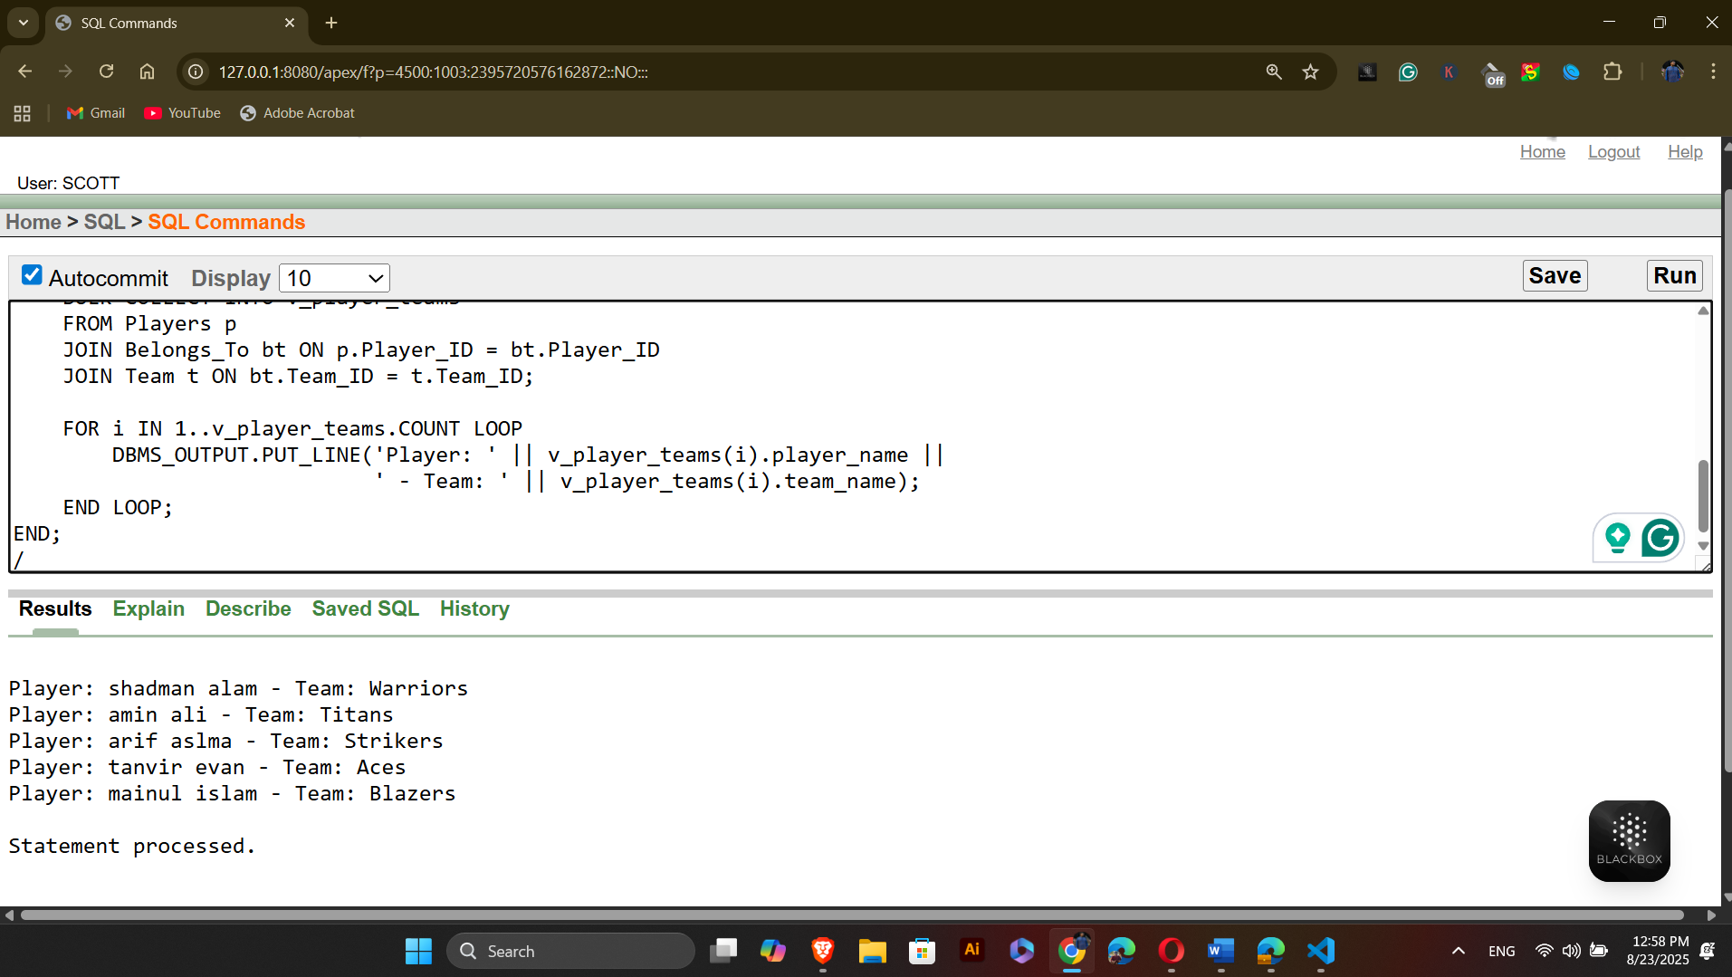

  - Row level trigger
Question-1: Create a row-level trigger that automatically sets the booking status to 'Pending' when a new booking record is inserted.
Answer:
CREATE OR REPLACE TRIGGER trg_booking_default_status
BEFORE INSERT ON Booking
FOR EACH ROW
BEGIN
:NEW.Status := 'Pending';
END;
/
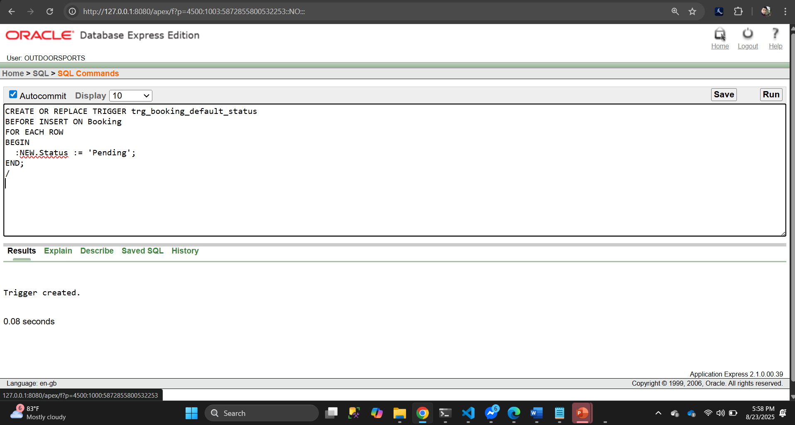
Question-2: Write a row-level trigger on the Players table that displays the name of a newly inserted player.
CREATE OR REPLACE TRIGGER trg_player_insert
AFTER INSERT ON Players
FOR EACH ROW
BEGIN
dbms_output.put_line('New Player Added: ' || :NEW.First_Name || ' ' || :NEW.Last_Name);
END;
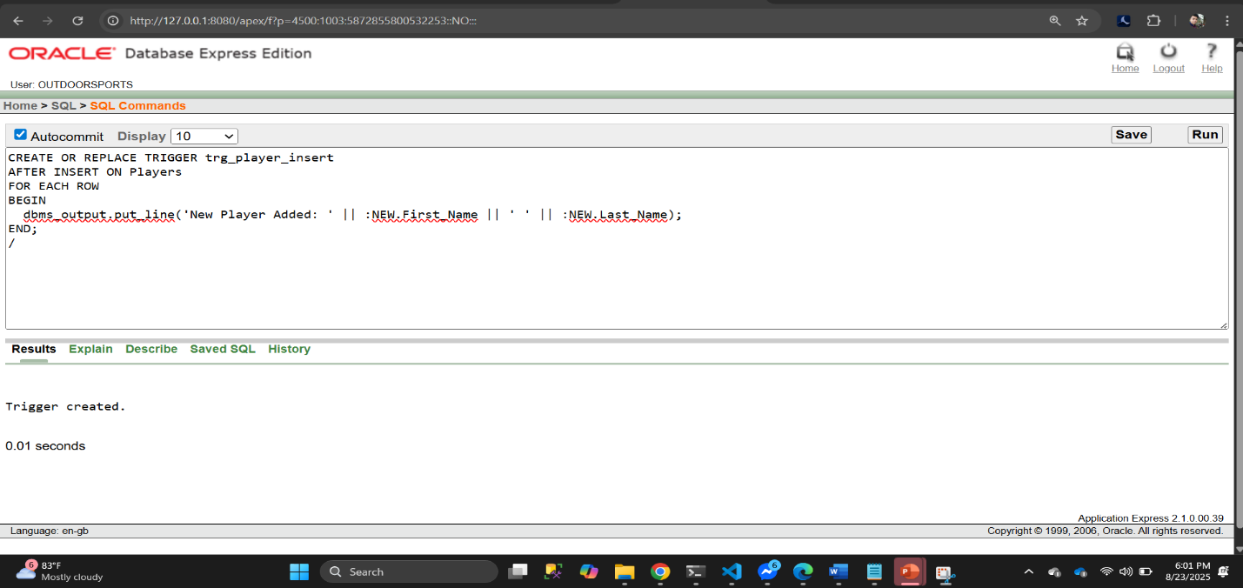
/

7. Statement level trigger
Question-1: Write a statement-level trigger that prints a message whenever a new event is inserted into the Events table.
CREATE OR REPLACE TRIGGER trg_event_insert_stmt
AFTER INSERT ON Events
BEGIN
dbms_output.put_line('An INSERT operation has been performed on Events table.');
END;
/
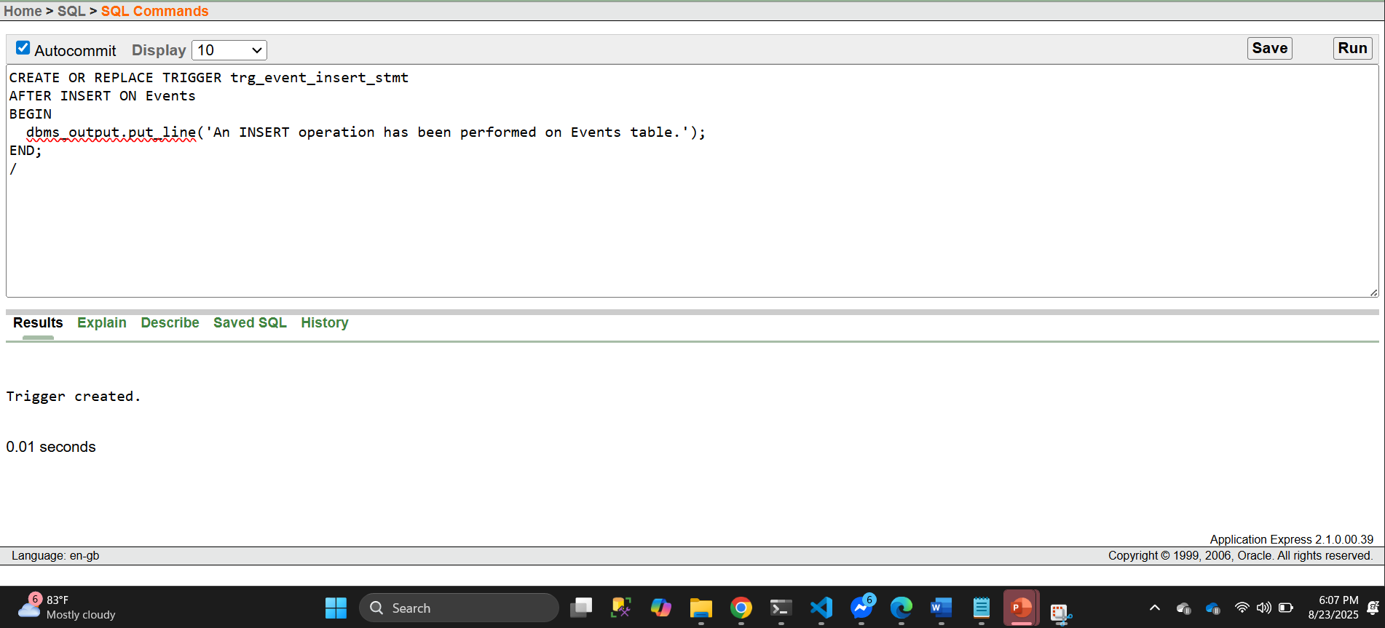

Question-2: Write a statement-level trigger that prints a message before any row is deleted from the Team table
CREATE OR REPLACE TRIGGER trg_team_delete_stmt
BEFORE DELETE ON Team
BEGIN
dbms_output.put_line('A DELETE operation is being performed on Team table.');
END;
/
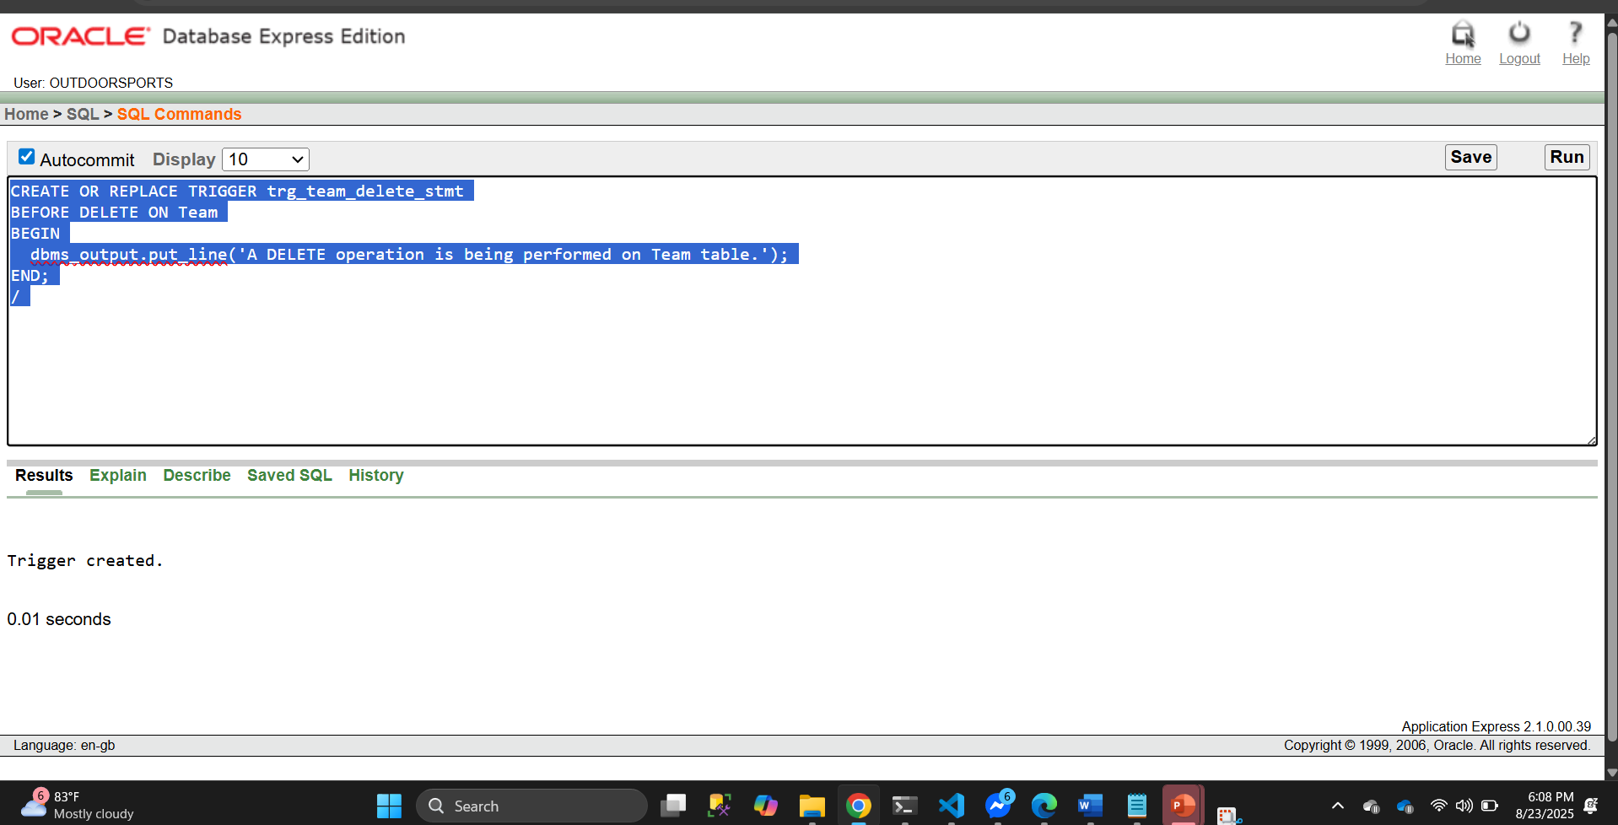
8. package
Question-1: Create a PL/SQL package named player_pack that contains procedures to display a player’s full name and date of birth from the Players table.
Specification
CREATE OR REPLACE PACKAGE player_pack AS
PROCEDURE show_player_name(p_id Players.Player_ID%TYPE);
PROCEDURE show_player_dob(p_id Players.Player_ID%TYPE);
END player_pack;
/
Body
CREATE OR REPLACE PACKAGE BODY player_pack AS
PROCEDURE show_player_name(p_id Players.Player_ID%TYPE) IS
p_name VARCHAR2(100);
BEGIN
SELECT First_Name || ' ' || Last_Name INTO p_name
FROM Players WHERE Player_ID = p_id;
dbms_output.put_line('Player Name: ' || p_name);
END;

PROCEDURE show_player_dob(p_id Players.Player_ID%TYPE) IS
p_dob DATE;
BEGIN
SELECT DOB INTO p_dob
FROM Players WHERE Player_ID = p_id;
dbms_output.put_line('Date of Birth: ' || TO_CHAR(p_dob,'DD-MON-YYYY'));
END;
END player_pack;
/
Usage
BEGIN
player_pack.show_player_name(1);
player_pack.show_player_dob(1);
END;
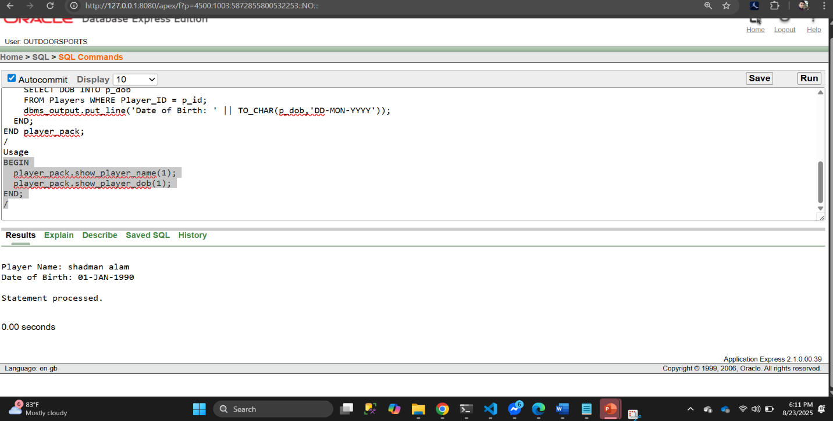
/

Question-2: Create a PL/SQL package named booking_pack that allows checking and updating the booking status in the Booking table.
Specification
CREATE OR REPLACE PACKAGE booking_pack AS
PROCEDURE show_booking_status(b_id Booking.Booking_ID%TYPE);
PROCEDURE update_booking_status(b_id Booking.Booking_ID%TYPE, new_status VARCHAR2);
END booking_pack;
/
Body
CREATE OR REPLACE PACKAGE BODY booking_pack AS
PROCEDURE show_booking_status(b_id Booking.Booking_ID%TYPE) IS
v_status VARCHAR2(50);
BEGIN
SELECT Status INTO v_status
FROM Booking WHERE Booking_ID = b_id;
dbms_output.put_line('Booking Status: ' || v_status);
END;

PROCEDURE update_booking_status(b_id Booking.Booking_ID%TYPE, new_status VARCHAR2) IS
BEGIN
UPDATE Booking SET Status = new_status WHERE Booking_ID = b_id;
dbms_output.put_line('Booking ' || b_id || ' updated to ' || new_status);
END;
END booking_pack;
/

Usage
BEGIN
booking_pack.show_booking_status(1);
booking_pack.update_booking_status(2, 'Confirmed');
END;
/
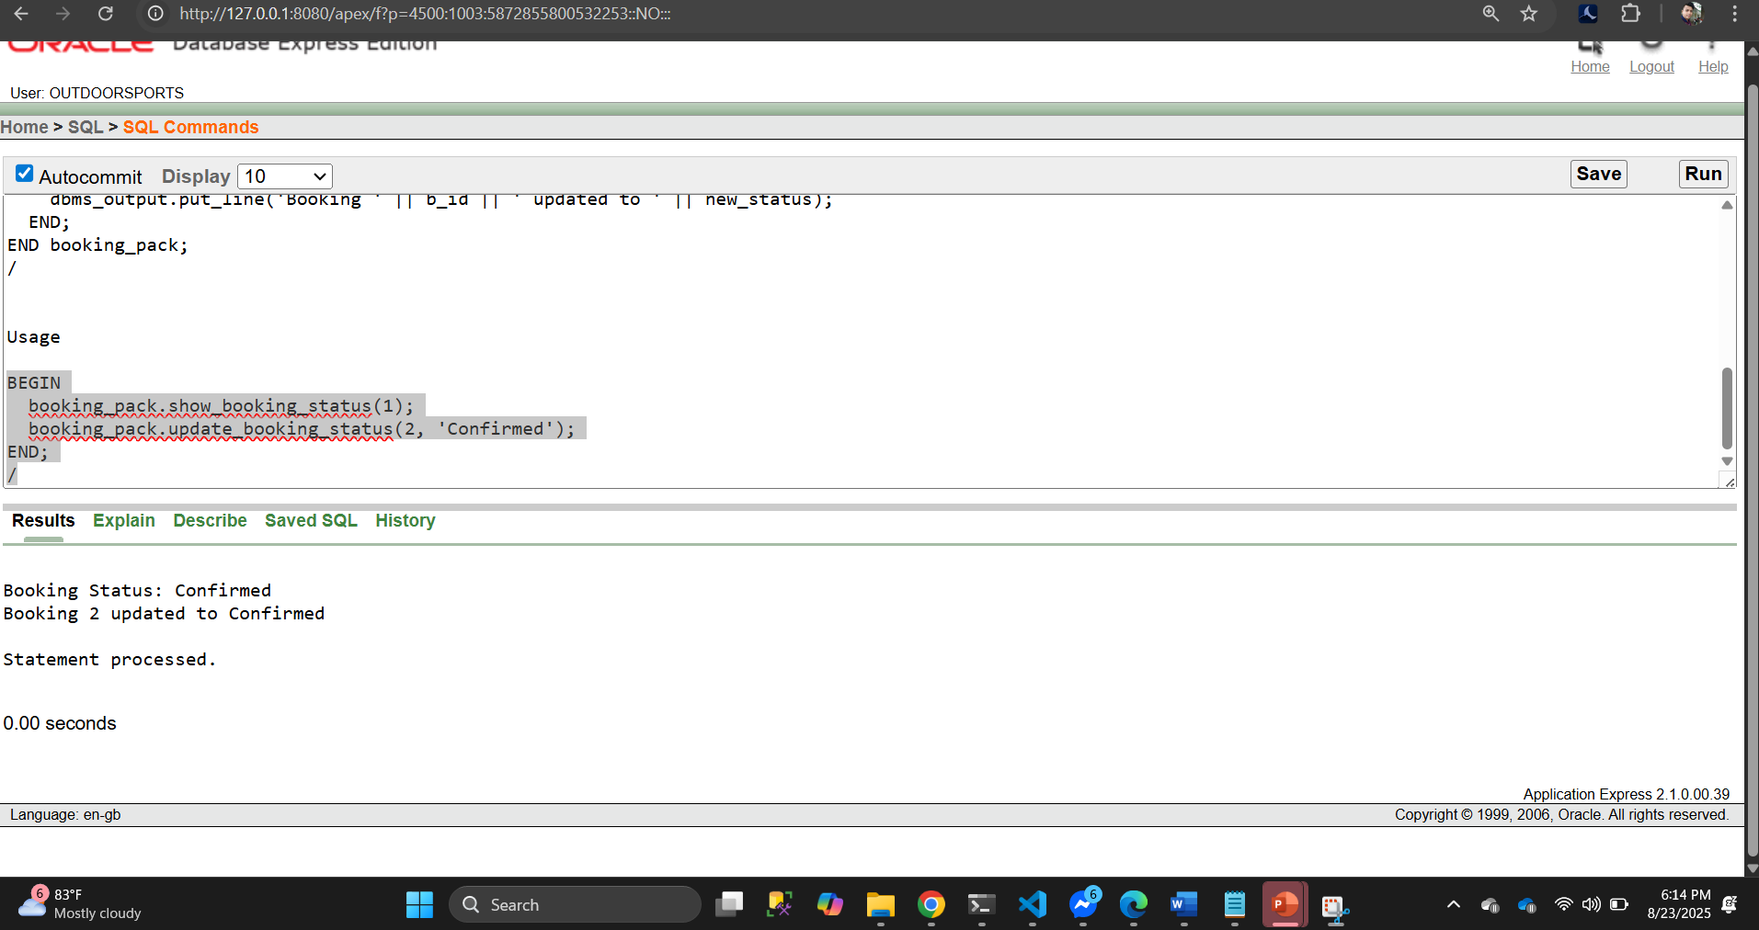

Conclusion:
The Outdoor Sports Facility Management System project successfully implements a comprehensive solution for managing turf bookings, team creation, event scheduling, and player profile management. By utilizing advanced database management techniques and PL/SQL for business logic, the system optimizes key functions such as real-time turf availability, seamless booking, and secure payments. The user interface design ensures an intuitive experience for both sports organizations and individual players.
Looking ahead, the system can be further enhanced by integrating optimization techniques such as AI for predicting turf usage and recommending events or teams, ensuring more efficient operations. Improving mobile app integration will allow users to manage bookings and teams on-the-go, adding greater flexibility. Additionally, expanding payment options, implementing multilingual support, and strengthening data security will make the platform more accessible and secure for a wider audience.
In future iterations, the system could explore cloud-based infrastructure for scalability, and integration with machine learning could help in data-driven decision-making for sports organizations, optimizing resource usage and event planning. With these future enhancements, the Outdoor Sports Facility Management System will evolve into a fully scalable, secure, and user-friendly platform, capable of meeting the growing demands of both sports organizations and participants in the industry.

